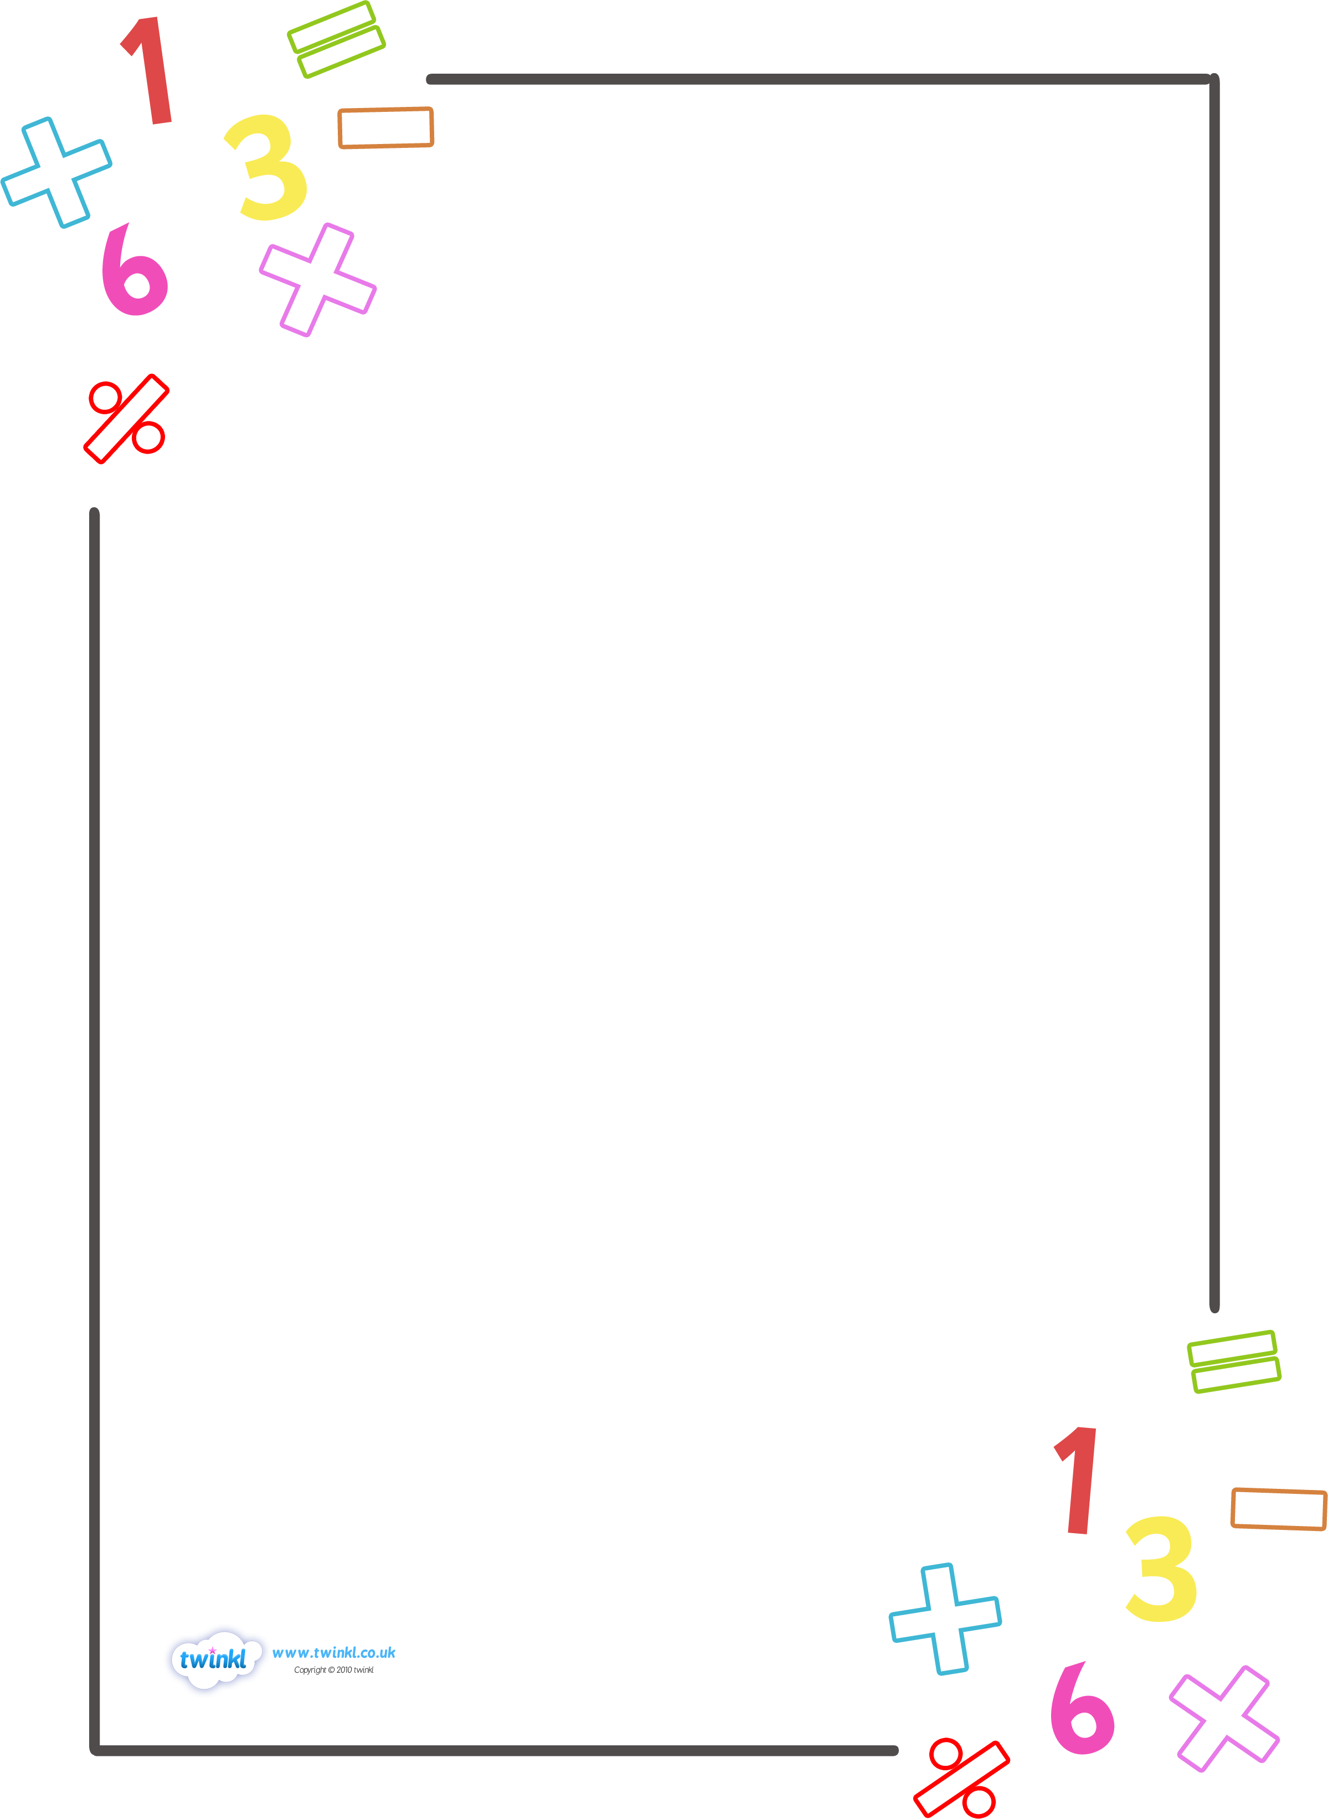

**Langstone Junior**

**Progression**

**through Calculations**

**Year 5 and 6**



**Vision for Maths**

**Langstone Junior’s Approach to Maths**

All planning should be driven by the aims…

* To become **fluent** in the fundamentals of mathematics, through **varied and frequent practise** of complex problems over time so that they have the ability to recall and apply knowledge rapidly and accurately.
* Reason mathematically by following a line of enquiry, conjecturing relationships and justifying, using mathematical language.
* Can **solve problems** by applying their mathematics to a variety of routine and non-routine problems with increasing sophistication, including breaking down problems into simpler steps and persevering in finding solutions.

With this in mind, we have three main aims that demonstrate the focus for our school.

* [We promote talk and discussion to **deepen**understanding and **challenge**new concepts.](http://langstone-jun.portsmouth.sch.uk/curriculum/maths/)

**Because…**our children learn best through **reflection**and **thinking**when discussing with their peers.

* We provide choices to allow children to challenge themselves and to promote independent enquiries.

**Because**…we have found that our children are reluctant to independently challenge themselves and embrace the value of learning from their own mistakes and false starts. By encouraging this, we will be promoting their ability to reason and make sense of solutions.

* We develop mathematical thinking through a three part process (physical resources, visual pictures and applying this knowledge to reasoning and problem solving contexts) to embed concepts.

**Because**…we have found that children can apply their learning more once they have the conceptual understanding. Through this, we are developing independent thinking.

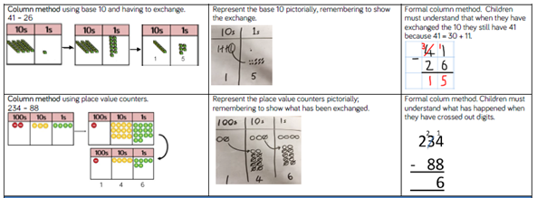

|  |  |  |
| --- | --- | --- |
| **Physical Resources** | **Visual Representations** | **Abstract Numbers** |

**PROGRESSION THROUGH CALCULATIONS FOR ADDITION**

* These standards are age-related expectations and therefore we expect the majority of children to achieve them.
* Children should understand that addition is commutative and therefore calculations can be rearranged, e.g. 4 + 13 = 17 is the same as 13 + 4 = 17.
* Ensure that children understand the = sign means is the same as, not makes, and that children see calculations where the equals sign is in a different position, e.g. 3 + 2 = 5 and 5 = 3 + 2.
* Children should be encouraged to approximate before calculating and check whether their answer is reasonable.
* Children will build on their knowledge of using Base 10 equipment and place value counters continue to use this to support with the transition into a vertical method.

**Different Types of Addition**

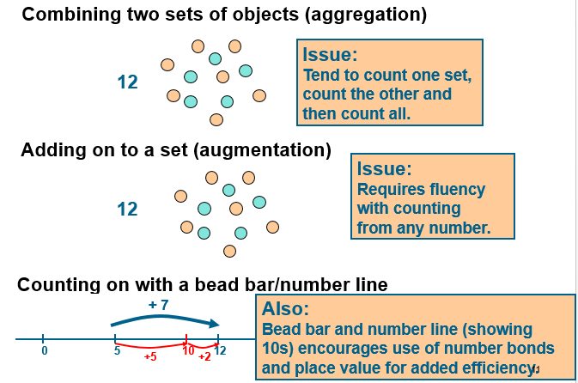

**Step One: Column Method**

Children will be building on their knowledge from the lower key stage. They will be using the column method to add whole numbers with more than 4-digits.

They will need to have a secure knowledge of place value and what each digit represents. Furthermore, they will need to understand when carrying is needed and what it represents. For example, as soon as you get more than 9 in the ones column, it then becomes something new a 10!

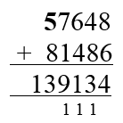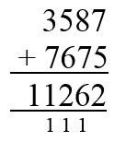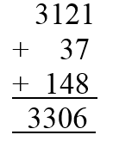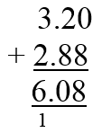

**Step Two: Appropriate Use of the Column Method**

This step is important and should be given emphasis because we want children to become independent thinkers. A competent mathematician seeks the most efficient method that allows them to attain the answer in the easiest and quickest way.

Discussions around efficient mental calculations and sensible estimations need to run through all steps. Sometimes children are too quick to move to computational methods, when changing the order leads to quick mental methods and solutions.



**2370 + 30 = 2400**

**35,750 + 250 = 36,000**



**By the end of Year 6, children will be using these methods to:**

* Add whole numbers with more than 4-digits (column method)
* Round to estimate and approximate
* Inverse operations (addition and subtraction)
* Multi-step addition problems
* Mental calculations and estimation
* Reasoning from known facts

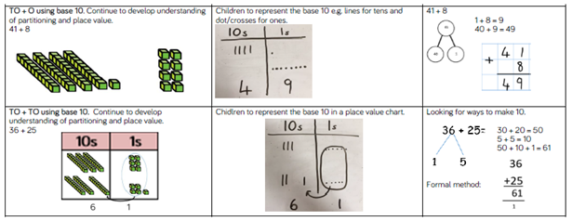**Examples of Addition Objectives Being Taught**

**PROGRESSION THROUGH CALCULATIONS FOR SUBTRACTION**

* These standards are age-related expectations and therefore we expect the majority of children to achieve them.
* Children should understand that subtraction is the removing or taking away one quantity from another (not necessarily the smaller number from the larger one) or finding the difference between two separate quantities.
* Children should understand that, unlike addition, subtraction is **not** commutative.
* Ensure that children understand the = sign means is the same as, not makes, and that children see calculations where the equals sign is in a different position, e.g. 9 – 5 = 4 and 4 = 9 – 5.
* Children should be encouraged to approximate before calculating and check whether their answer is reasonable.

**Different Types of Subtraction**

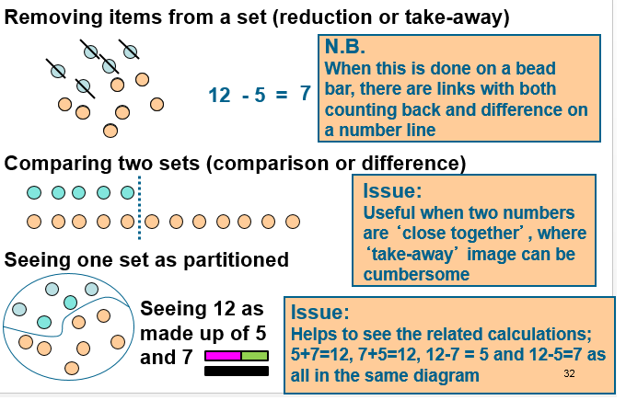

**Step One: Subtracting Using the Column Method with More than 4-Digits**

Children need to recognise which column they begin subtracting from first (the ones). A common misconception for many children is that if the number on the top line is smaller then what they are subtracting, you can just swap the numbers around. They need to understand that this would completely change the total, it can be done but we are trying to work with positive, whole numbers.

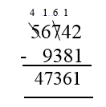

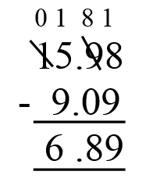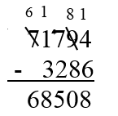

**Step Two: Appropriate Use of the Column Method**

As mentioned in the addition section of the policy,discussions around efficient mental calculations and sensible estimations need to run through all steps. Sometimes children are too quick to move to computational methods, when changing the order leads to quick mental methods and solutions.

If the numbers involved in the calculation are close together or near to multiples of 10, 100 etc, children should be encouraged to recognise that it is more efficient to find the difference by counting up.

e.g. 3002 - 1997 = 1005

+1000

+2

+3

1997 2000 300 3002

**+ - + - + - + - + - + - +**

**By the end of year 6, children will have a range of calculation methods, mental and written. Selection will depend upon the numbers involved.**

**Children should not be made to go onto the next stage if:**

1. **They are not ready.**
2. **They are not confident.**

**Children should be encouraged to consider if a mental calculation would be appropriate before using written methods.**

**Subtraction as finding the difference**

If the numbers involved in the calculation are close together or near to multiples of 10, 100 etc, children should be encouraged to recognise that it is more efficient to find the difference by counting up.

e.g. 511 – 197 = 314

+300

+11

+3

197 200 500 511

**Help children to become more efficient with counting on by:**

* Subtracting the units in one jump;
* Subtracting the tens in one jump and the units in one jump;
* Subtracting the hundreds in one jump, the tens in one jump and the units in one jump.

**NB – number lines should be used to help model mental strategies of subtraction.**

**By the end of Year 6, children will be using these methods to:**

* Subtract whole numbers with more than 4-digits (column method)
* Round to estimate and approximate
* Inverse operations (addition and subtraction)
* Multi-step subtraction problems
* Mental calculations and estimation
* Reasoning from known facts

**Examples of Subtraction Objectives Being Taught**

**PROGRESSION THROUGH CALCULATIONS FOR MULTIPLICATION**

* These standards are age-related expectations and therefore we expect the majority of children to achieve them.
* Children need to understand that multiplication is commutative and use this information to rearrange calculations knowing that 4 x 6 = 24 gives the same answer as 6 x 4 = 24.
* Children need to understand that multiplication is repeated addition.
* Ensure that children understand the = sign means is the same as, not makes, and that children see calculations where the equals sign is in a different position, e.g. 3 x 5 = 15 and 15 = 3 x 5.
* Children should be encouraged to approximate before calculating and check whether their answer is reasonable.

**Different Types of Multiplication**

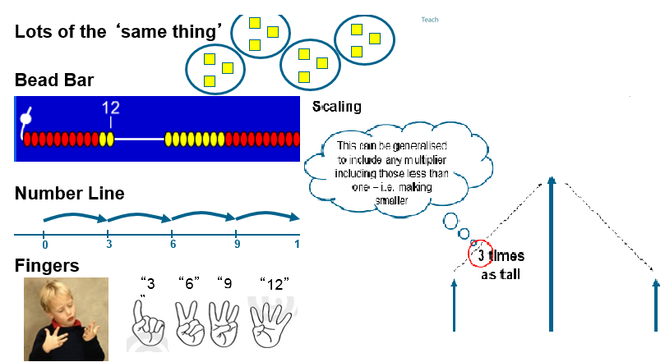

**Step One: Moving from the Grid Method to Short Multiplication**

Before these methods, children should recognise that multiplication and division have a multiplicative relationship. Within multiplication and division, the methods should always refer to the number in a group, the number of groups and the total. This way children will see how the two operations connect and are the inverse of one another.

**HTU x U (Short grid multiplication – multiplication by a single digit)**

346 x 9

|  |  |  |  |  |  |  |
| --- | --- | --- | --- | --- | --- | --- |
| x | 300 | 40 | 6 |  |  |  |
| 9 | 2700 | 360 | 54 |  |  | 2700 |
|  |  |  |  |  |  | + 360 |
|  |  |  |  |  |  | + 54 |
|  |  |  |  |  |  | 31 1 4 |

1 1

4.9 x 3

|  |  |  |  |  |  |
| --- | --- | --- | --- | --- | --- |
| x | 4 | 0.9 |  |  |  |
| 3 | 12 | 2.7 |  |  | 12 |
|  |  |  |  |  | + 2.7 |
|  |  |  |  |  | 14.7 |
|  |  |  |  |  |  |

**TU x TU (Long grid multiplication – multiplication by more than a single digit)**

72 x 38

|  |  |  |  |  |  |
| --- | --- | --- | --- | --- | --- |
| x | 70 | 2 |  |  |  |
| 30 | 2100 | 60 |  |  | 2100 |
| 8 | 560 | 16 |  |  | + 560 |
|  |  |  |  |  | + 60 |
|  |  |  |  |  | + 1 6 |
|  |  |  |  |  | 2736 |

1

**Step Two: Moving from the Gird Method to Short and Long Multiplication**

When mathematically ready, children can progress onto HTU x TU.

**ThHTU x U (Short multiplication – multiplication by a single digit)**

4724 x 8

4724

x 8

37792

5 1 3

**ThHTU x U (Short multiplication – multiplication by a single digit)**

4724 x 8

4724

x 8

37792

5 1 3

4.92 x 3

4.92

x 3

14.76

2

**TU x TU and HTU x TU (Long multiplication – multiplication by more than a single digit)**

53 x 34

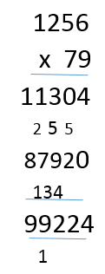

53

x 34

212

1

1590

1802

1

**By the end of Year 6, children will be using these methods to:**

* Multiply multi-digit number up to 4 digits by a 1 and 2-digit number using the formal written method of long multiplication.
* Perform mental calculations, including with mixed operations and large numbers.
* Identify common factors, common multiples and prime numbers.
* Use their knowledge of the order of operations to carry out calculations involving the four operations.
* Solve problems involving addition, subtraction, multiplication and division.
* Use estimation to check answers to calculations and determine in the context of a problem, an appropriate degree of accuracy.

**+ - + - + - + - + - + - +**

**By the end of year 6, children will have a range of calculation methods, mental and written. Selection will depend upon the numbers involved.**

**Children should not be made to go onto the next stage if:**

1. **They are not ready.**
2. **They are not confident.**

**Children should be encouraged to consider if a mental calculation would be appropriate before using written methods.**

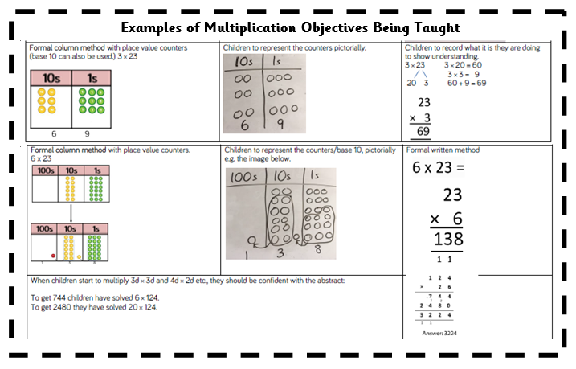

**PROGRESSION THROUGH CALCULATIONS FOR DIVISION**

* These standards are age-related expectations and therefore we expect the majority of children to achieve them.
* Children need to understand that division can be sharing or grouping (repeated subtraction).
* Children should understand that, unlike multiplication, division is **not** commutative.
* Ensure that children understand the = sign means is the same as, not makes, and that children see calculations where the equals sign is in a different position, e.g. 12 ÷ 3 = 4 and 4 = 12 ÷ 3.
* Children should be encouraged to approximate before calculating and check whether their answer is reasonable.

**Different Types of Division**

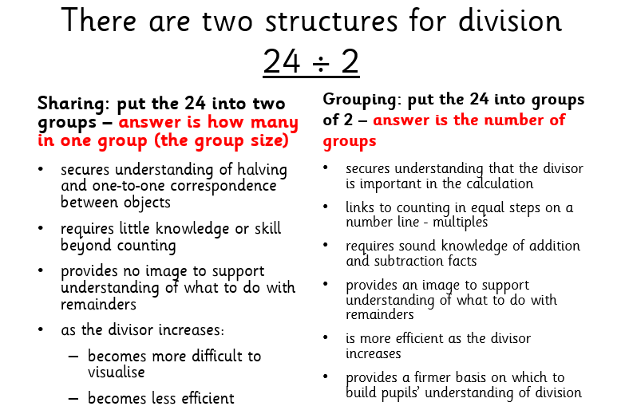

**Step One: Short Division with Chunking**

**Short division - chunking (TU ÷ U)**

Children should write key facts in a menu box. This will help them in identifying the largest group they can subtract in one chunk.

72 ÷ 3

24

1x 3

2x 6

5x 15

10x 30

3) 72

- 30 10x

42

- 30 10x

12

- 6 2x

6

- 6 2x

0

Answer: 24

Children should write their answer above the calculation to make it easy for them and the teacher to distinguish.

Any remainders should be shown as integers, i.e. 14 remainder 2 or 14 r 2.

Children can start to subtract larger multiples of the divisor (e.g. 20x).

**Short division - chunking (HTU** ÷ **U) and (HTU ÷ TU)**

196 ÷ 6

The key facts in the menu box should be extended to include 4x and 20x.

1x 6

2x 12

4x 24

5x 30

10x 60

20x 120

32 r 4

6 )196

- 180 30x

16

- 12 2x

4

Answer: 32 remainder 4 or 32 r 4

Any remainders should be shown as integers, i.e. 14 remainder 2 or 14 r 2.

Children need to be able to decide what to do after division and round up or down accordingly. They should make sensible decisions about rounding up or down after division. For example 240 ÷ 52 is 4 remainder 32, but whether the answer should be rounded up to 5 or rounded down to 4 depends on the context.

**Step Two: Short division (HTU ÷ U)**

196 ÷ 6

0 3 2 r 4

6 ) 1 19 16

Children may still use the menu box if required, but would also be expected to use larger multiples of the divisor (e.g. 20x, 30x, 40x).

**Short division (HTU ÷ U) – moving to using decimals as remainders**

196 ÷ 6

0 3 2 . 6 6

6 ) 1 19 16 . 40 40

**Step Three: Long division (HTU** ÷ **TU)**

972 ÷ 36

1x 36

2x 72

4x 144

5x 180

10x 360

20x 720

27

36 )972

72

252

252

0

Any remainders should be shown as fractions, i.e. if the children were dividing 32 by 10, the answer should be shown as 3 2/10 which could then be written as 3 1/5 in its lowest terms.

This method should be extended to be used with decimals with up to two decimal places. Children should know that decimal points line up under each other.

e.g. 87.5 ÷ 7

1 2. 5

7 )817.35

Children will apply the compact method for both short multiplication and long multiplication to a range of problems

**By the end of Year 6, children will be using these methods to:**

* Divide numbers up to 4 digits by a 2-digit whole number using the formal written method of long division, and interpret remainders as whole number remainders, fractions, or by rounding as appropriate for the context.
* Divide numbers up to 4 digits by a 2-digit number using the formal written method of short division, interpreting remainders according to the context.
* Perform mental calculations, including with mixed operations and large numbers.
* Identify common factors, common multiples and prime numbers.
* Use their knowledge of the order of operations to carry out calculations involving the four operations.
* Solve problems involving addition, subtraction, multiplication and division.
* Use estimation to check answers to calculations and determine in the context of a problem, an appropriate degree of accuracy.

**+ - + - + - + - + - + - +**

**By the end of Year 6, children will have a range of calculation methods, mental and written. Selection will depend upon the numbers involved.**

**Children should not be made to go onto the next stage if:**

1. **They are not ready.**
2. **They are not confident.**

**Children should be encouraged to consider if a mental calculation would be appropriate before using written methods.**

**Examples of Division Objectives Being Taught**

