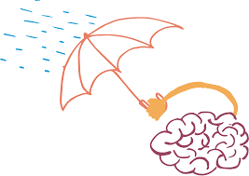
Year 4 - Home Learning Tasks
WB: 27.4.20
Our theme for this half term will be the concepts of ‘responsibility’ and ‘resilience’.
This week we will exploring different types of poems revolving around these themes and learning their different features. We will also be exploring ‘karma’ in RE and how this can encourage people to take responsibility of their choices. Other learning includes researching the layers of our oceans, recapping methods for addition and answering the question: Why do animals have different ear shapes?
 | Activity 1 | Activity 2 | Activity 3 | Away from screen time challenge!
Monday | Reading – Use the links below to listen to our poems for this week.  Consider the theme of the poems and what you like about each of them. | Spelling – Use the website to recap the suffix ‘shun’. https://www.bbc.co.uk/bitesize/topics/zt62mnb/articles/zyv4qhv | Topic – Learn about the different layers of the oceans  Feel free to watch this to find out about what lives at the bottom of our oceans: https://www.bbc.co.uk/iplayer/episode/b09f8vtb/blue-planet-ii-series-1-2-the-deep | Listen to some music – bust out your best moves with those in the house!
Tuesday | Reading – All the poems today are a certain kind. Watch the clip before seeing if you can identify what type of poem they are! | Maths – Practise your column method for addition. | PSHE – Research why caffeine is a drug and the effect it has on your body.  https://kidshealth.org/en/parents/child-caffeine.html | Grab a board game/pack of cards from around the house and challenge a family member or two!
Wednesday | Writing – Use what you learnt about Haikus to finish the poems provided with its needed features. | Maths – Complete word problems using methods for addition. | Topic – Choose two different layers of the ocean and research the answer to:  How do living things in the ___ compare to those in the ____? | Help your adults with chores around the house!
Thursday | Reading – All the poems today are a different kind. Watch the clip before seeing if you can identify what type of poem they are! | RE – Karma  Let’s explore the meaning of the word ‘karma’. | Science – Why do animals have different ear shapes?  Make observations and draw predictions of animals and their ears. | Keep fit:  Complete 10 x star jumps, 10 x squats and 10 x lunges before repeating three times.
Friday | Writing – Use what you learnt about narrative poetry to finish the poem provided with its needed features. | Maths – Use a range of strategies and methods in today’s arithmetic. | Computing – Learn about algorithms and sequencing before creating your own hand jive. | Feeling creative? Sketch your view from out of your window using your shading techniques.
These are the details and links to some of the activities posted on Google Classroom this week. Where possible, below you will find the task sheets which will explain the activities in more detail. If you experience any problems, please contact your child’s class teacher via email.

Monday – Reading - Poetry
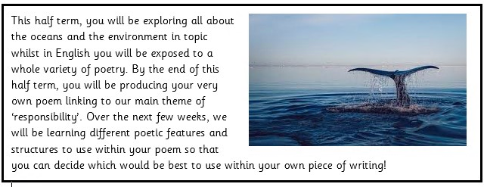

Below are some poems. Some of them you can watch and the others you can read. Watch/read each of them and reflect on what you like about them.

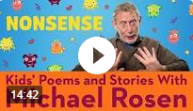
https://www.youtube.com/watch?v=kt28bVw0xYw

What did you like about this poem?

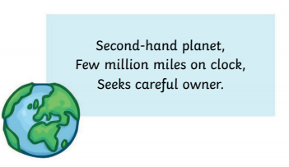

What do you think the theme is?

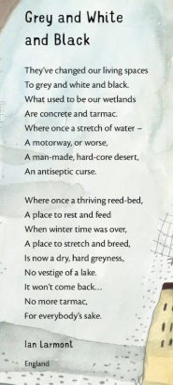

What is the theme of this poem?

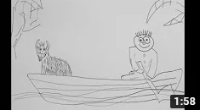
https://www.youtube.com/watch?v=VtLQO1Gk39g
What do you like about these poems?

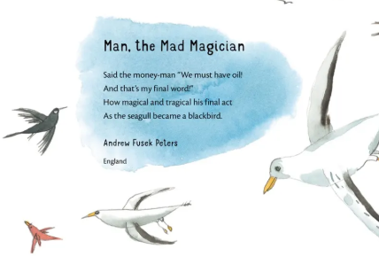

What do you like about this poem?

Monday – Spellings – ‘shun’ suffix
Suffixes: -cian, -sion, -tion, -ssion
-cian | -sion | -tion | -ssion
All these words have a ‘shun’ sound at the end. Can you choose the correct suffix and put these words in the correct columns? Feel free to use a dictionary if you are not sure!
Magi____ Mathemati____
Comprehen____ Inven___
Comple____ Exten____
Musi___ Permi____
Injec___ Admi____
Ac___ Expre____

CHALLENGE: Can you think of any of your own ‘shun’ words?

Monday – Topic – Layers of the Ocean
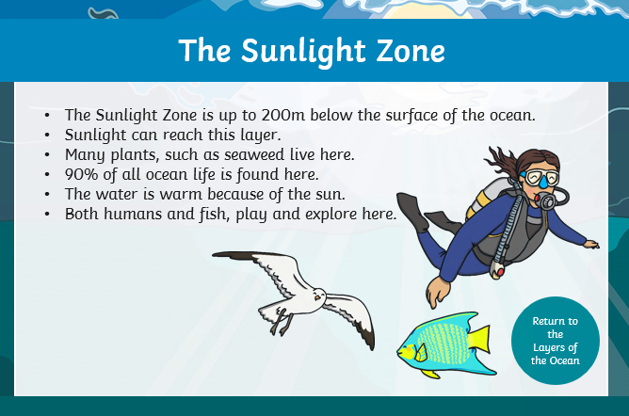
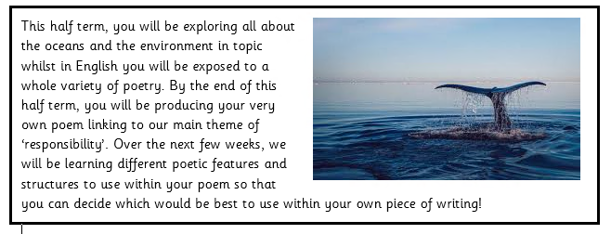
Read the research below about the different layers of the ocean:

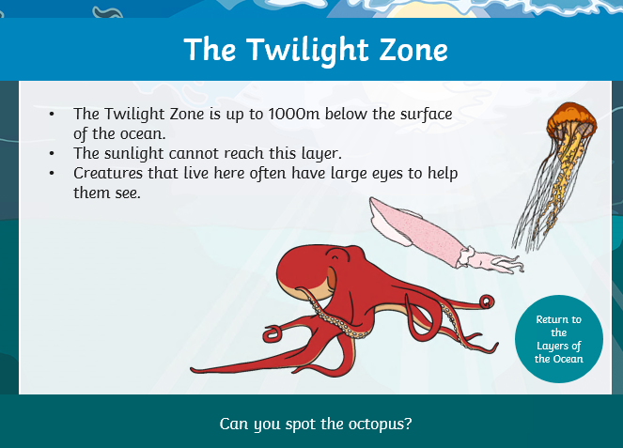

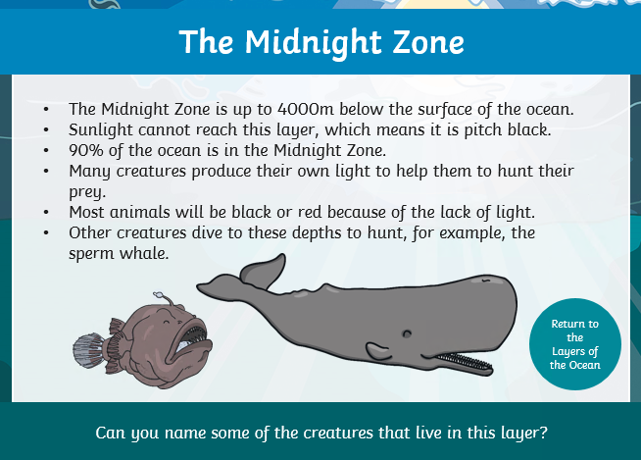

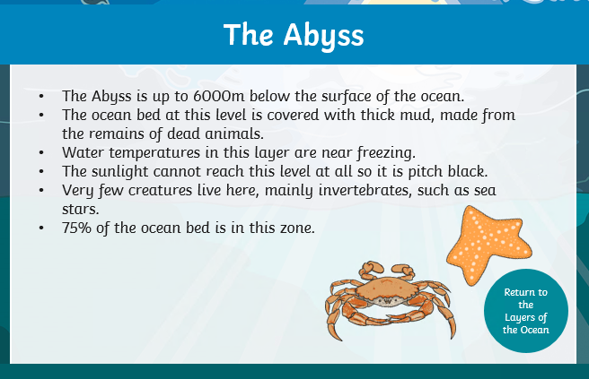

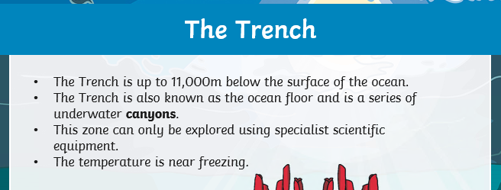

When you feel confident, have a go at the quiz below:
(Please note the hadal zone can also be called the trenches!)
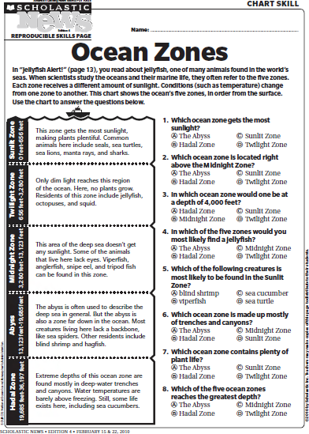

Tuesday – Reading - Poetry

Watch this clip which tells you about different types of poetry.

https://www.youtube.com/watch?v=ad2RDUIV8yg

Here are some posters that might help too:

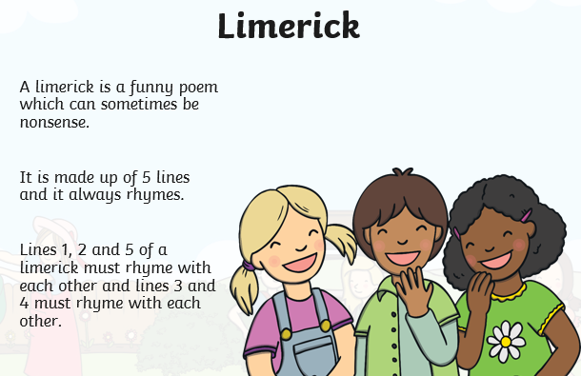

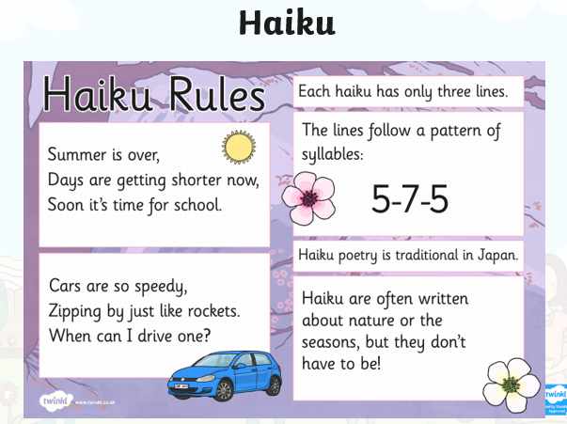

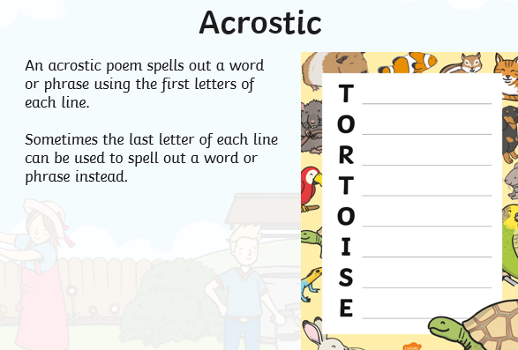
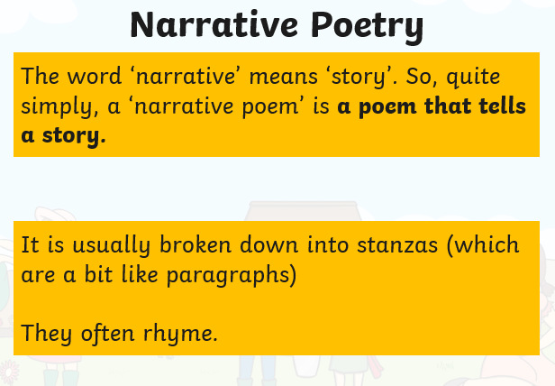

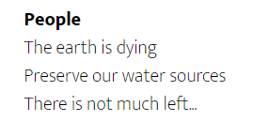
Below are lots of examples of a particular type of poem. Can you identify what type they are and justify why?
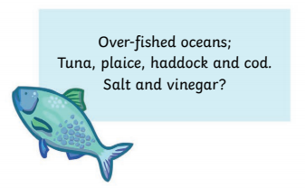

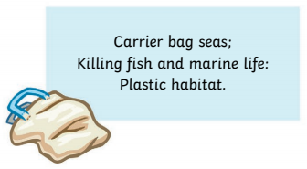
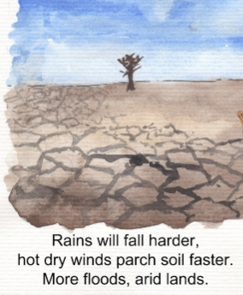

What types of poems do you think these are?
Why do you think this? What features do these poems all have?

Tuesday – Maths – Column Method

Wednesday – Writing – Finish the poem

In yesterday’s reading lesson, you hopefully would have identified all the poems as Haikus.

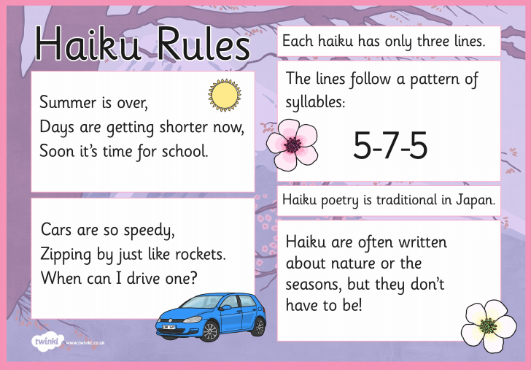

If you are unsure of what a syllable is….

Syllables are broken up sounds that are used to create words. They are used in poems to create rhythm.
Here are some examples of syllables:

zipping= zip + ing
seasons= sea sons
furniture = furn + it + ture

Look at the Haiku’s below. Can you complete them and remember that in a Haiku, the first line has 5 syllables, the second line has 7 and the third line has 5.
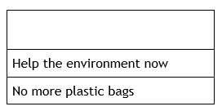
Oceans are warming
Sea levels are rising more
Always turn lights off
Put trash in a bin
Dive deeper challenge!

Can you write some of your own haiku’s independently?

Wednesday – Maths – Word Problems
Use the column method to answer these questions. This can be done on paper or in your home learning book, then upload a picture. Check your answers using a calculator.

- If John has 158 toy cars and Tom has 278 toy cars, how many toy cars do they have altogether?

- One farmer has 336 lambs and another has 287. How many lambs do the two farmers have together?

- A grocer sold 127 bags of sweets on Monday, 335 bags on Tuesday and 118 bags on Wednesday. How many did they sell in those three days?

- In the first 3 generations of pokemon, there are 386 different monsters. In the remaining generations there are 508 monsters. How many are there in total?

- An orchard contains 725 apple trees, 219 pear trees and 282 plum trees. How many trees are in the orchard?

- There are 2859 Portsmouth supporters at a game. The opposing side has 3577 supporters. How many people are at the game altogether?

- In February, a museum in London had 2116 visitors. In March, 4356 people visited the museum. In April, only 2284 visited. How many people visited during those three months?

- In the Alderman Lacey library, there are 4381 books. The Carnegie Library has 5128 books. North End Library has 3723 books. How many do they have in total?

Challenge: Could you write a 2 step problem using addition and subtraction?

Wednesday – Topic – Oceans Research
Choose two layers of the ocean to fill in the following:
Question: How do living things in the _____ compare to those living in the _______?
For example: How do living things in the twilight zone compare to those living in the Abyss?
Here are some websites to help you research:
All Zones (use the links down the side): http://www.extremescience.com/ocean-zones.htm
Sunlight Zone:
https://www.enchantedlearning.com/biomes/ocean/sunlit/
Sunlight, Twilight and Midnight Zone: http://www.mbgnet.net/salt/oceans/zone.htm
Midnight Zone: https://animals.mom.me/what-lives-in-the-midnight-zone-7798105.html
Abyss:
http://www.seasky.org/deep-sea/ocean-layers.html
https://blog.csiro.au/what-creatures-lurk-in-the-deep-abyss/
https://theconversation.com/curious-kids-how-do-creatures-living-in-the-deep-sea-stay-alive-given-the-pressure-111940
Below is a table showing one way in which you could record your research:
Layer 1: | Layer 2:
Now answer your question:
In the ____ zone, living things are….. However, in the ______ they…
In the ____ zone, living things have to….. However, in the ______ they…
In both zones, …. A similarity is… A difference is….

Thursday – Reading - Poetry
Watch this clip which tells you about different types of poetry.

https://www.youtube.com/watch?v=ad2RDUIV8yg

Here are some posters that might help too:

Below are lots of examples of a particular type of poem. Can you identify what type they are and justify why?

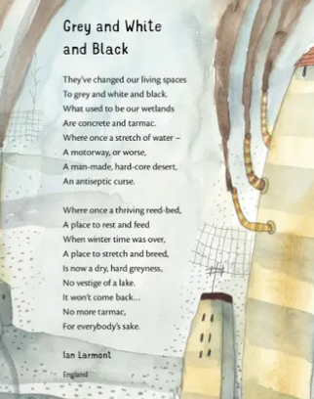

Winter Morning Poem
Winter is the king of showmen,
Turning tree stumps into snow men
And houses into birthday cakes
And spreading sugar over lakes.
Smooth and clean and frosty white,
The world looks good enough to bite.
That's the season to be young,
Catching snowflakes on your tongue!
Snow is snowy when it's snowing.
I'm sorry it's slushy when it's going.
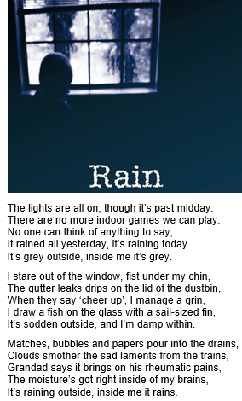

What types of poems do you think these are?

Why do you think this? What features do these poems all have?

Thursday – RE – Karma
Stop and think….

When was the last time you were mean to someone?

When was the last time you helped a friend or a family member?

What happened after?

Some people believe in ‘karma’ - have you heard this word before?
You may have heard it put a different way…

What do think these phrases mean?
What is your opinion? Do you agree/disagree? Why?
CHALLENGE: How might this apply to a religious person and their beliefs?
Thursday – Science – Sound
Below are some different animals and a little bit about them:
Read the information below and then think about what you notice! How does the size and shape vary? Why do you think that is? –Think about how it may help them survive!
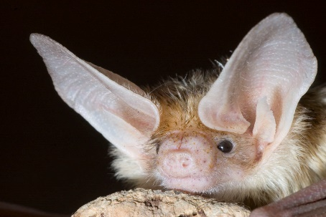
Animal: Bat
Habitat: bats live in a range of places but often live in trees or dark caves. They prefer warmer climates so they hibernate in the winter or migrate to warmer places.
Did you know… bats are nocternal so they hunt at night.

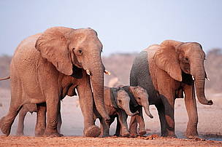
Animal: African Elephant
Habitat: rainforests and deserts in south and centrel Africa. 70% of them live in the south of Africa where it is very hot.
Did you know… African elephants weigh 6,000kg on average and can live up to 70 years old.
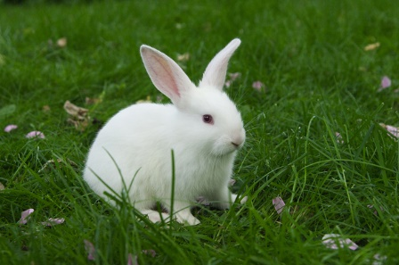
Animal: Rabbit
Habitat: The natural habitat of rabbits largely depends on their species, but it includes meadows, prairies, deserts, farmlands, thickets, forests, wetlands and moorlands.
Did you know… rabbits can move their ears independently and hear from two different directions at once.
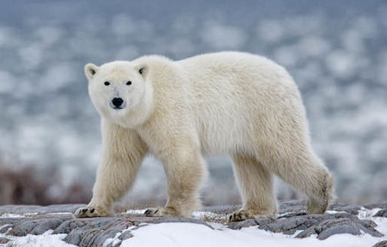
Animal: Polar Bear
Habitat: Polar bears are marine mammals, and spend much of their time on Arctic sea ice. Many adaptations make polar bears uniquely suited to life in icy habitats.
Did you know… polar bars are actually black not white. Their skin is translucent and only appears white because it reflects light.
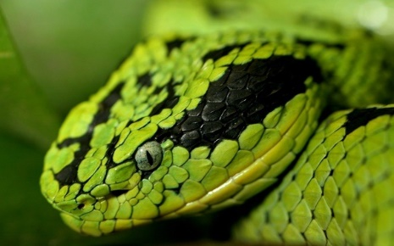
Animal: Snake
Habitat: Most snakes are found in tropical regions. Snakes are found in many habitats including in the water, forests, deserts and prairies.
Did you know… Snakes feel vibrations through their jaw bone.
Now it’s time for your observations!
I noticed some of the animals’ ears were….and others had….
I think the ______ had larger ears so that…. I think the _____ had pointy ears so that….
I think the ______ had ears which you couldn’t even see because….

Friday – Writing – Finish the poem
In yesterday’s reading lesson, you hopefully would have identified all the poems as narrative poetry.

Watch this link to learn more about narrative poetry:
https://www.bbc.co.uk/bitesize/topics/z4mmn39/articles/z3btrwx

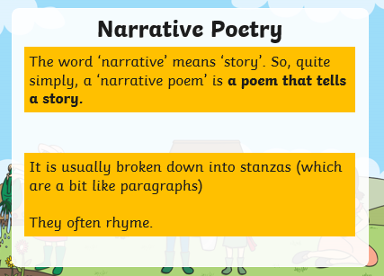

Watch this video of The Owl and PussyCat which is another example of a narrative poem.
https://www.youtube.com/watch?v=HpwAP36-w7E

Let’s write a narrative poem about rain together. I have written 4 lines and I would like you to write the four missing lines. Can you make the lines rhyme? I’ve added some rhyming words at the bottom of the page for support.

Here is an example:

How beautiful is the rain,
It flows like a train,
Down the narrow street,
I cannot feel any heat,
It gushes along the lane,
And against the window pane,
I just want to go out and play,
But that will not happen today.

How beautiful is the rain, | Can you think of a word that rhymes with rain for this line?
Down the narrow street, | Can you think of a word that rhymes with street for this line?
It gushes along the lane, | Can you think of a word that rhymes with lane for this line?
I just want to go out and play, | Can you think of a word that rhymes with play for this line?

Rhyming support:
rain | street | lane | play
Lane  Pain  Pane  Gain  Stain  Plain  Grain  train | Sheet  Heat  Complete  Neat  Cheat  Eat  sleet | rain  Pain  Pane  Gain  Stain  Plain  Grain  train | Day  Today  Grey  Hay  Spray  lay

Dive Deeper Challenge:
Can you write your own narrative poem?

Friday – Maths – Arithmetic
1. ________ = 2316 + 1643
2. 8963 – 4781 = _________
3. 240 x 10 = _______
4. What is 100 more than 2866?
5. 24 divided by 4 = ____
6. 7 x 50 = ______
7.

8. 7 – 10 = ____
9. 4 x 352 = ______

Friday – Computing

