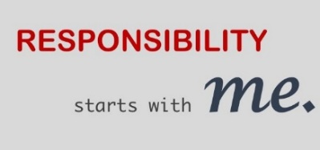
Year 4 - Home Learning Tasks
WB: 04.05.20
Our theme for this half term will be the concepts of ‘responsibility’ and ‘resilience’.
With it having been 75 years since VE Day this week, we will be learning about the importance of this day and some of the key events that came before it.
 | Activity 1 | Activity 2 | Activity 3 | Away from screen time challenge!
Monday | Reading –  Read and enjoy WW2 themed poetry.  You can even listen to some written and performed aloud by children here: http://www.keystage2literacy.co.uk/ww-poem-videos.html | Crack the Codes – Learn about the phonetic alphabet as well as Morse code | History – Understanding VE Day  On 8th May 1945, Britain celebrated the end of WW2. Use the links, such as: https://www.bbc.co.uk/teach/class-clips-video/history-ks2-ve-day/z7xtmfr to create a timeline of important events leading up to this. | Make a list of 7 kind things you can do for someone else. This could be for people you live with or don’t get to see every day. Each day, do one of the seven kind things from your list!
Tuesday | Reading – Answer some questions about one of our WW2 themed poems from Monday. | Picture News – How can one person make such a difference? | Music – VE Day songs  Can you create your own motivational song using the examples as inspiration? | Make a playlist of your favourite feel-good music. Keep adding to the playlist every day as you think of more music that makes you happy.
Wednesday | Writing – WW2 poetry  Write your own acrostic poem. | Geography - Colour in the countries on the map according to whether they were Allies, Axis, Axis controlled or Neutral.  NatGeo Kids - WW2 History | History – Who is Winston Churchill?  What was he responsible for?  Find out more about him before creating a fact file/poster displaying your information. | Make a poster to thank your postman/postwoman and any delivery drivers that bring food and other items to your house. Then display it outside your door where they’ll see it.
Thursday | Maths – Battleships co-ordinates | ‘Stay At Home’ Street Party  Read this article on Newsround and look closely at the photographs. How did people celebrate in 1945? Plan your own ‘stay at home’ street party. | Science – Spitfire Science  Design and make your own Spitfire. You could make it out of paper, wood, recycled materials, etc. How far does it glide?  Does the material used for your plane affect the distance it travels? | During WW2, there was a shortage of materials to make clothes. People were trying to ‘make do and mend’. Do you have any clothes that you could ‘upcycle’ into new clothing or something completely different? Create a design to show what you could turn it into.
Friday | Catch up and Chill – Today is the day to take part in any of the activities above if you hadn’t had a chance yet. Instead, you may have some ideas of your own! No matter what you choose to do today, make sure you relax and take some time for you!
These are the details and links to some of the activities posted on Google Classroom this week. Where possible, below you will find the task sheets which will explain the activities in more detail. If you experience any problems, please contact your child’s class teacher via email.

Monday – Reading – WW2 Poetry
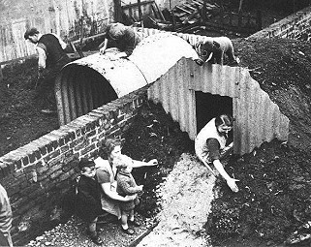
Air raid shelters, damp and black
Bombs exploding, back to back
Children crying, adults too
“Down the cellar – after you”
Evacuees on the train
Farewells said in pouring rain
Gone to live in some strange place
Hoping for a friendly face.

In the city, parents wait
Just to hear of their child’s fate
Knowing that they have arrived
Think – What pictures do you get in your head as you read this? How does this make you feel?
Leaves them thankful they’ve survived
Memories now not theirs to make
No hugs or kisses; birthday cake.
Only painful loss is theirs
Parting sorrow, daily prayers.
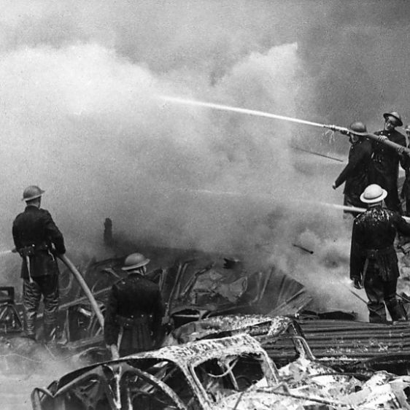
Quick to jar them from their pity:
Raids repeating on the city.
Sirens screeching, chaos calls,
Thunderous noise as buildings fall.
Underground : imaginations,
Violent earth reverberations.
Why oh Why? Despair abounds.
eXit all, as fear resounds…..

Yesterday for now is gone
Zeal for life and peace lives on.

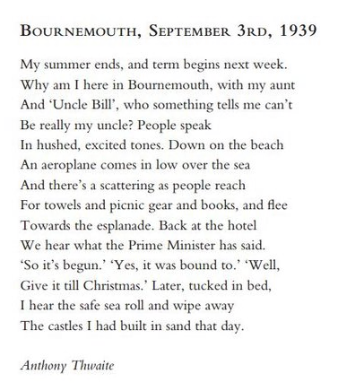

THINK – when in the war was this set? Find more than one piece of evidence that justifies your thinking.

The Click of the Garden Gate

I hear the click of the garden gate
But it is not he
He comes no more either early or late
To his dinner or tea
He is far away in an Air Force Camp
Learning to fight
(I wonder if his blankets are damp
And if he sleeps well at night)

Not twenty years when went away
Just a boy
He may never again come back to stay
To delight and annoy
Will what he has gained balance what he has lost?
He will change
Will his growth to manhood improve him most?
Or make him change?

I open the casement into his room
So tidy and neat
And the sun shines in and chases the gloom
And the wind blows sweet
Ready for him when, early or late
He comes back home to the sea
I hear the click of the garden gate
But it is not he.
(Perhaps it is Rene coming to tea!)

May Hill, December 1940
THINK – If she knows where he is, why do you think she keeps listening out for the gate?

Monday – Code Breaker
In World War 2, messages were sent in lots of different ways. This included Morse code, an alphabet made from combinations of dots and dashes and the phonetic alphabet. Watch the video about Morse code then use the alphabet below to help you crack the codes.
How Does Morse Code Work?

-/…./. .--/.-/.-. ../… ---/…-/./.-. ../-. ./..-/.-./---/.--./.
___________________________________________
---../-/…. --/.-/-.-- .----/----./….-/…..
__________________________
Can you write your own message in Morse code for someone to translate?

Can you research the phonetic alphabet and write a code using that too?

Monday – History – Understanding VE Day
On 8th May 1945, Britain celebrated the end of WW2. Watch the video link below and use it to create a timeline of important events leading up to this.
https://www.bbc.co.uk/teach/class-clips-video/history-ks2-ve-day/z7xtmfr
Choose 4 of the main points of the video and use them to form a timeline. Do not forget to add dates if you can!
Below is a WAGOLL that you can look at before you start.

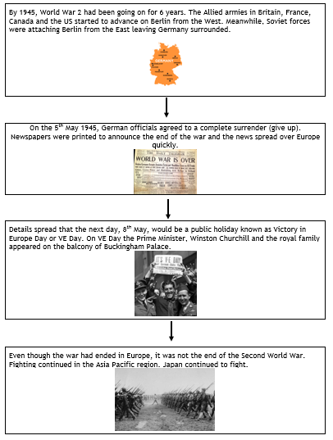

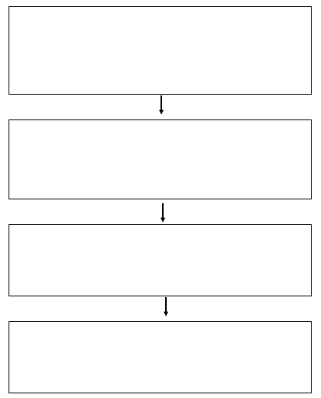

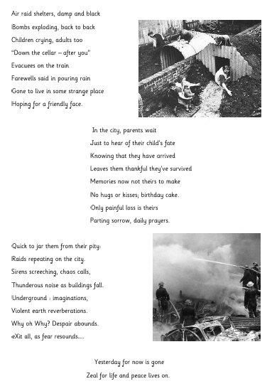
Tuesday – Reading – WW2 Poetry

Re-read back through the first of our poems from Monday.
Now answer some of the questions below:
- What do you notice about the start of each line of the poem? There is something particularly special about this poem – can you spot it?

- What poetic devices are used in the poem? Can you find any examples?
(Think about alliteration, similes and rhyme)

- In the third stanza, there is the word ‘reverberations’:
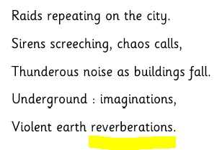
What do you think this word means and why?

- In each of the stanzas (sections) there are 8 lines except the last stanza which only has 2. Why do you think this is?

Tuesday – Picture News
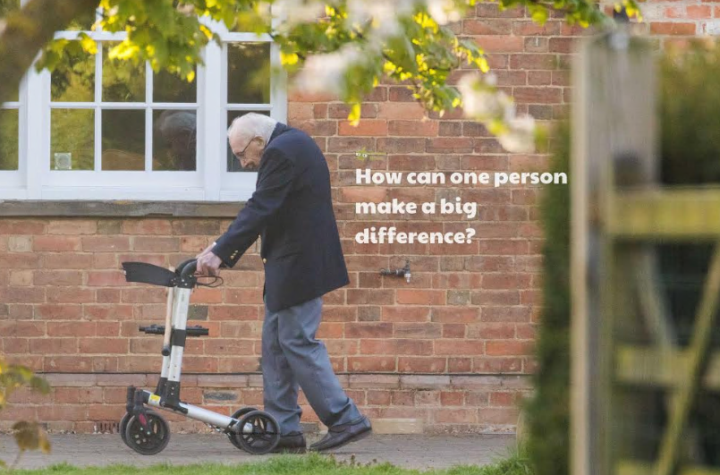
Who is this man?
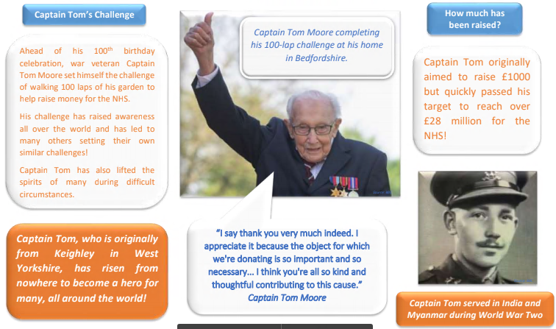
It is not the biggest actions that can have the biggest impact. All the things that we do affect the world around us!
THINK – Who in your local community has made a difference? What would you say to them?
How can you make a difference too?
Tuesday – Music – VE Day songs

Try and learn the Horrible Histories VE Day song on your own or with your siblings and perform it to your family.

https://www.bbc.co.uk/cbbc/watch/horrible-histories-songs-ve-day-song?collection=horrible-histories-songs

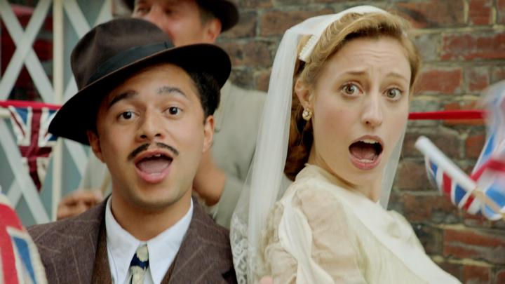

Now have a go at creating your own motivational song. Use the links below to listen/read the lyrics of some traditional war time songs for inspiration.

Wartime song lyrics- http://www.primaryhomeworkhelp.co.uk/war/songs.htm

Run, rabbit, run!- https://www.youtube.com/watch?v=0uWL1O9r_mI

Long way to Tipperary/ Pack up your troubles- https://www.youtube.com/watch?v=mPLS5nNFWTU

We’ll meet again- https://www.youtube.com/watch?list=RDWAaxkAgVkHQ&v=8Nzy1cfnKh4

The White Cliffs of Dover- https://www.youtube.com/watch?v=d5aeClRY4kA

My song lyrics

Dance time!

When you have written your war time song, watch this clip to see what a dance party would look like during the war in Britain:
https://www.bbc.co.uk/bitesize/clips/zwn4wmn

American soldiers stationed in Britain during World War Two brought their dances with them. Lindy was a fusion of many dances combining partner and solo dancing. It is mainly based on jazz, tap, breakaway and the Charleston.

Learn step-by-step how to dance how people would in a 1940s dance party.
https://safeyoutube.net/w/cXI7

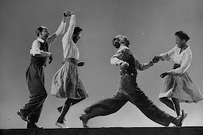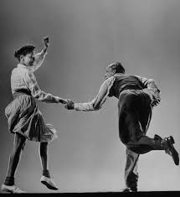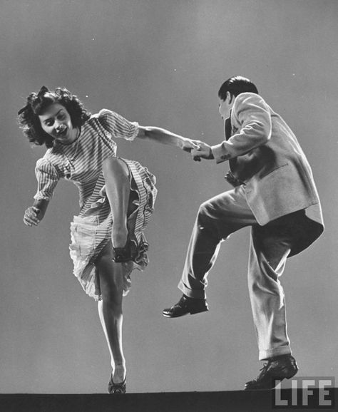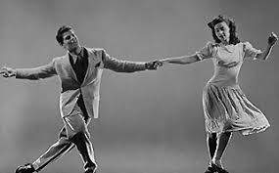

Wednesday – Writing
Today we will be writing an acrostic poem inspired by what life was like in the Blitz.

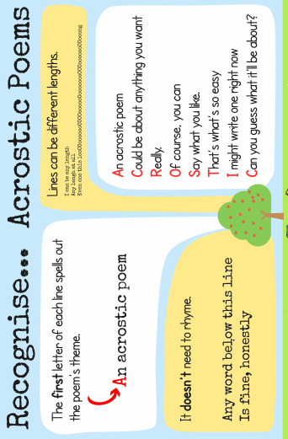

Watch these clips and look at these photos to learn what the Blitz was and what life was like.

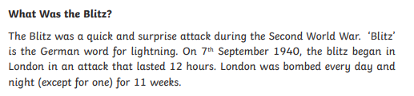

https://www.youtube.com/watch?v=N6yisNi5ZWY

https://www.bbc.co.uk/teach/class-clips-video/history-ks2-living-through-the-air-raids/zjnyrj6

http://www.primaryhomeworkhelp.co.uk/war/blitz.htm

Now have a go at drafting your own acrostic poem.

Here is a WAGOLL:

Bombs are falling
Lighting up the sky
I feel frightened
Terrible sounds filling the air
Zero hours of sleep

Your turn!

B
L
I
T
Z

Dive Deeper Challenge:
Can you create some more examples of acrostic poems? You may choose to have a different word down the side.

If you do this in your home learning book, ask your parents if they can take a photo and email it to your teacher- we love seeing what you have been doing at home!

Wednesday – Geography

World War 2 was a battle between two groups of countries: the “Allies” and the “Axis“.
At the start of World War II, the Allies were the United Kingdom, France and Poland. These nations had made a pact to stand together against Hitler and the Axis Powers. The Allies were soon joined by the British Commonwealth (South Africa, Canada, Australia and New Zealand) and then the Soviet Union, the United States of America and China. Other Allies included British India, the Netherlands and Yugoslavia.

The Axis Powers were Germany, Japan and Italy, who made a pact to stand together in opposition to the Allies.
During the course of the war, German forces advanced through Europe. By the summer of 1941 they had invaded France, Belgium, Holland, Luxembourg, Denmark, Norway, Greece, Yugoslavia (which in modern day is Serbia Mentrnegro, Croatia, Slovenia and Bosnia- Herzegovina) and the USSR (which in modern day includes Russia, Ukraine and Estonia).
Some countries remained ‘neutral’ in World War 2 such countries were Spain, Sweden and Switzerland – who chose not to join either side.

Task
On the next page, there is a map which shows Europe at the end of World War 2 and whether each country was neutral, an axis/axis controlled country or part of the allies.

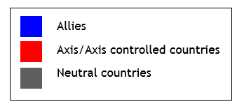

Your task is to use an atlas, map, globe or the internet to label the map.

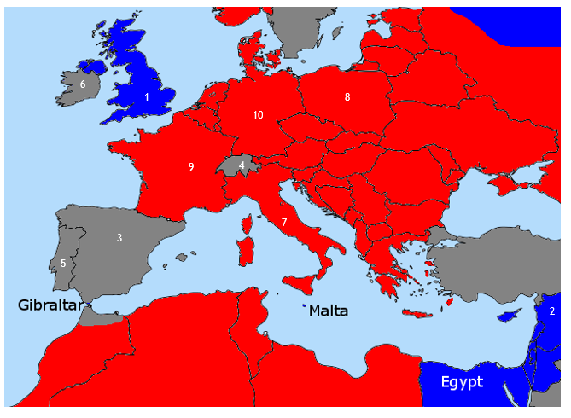

1
2
3
4
5
6
7
8
9
10

Dive Deeper Challenge- Why do you think there are not many Allies shown on the map?

Wednesday – History – Who is Winston Churchill?
Read the following information about Winston Churchill, one of the prime ministers during World War 2. Continue your research online then display your learning as a fact file, poster or mind map.

Other websites to continue your learning
https://www.bbc.co.uk/bitesize/topics/zkrkscw/articles/zfq9pg8
https://www.ducksters.com/biography/winston_churchill.php
https://www.historyforkids.net/winston-churchill.html
https://kids.kiddle.co/Winston_Churchill

Thursday – Maths
Coordinate Battleships
Watch the following clip https://www.bbc.co.uk/bitesize/topics/zgthvcw/articles/z96k9qt
A point on a grid has two numbers to identify its position. These numbers are known as coordinates.
Coordinates are always written as the number of steps across first, then the number of steps up or down. For example 2 along and 4 up would be written (2,4).
Grids have two axes. The horizontal axis is called the x-axis and the vertical axis is called the y-axis. These axes can be used to find a point on a grid.
Instructions

Each player plots 5 small and 5 large battleships on the grid (See below for examples).
Take it in turns to ask co-ordinate points to try and find where your opponent has hidden their battleships. The other player must say if it is a "hit" or a "miss". This can be recorded on the enemy’s map. The winner is the first person to destroy the other one's fleet!

X X X Small Battleship
X X X X Large Battleship
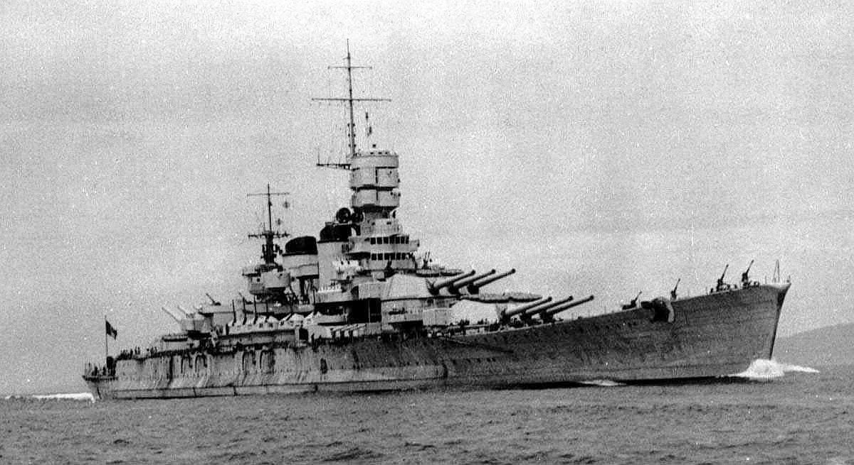
Enemy’s Map
As you find out where their ships are placed, plot them on here. You could use a certain shape or colour to remind yourself of where an enemy ship is placed, and where there are no ships.

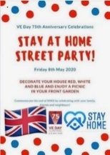
Thursday – Stay at home Street Party
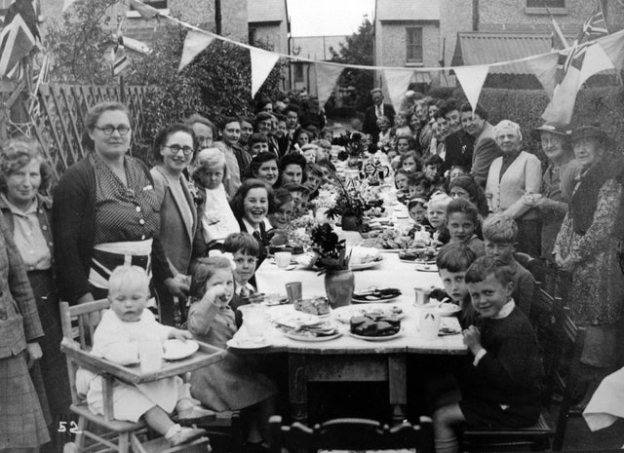
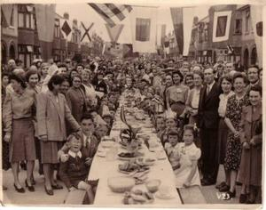
Late on the 7th May 1945, an announcement was made over the wireless that the war in Europe had ended. A national holiday was declared in Britain for 8 May 1945, Victory in Europe day or VE day. The Board of Trade announced that people could purchase red, white and blue bunting without using ration coupons and there were even commemorative items hastily produced in time for the celebrations, including ‘VE Day’ mugs. Some restaurants had special ‘victory’ menus.
These photos show some of the street parties that were held across Portsmouth to celebrate VE day. Even though rationing was still taking place people made cakes and other delicious items to celebrate.
Look closely at the decorations and things that they have on the tables. What do you notice?
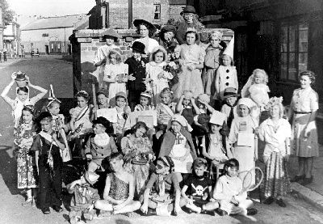
Can you plan and create your own (at home) street party?
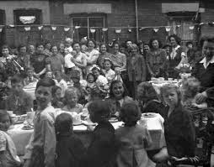
You will need to think about food, decorations and entertainment. This could include music or games to play.
Take pictures of what you have created and send them to your teacher!
Menu- Look at some of these recipes from WW2. They have had to substitute sugar and other rationed items. What would you choose for your street party and why?
http://home.bt.com/lifestyle/eating-for-victory-try-these-real-wartime-ration-recipes-for-ve-day-11363980000968
https://www.twinkl.co.uk/resource/t2-h-4750-wartime-recipe-booklet

I have chosen… because…

Games- Children in this era definitely didn’t have video games! Egg and spoon races, wheelbarrow races, tin can alleys and tug of war were all popular games that people played during street parties. Can you recreate one and take a photo?

Decorations- Decorations were so important during this time that they even allowed people to purchase bunting without using ration coupons. Fresh flowers were also popular because they were available from people’s gardens. Can you design your own bunting?

Thursday – Science – Spitfire Challenge
Design your own Spitfire out of paper, wood, newspaper or even tinfoil – it is up to you!
Below are some templates and instructions to give you some ideas.
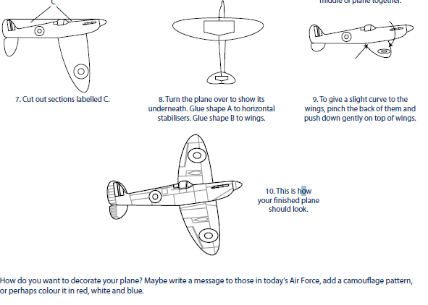
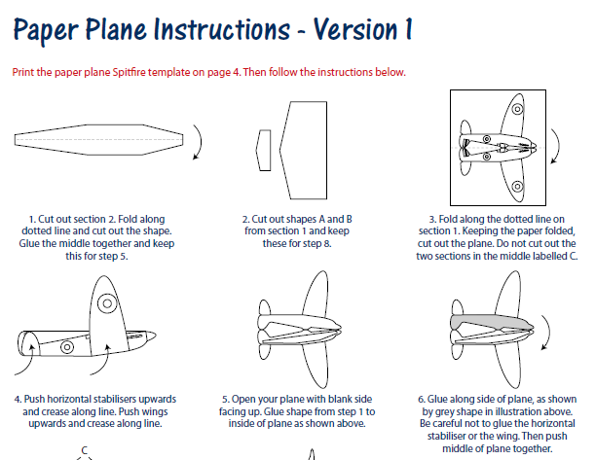

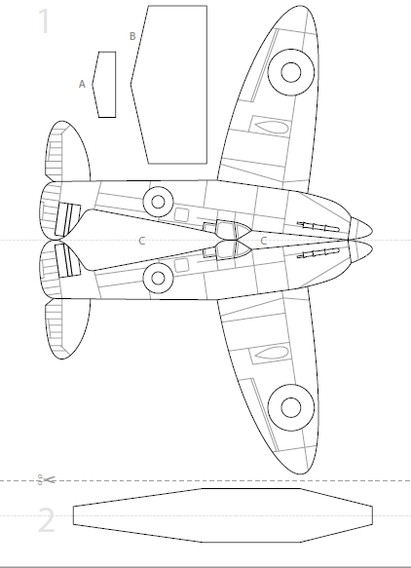

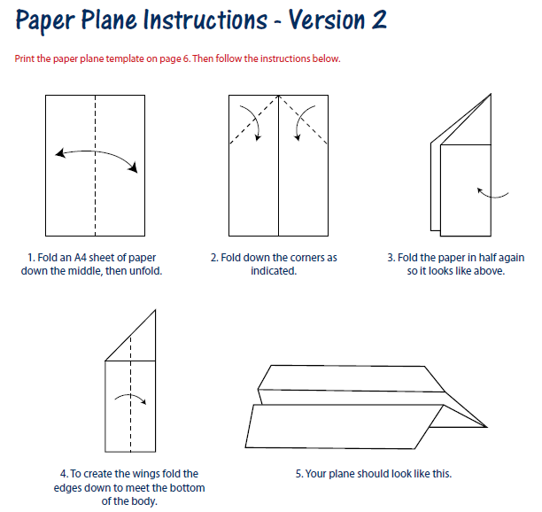
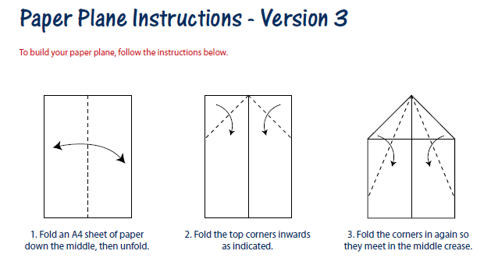
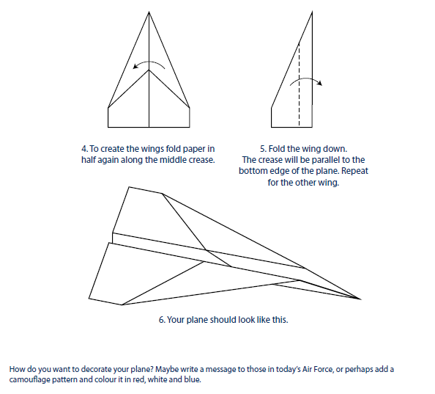

Science - Fair Test
This is one way you could plan your investigation to the following question…
Aim
Does the material used for your plane affect the distance it travels?
Prediction – What do you think will happen and why?

Variables
What will you change, measure and keep the same during your investigation?
Variable(s) to change – Independent Variable | Variable(s) to measure –  Dependent Variable | Variable(s) to keep the same –  Control Variable
What the aeroplane is made out of

Method
In the space below, list the apparatus you will use.
- -
- -
- -
- -

Draw a diagram of how you will set up your apparatus if it helps.

Recording & Presenting Data
- Results table. Use the grid below to construct a results table. You do not have to use all the cells.

 | Material 1 | Material 1 | Material 3 | Material 4 | Material 5

Analysing data and Making Conclusions
What do your results show? Which material(s) were best and why? Which were not so successful?

Friday – Catch up and Chill
Today is the day to take part in any of the activities above if you hadn’t had a chance yet. Instead, you may have some ideas of your own! No matter what you choose to do today, make sure you relax and take some time for you!
