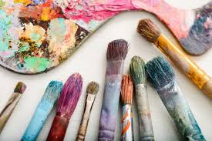
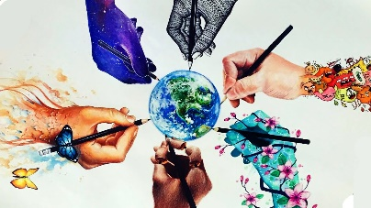
Year 5 - Home Learning Tasks
WB: 18.05.20
Our theme for this half term is Ancient Greece but...
This week it is ‘Arts Week’ where we will be learning about four different styles of art.
We are aware that your art supplies at home may be very limited so we have included a range of activities which you can experiment with. However, be sure to get creative. Think about what you have in the house. You could use coffee, ketchup, water or even mud if you don’t have paint. Experiment with different items as paint brushes such as your fingers, sponges, grass, leaves etc. We are excited to see what you come up with!
 | Activity 1 | Activity 2 – VE Activities | Activity 3 – VE Activities
Monday | International Project  Dream Catchers  Create your own dream catcher and share an image for us to send to our international pen pals. | Pop Art!  Find out more about pop art, Andy Warhol and how to create your own pop art words. | Day Explorer  ‘The Bad Painter who is an Artistic Genius!’  Read the article and share your thoughts on the big question. You could even create your own masterpiece inspired by the ‘Bad Painter’.
Tuesday | Reading – Street Child  Complete these questions based around Chapter 3. | Impressionism  Learn a little bit about impressionism and some famous impressionist artist before trying out some of the different brush stroke styles they used in their art. | Claude Monet  Research about the famous impressionist artist Claude Monet and then create your own quiz about him to test the family.
Wednesday | Maths  10 minute arithmetic test  Complete the 10 arithmetic questions in ten minutes. | Fauvism  Discover more about fauvism and how it is has influenced artists. Then, create your own portrait inspired by fauvism. | Colour Poems  Use what you have learnt about colour to create colour poems.
Thursday | Spelling  If you cannot access Google forms, the list of spelling words is below. Ask a member of your family to test you. | Pointillism  Find out about Pointillism and use it to create your own bookmark. | History – Timeline of Art  After learning about our four types of art, create a timeline showing where these art movement occurred in history.
Friday | Catch up and Chill – Today is the day to take part in any of the activities above if you hadn’t had a chance yet. Instead, you may have some ideas of your own! No matter what you choose to do today, make sure you relax and take some time for you!
These are the details and links to some of the activities posted on Google Classroom this week. Where possible, below you will find the task sheets which will explain the activities in more detail. If you experience any problems, please contact your child’s class teacher via email.
Monday – International Project – Dream Catcher
I have shared your hearts with the teachers to pass on to their children - they will love them. I've attached a few pictures of some of their creations for you.
This week, the children around the world taking part in our international project are each creating dream catchers to hang in their bedrooms. Some of you may be worrying more at this time and you may have trouble sleeping. Legend has it that dream catchers can help you sleep better by keeping bad dreams away.
So, this week, your task is to create your very own dream catcher! You can make these out of various materials - just use what you have. I like the natural ones made from twigs! I've attached some information about what dream catchers are and where they originated and here are some examples.
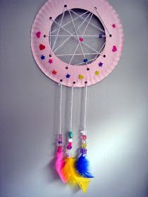
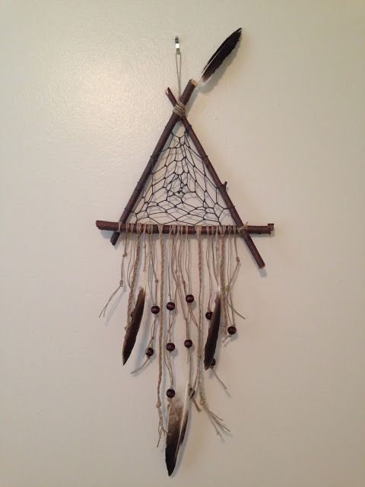
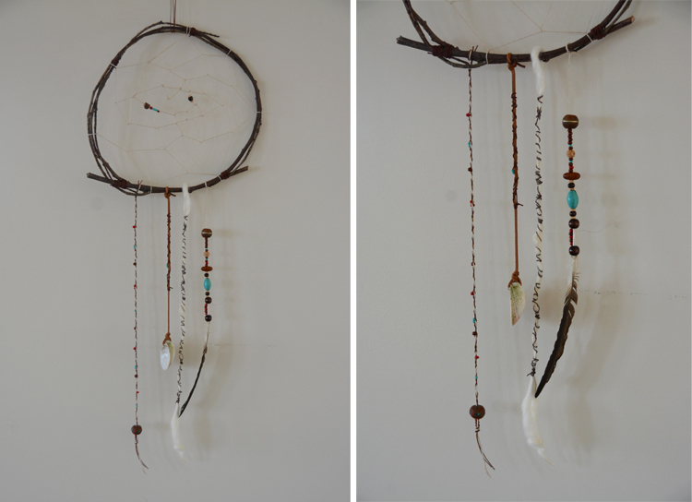

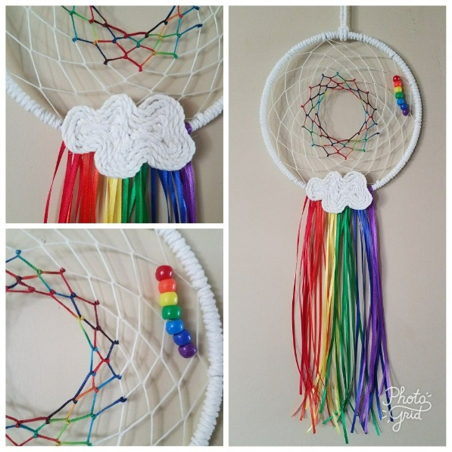
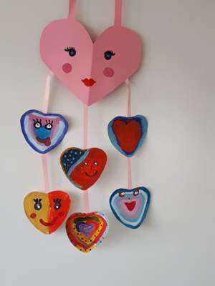

Ojibwa Indians in Olden Times
Dream catchers were designed to "catch" evil spirits, tangle them up, before they could enter your dreams. They were made with an open weave so the good dreams could get through. Dream catchers were woven by the grandfathers and grandmothers. They were hung above a sleeping baby.
Good Dreams: The Ojibwa believed that good dreams are light as air. Good dreams can wander gently through the night, and make their way down to a sleeping child, through the feathers and twigs of a dream catcher.
Bad Dreams: But there is nothing gentle about a bad dream. Bad dreams are violent and rambunctious. They plunge about in the night air, and dart down towards a sleeping baby. The dream catchers catches them in its web. The bad dreams are tangled in the catcher. There they stay, trapped, until morning, when the sun rises and sends them away.
As other tribes heard about Ojibwa dream catchers, they adopted the idea. Today, many Native American artists make beautiful dream catchers to sell, to share, and to keep.

Monday – Pop Art!
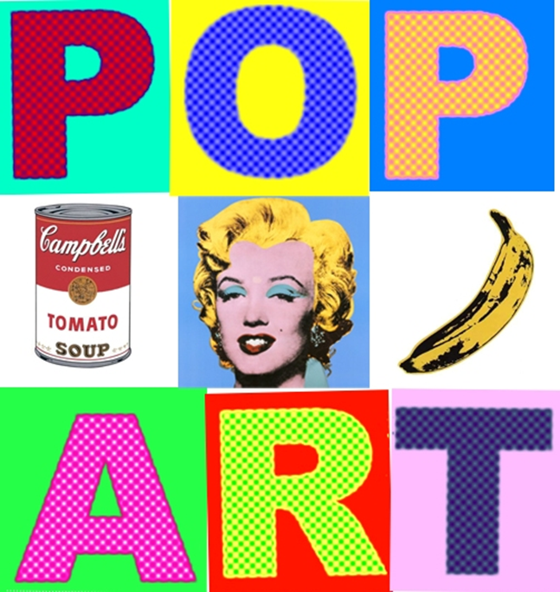
What is Pop Art?
Pop art is a fun form of art. It started after the Second World War and was very different to the very serious fine art of the past.

Pop art often uses images which are popular in the modern world such as…
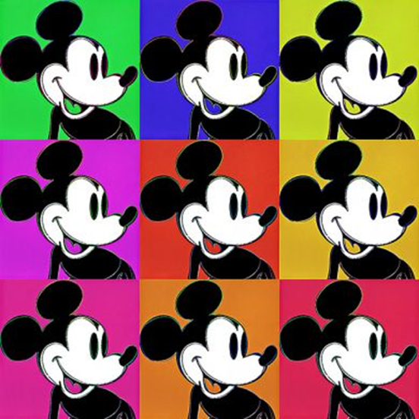
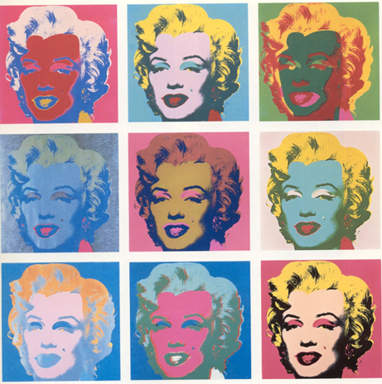
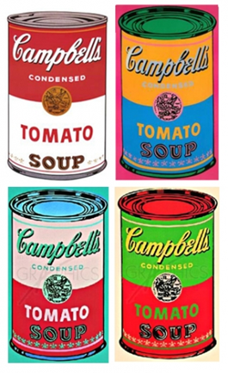
Famous celebrities & Disney Characters:
Everyday objects which could be found around the home were also made the focus of works of art such as:
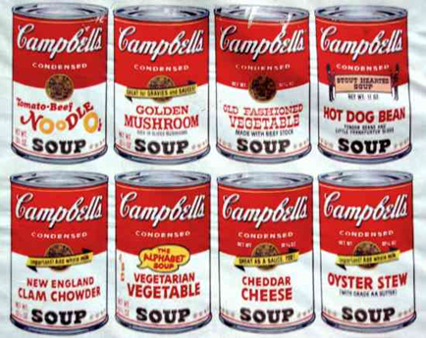
Soup cans

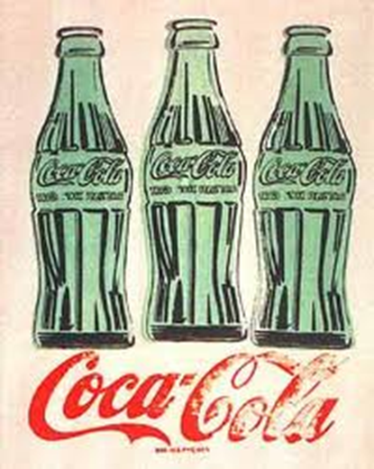
Soft drinks
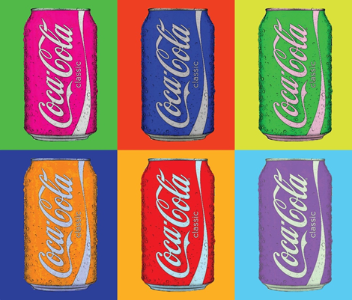

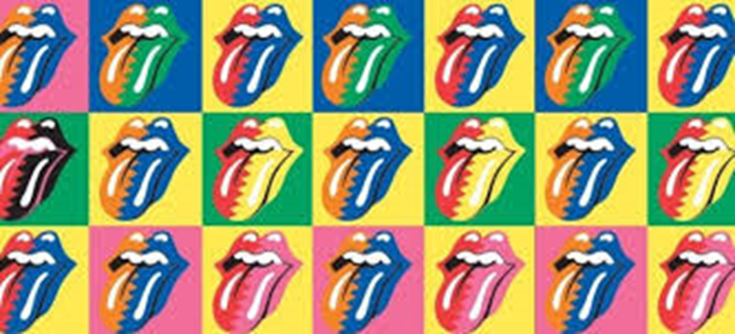
As you can see, in many forms of pop art, the items are drawn repeatedly with different colours and textures each time:
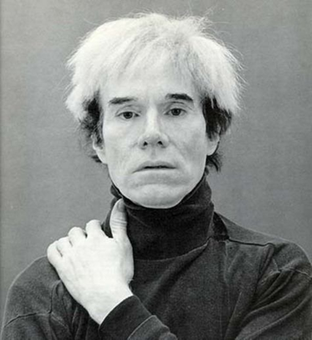
Andy Warhol
One of the most famous artists is called Andy Warhol. He used a techniques called screen pritning to create lots of prints that look the same. He often changed the colour of the pictures as well. Some of his prints can be seen above.
Activity 1
Find out more about Andy Warhol and produce a fact file, biography or even an autobiography about him and his works.
You may find the following website and videos useful:
https://primaryfacts.com/818/10-andy-warhol-facts/
https://www.tate.org.uk/kids/explore/who-is/who-andy-warhol
https://www.bbc.co.uk/teach/class-clips-video/art-and-design-ks2-andy-warhols-marilyn-diptych/z42r2sg
Pop Art Words
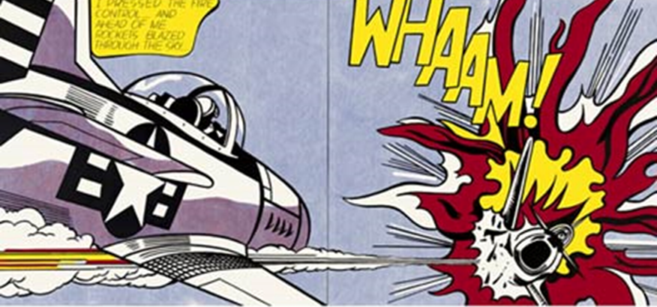
Pop art words were also used in elements of popular culture such as magazines, newspapers or comic strips.
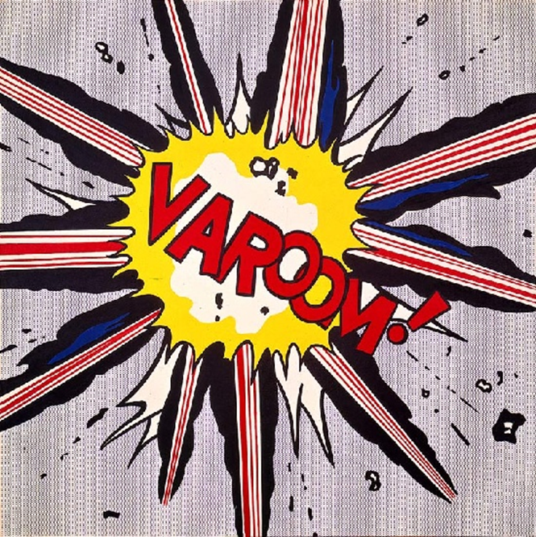
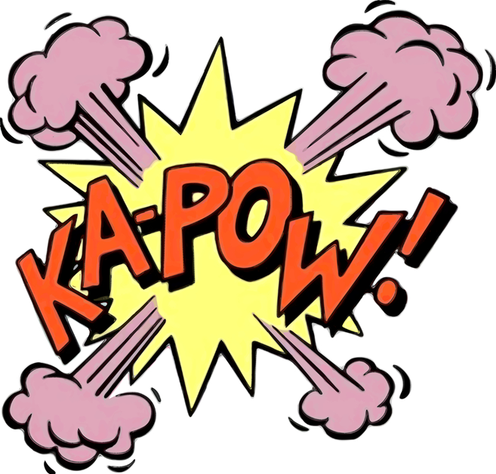
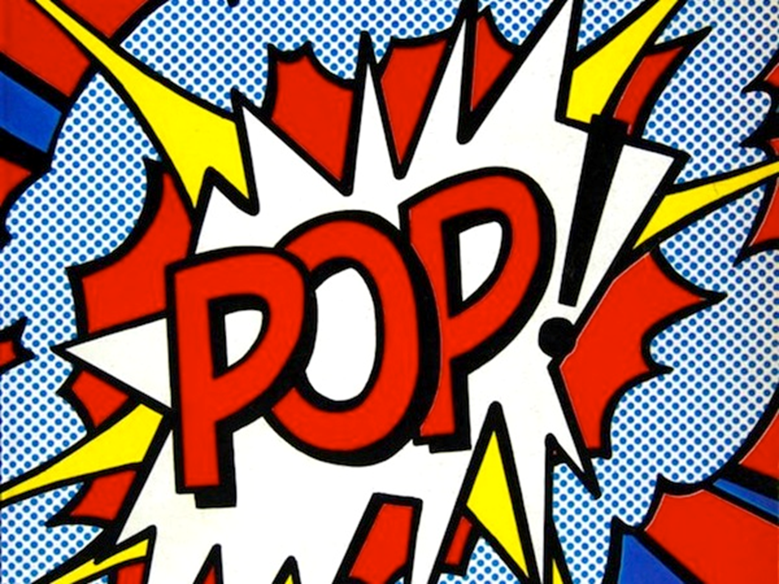
A famous pop artist who worked in this comic strip style is called Roy Lichtenstein. Words were also given the comic strip effect by Lichenstein.

Activity 2
Create your own comic strip style pop art words.

First, choose your own word which you want to use!
You could choose from the following:
Crunch Bang Boom Kapow Zwoosh Ouch Crack

There are a couple of ways to create your pop art word. You could just draw it straight onto paper or check out the ideas on the next page.
These instructions were adapted from: http://artisandesarts.blogspot.com/2011/11/onomatopoeia-art.html?m=1

- Begin by writing out your word using words using a style of bubble writing. Then, colour it in. Try to only use one colour as this will make the word stand out!
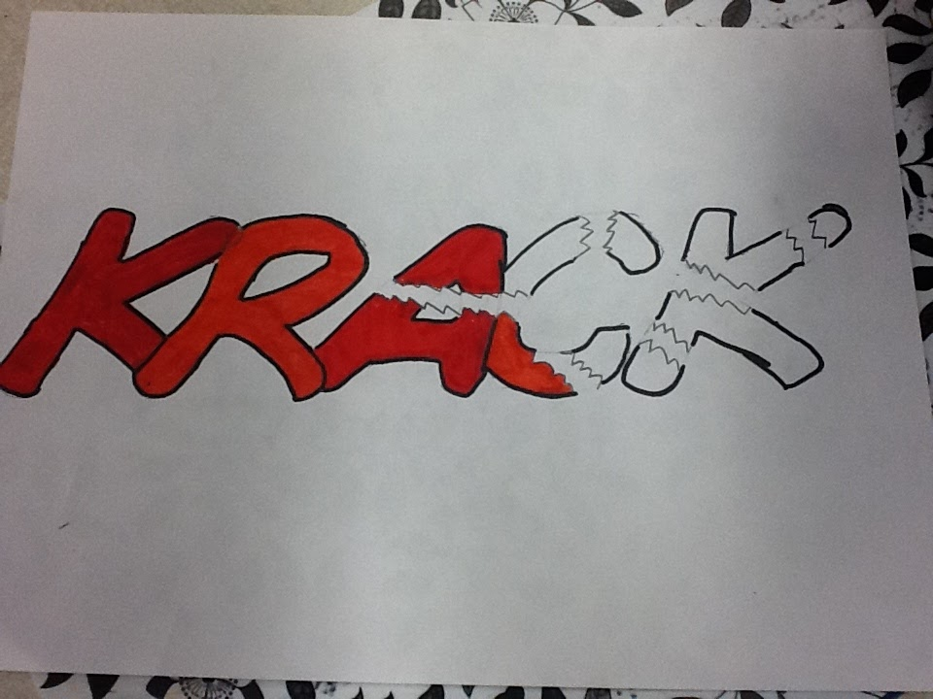
- Cut our your word.
- You could create the background for your work in a couple of different ways. You could just use plain or coloured paper or you create a collage of old book pages which you have stuck together. Trace a shape, such as an explosion, onto the back of the paper and then cut it out.
- Stick this shape onto another piece of coloured paper (or colour in some paper) and then cut the shape out again but leave a border.
- Then stick that shape onto another piece of coloured paper (or colour in some paper).
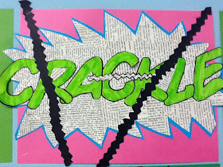
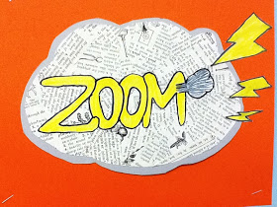
- Stick your word over the top. You can add extra bits for effect. Check out these finished ones below:

You could also try creating our own pop art words on the computer or tablet. Soe good programmes you could try to use are Microsoft Publisher and Paint. On your tablet, depending on which one you have, you could use Doddle Buddy, Bamboo Paper, Draw Free for IPad, Kids Doodle or 123 Draw. Be creative!

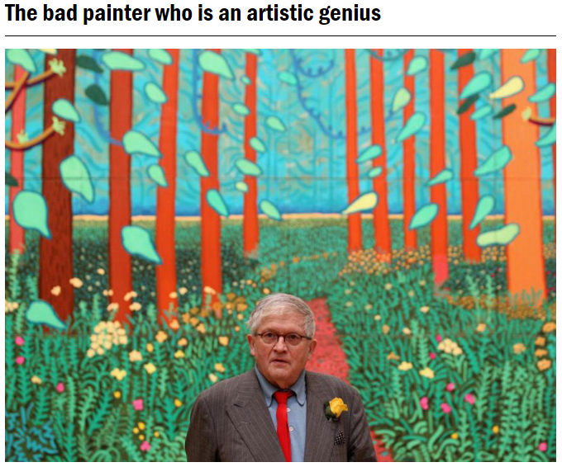
Monday – Day Explorer

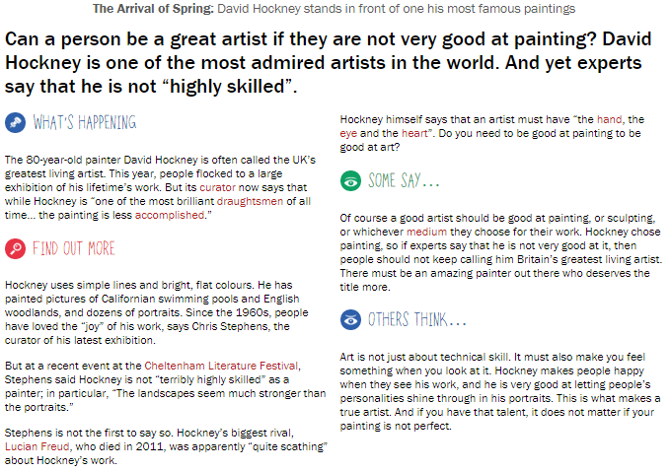

Can a person be a great artist even if they are not very good at painting?
What are your thoughts? Try and consider both sides of the argument. You could write this in your home learning book or add it to the Google Classroom Doc.
Follow-up activity: You could research and find out more about David Hockney presenting this information however you choose or you could make your own artwork inspired by David Hockney.
Tuesday – Reading – Holes

Street Child – Chapter 3 Questions
Answer the following questions:

1) How did Rosie know that the family had been thrown out of their home before she’d asked them?

2) Why were the children so scared of the workhouse?

3) Why is Mrs Jarvis’s voice suddenly ‘steady and stronger’?

4) How do you think Mrs Jarvis felt when she had to leave Lizzie and Emily?

5) ‘Jim daren’t look at her. He daren’t listen to the sounds that she was making now that they were into the day”
What is the author suggesting Jim’s mother is doing here?
1) How did Rosie know that the family had been thrown out of their home before she’d asked them?
She saw that the children were clutching bundles of clothes and belongings.
2) Why were the children so scared of the workhouse?
They had heard stories that people stayed there for their whole life, or died there. That people would rather live on the streets or in fields than go to the workhouse.
3) Why is Mrs Jarvis’s voice suddenly ‘steady and stronger’?
She’s had some tea, she has hope, she wants to appear strong because her children are scared.
4) How do you think Mrs Jarvis felt when she had to leave Lizzie and Emily?
Sad, but happy that she has kept her children out of the workhouse.
5) ‘Jim daren’t look at her. He daren’t listen to the sounds that she was making now that they were into the day”
What is the author suggesting Jim’s mother is doing here?
Crying.

Tuesday – Impressionism

What is impressionism?
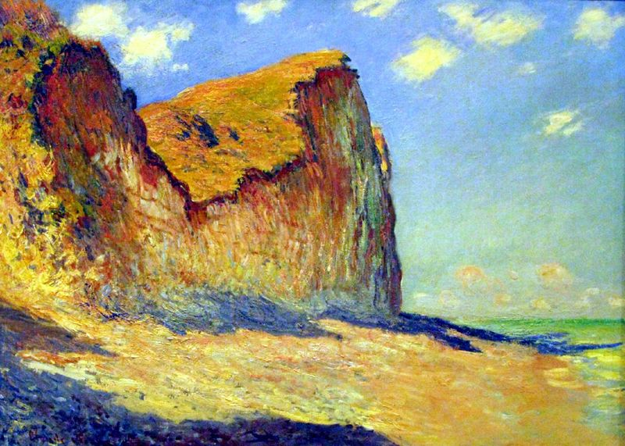
Impressionism is a 19th-century style of painting that focuses on the effects of light and atmosphere on colours and forms.

Impressionist artists often used broken brush strokes rather than smooth and unnoticeable ones and also used many colours to paint scenes of everyday life.

Watch this short clip from the Tate Modern to learn more:
https://www.youtube.com/watch?v=nesTk_6j-0c

Impressionist artists were not trying to paint a reflection of real life, but an ‘impression’ of what the person, light, atmosphere, object or landscape looked like to them. And that’s why they were called impressionists! They tried to capture the movement and life of what they saw and show it to us as if it were happening before our eyes.

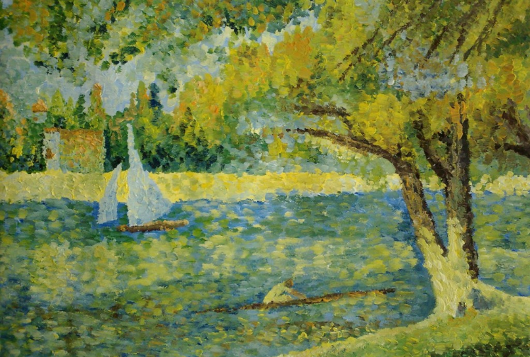

Some of the main impressionist artists are below:
- Claude Monet 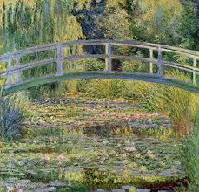
- Berthe Morisot 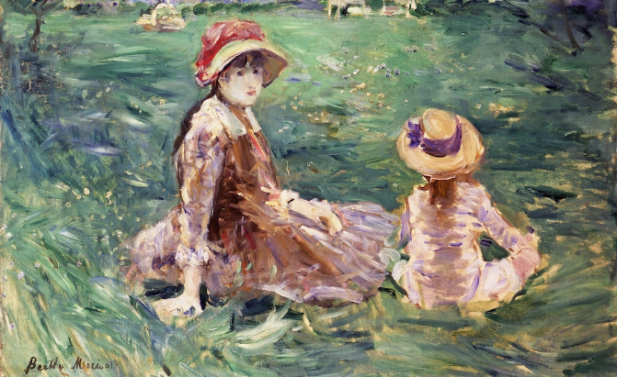
- Edgar Degas 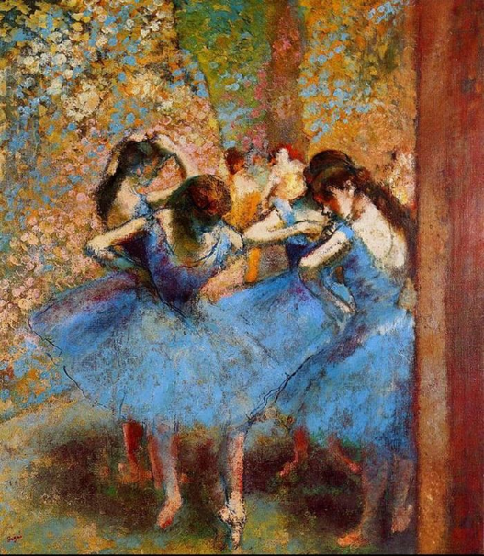

Activity - using impressionist brushstrokes

The Impressionist painters used layers of colours, leaving gaps in the top layers to reveal the colours underneath. The technique is achieved through hatching, cross-hatching, stippling and drybrushing. Mixing of brighter colours is done directly on the canvas to aid in creating the broken colour effect and only darker colours are mixed on the palette.

Use these techniques to create your own impressionist style painting.
- Practice the different types of techniques (see examples below)
- If you are feeling confident, create your own impressionist painting - this could be a copy of a famous painting, the view from your window or an imaginary picture.

If you do not have access to paints, be creative; you could use felt pens, coloured pencils or take a look in the kitchen cupboards! (How about using ketchup, coffee or even gravy granules?!)

Impressionist Techniques:
- Broken Colour: this refers to the effect of blending colours on the paper rather than on the palette. The impressionist painters used layers of colours, and broke up the top layers to reveal the colours underneath
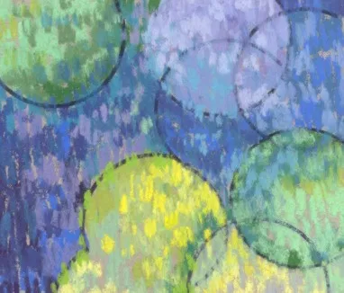
- Brush techniques: the artist can use dots (referred to as stippling), brushstrokes (referred to as drybrushing), and scratches (known as sgraffito) to create the effect. Hatching refers to painting using layers of short straight brush strokes. If strokes cross, this is called cross-hatching.
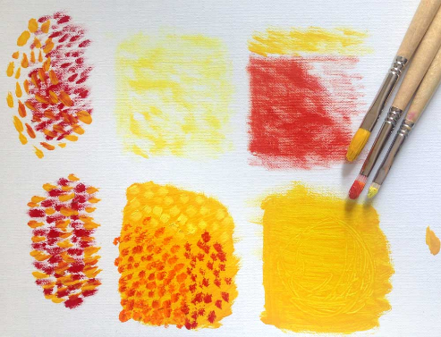

- Wet Paint: wet paint is placed into wet paint without waiting for previous applications to dry.

Some children’s examples:
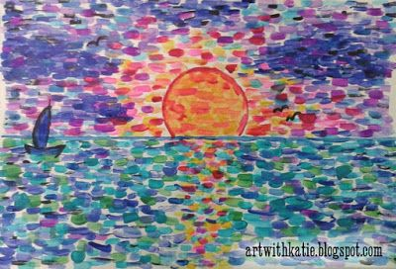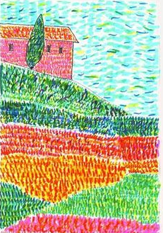

Examples of impressionist paintings you may wish to recreate:
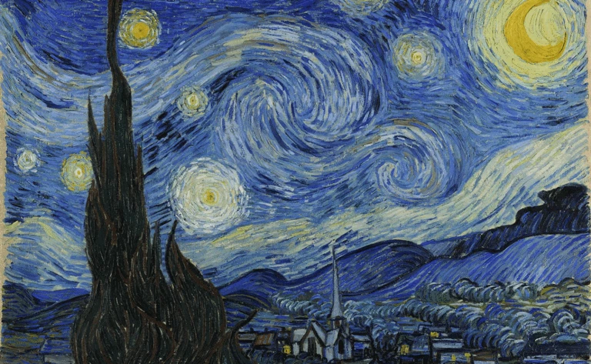
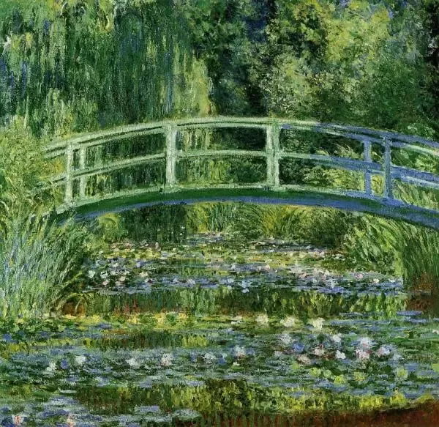
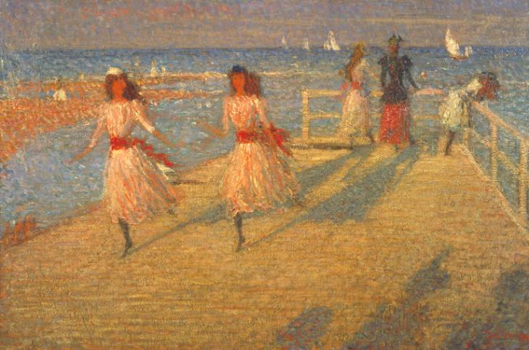

Tuesday – Claude Monet
Who is Claude Monet?
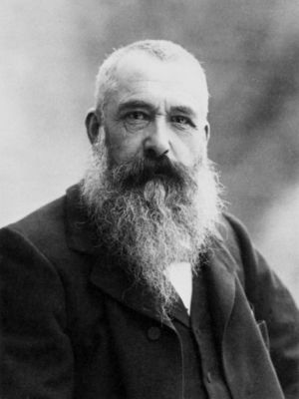
As one of the most famous impressionist artists of the time, Claude Monet is still celebrated today as one of the greats.

Use the links below, and any other resources you have, to find out all about him.

Then create your own quiz to test your family at home.

You could write this in your home learning book or create it digitally.

Things to think about when creating your quiz:

- Can you create a range of rounds for your quiz? For example: early life, famous paintings, dates, family life, picture round etc.
- Is it going to be multiple choice or not?
- Will you have a tiebreaker question?
- How will you make it look appealing? (pictures, decorations, answer sheets)

Web links to help you:

https://www.coolkidfacts.com/claude-monet/
https://www.tate.org.uk/kids/explore/who-is/who-claude-monet
https://wiki.kidzsearch.com/wiki/Claude_Monet
https://primaryfacts.com/843/claude-monet-facts-and-information/
https://primaryfacts.com/843/claude-monet-facts-and-information/

Below is some information about Monet:

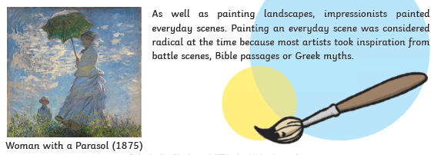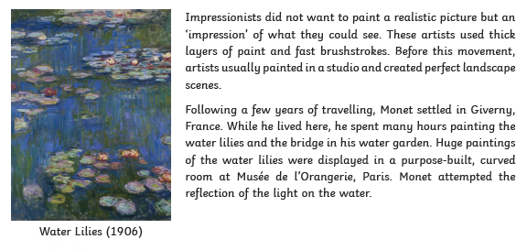
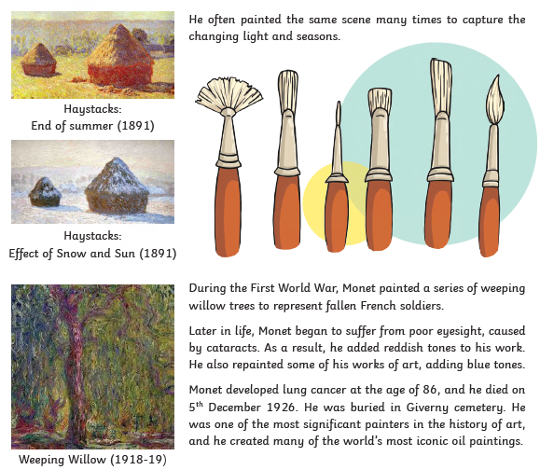
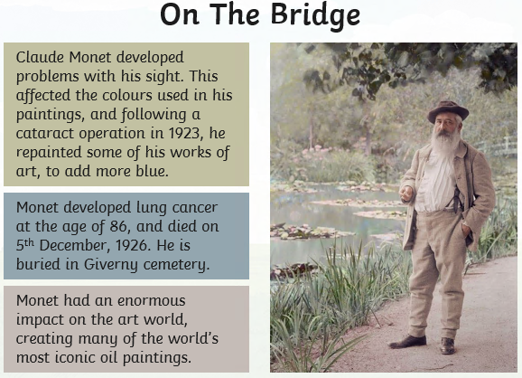
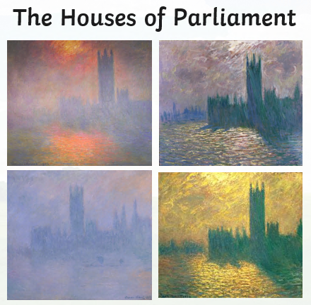
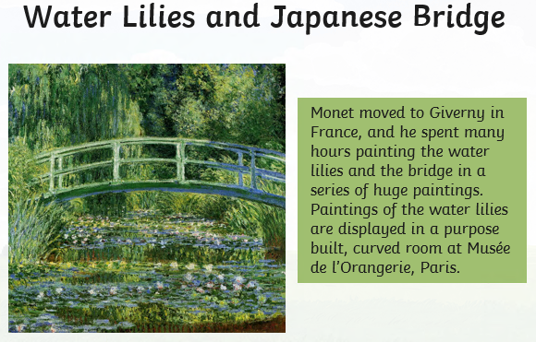
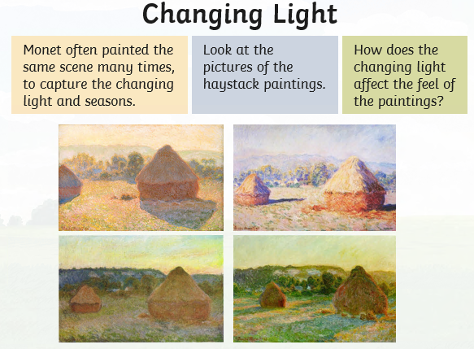#####

Claude Monet (14 November 1840 – 5 December 1926) was a French impressionist artist. One of his most famous paintings was called Water Lilies, which he repeated many times in various conditions.
Monet was born in Paris, France. His father wanted him to help run the family's grocery business. However, Monet wanted to be an artist. When he was young he met the painter Eugène Boudin who taught him to use oil paints, and encouraged him to paint out of doors.
Monet joined the French Army in Algeria for two years from 1860-1862. When he became ill he left the army to study art at university. He did not like the way art was taught, and joined the painter Charles Gleyre in his studio. He met other artists here, including Pierre-Auguste Renoir and Alfred Sisley. They shared their ideas about painting.
In 1866 Monet had a child with Camille Doncieux, who had been his model. They married in 1870 and had two children, Michel and Joseph. In 1870 he moved to England to escape the Franco-Prussian War, and in 1871 he moved to Argenteuil near Paris where he painted some of his most famous pictures. In 1873 he painted Impression, Sunrise, showing the sea at Le Havre. When this picture was shown in 1874 one critic took its title and called the group of artists "Impressionists". He intended to make fun of the artists, but the name has stuck and this is what people today call this style of painting.
In 1879 Camille died of tuberculosis. Alice Hoschedé decided to help Monet by taking care of his children as well as her own. In 1883 they moved to a house in Giverny where Monet planted a large garden. Monet married Alice in 1892.
Monet found that his garden inspired him to paint pictures of it, particularly the water lilies. Alice died in 1911, and his son Jean was killed in World War I in 1914.
Monet used broad brush strokes to build up his pictures, and painted quite quickly to try and get the idea of the light he could see into his paintings. If you go very close to one of his pictures it is hard to see what it shows, but if you stand back everything becomes clear.
His later paintings include series, in which he paints the same subject in different lights. For example, he painted a series of pictures of haystacks in a field, and another series of pictures of the west front of Rouen Cathedral.
Here are some facts about the French impressionist painter, Claude Monet.
- Claude Monet was born on 14th November 1840 in Paris, France.
- He was named Oscar-Cluade, and his parents called him Oscar.
- Monet’s father was a grocer and his mother was a singer. Claude decided not to take up a position in his father’s business – he wanted to be an artist instead.
- He went to Le Harve School of Arts in 1851 and he used to sell caricatures in charcoal to help bring in some extra money.
- Monet moved to England following the start of the Franco-Prussian War in 1870. He was inspired by the work of John Constable. In May 1871 he moved to Zaandam in the Netherlands, before returning to France in November 1871.
- Monet married Camille Doncieux in 1870. They had two children and Camille died of tuberculosis aged just 32.
- Monet suffered with cataracts. In 1923 he had surgery to remove them from his eyes. The works he painted when he had cataracts are more red than the ones he painted after his operation.
- Claude Monet was the founder of the impressionist movement. He was focused on capturing movement and changing light and colour in his paintings, and was less concerned with realism. He wanted to paint how humans look upon a scene, rather than what is actually there.
- Monet died on 5th December 1926. He had lung cancer and was 86. He is buried in the Giverny cemetery.
- Paintings by Claude Monet now sell for tens of millions of pounds. He produced more than 1000 individual paintings during his career.
- He is probably most well-known for his series of paintings of water lilies, but he also painted many other landscapes and seascapes. He produced a series of paintings of weeping willows – a tribute to the fallen French soldiers in World War 1.

Wednesday – Maths - Arithmetic

Welcome to the new format of our weekly arithmetic!
It is multiple choice and you can record your answers in a way that suits your personal style. If you wish to write them on paper or record jottings, that it okay.
It should take approximately 20 minutes. As always, if you finish before then you need to check your workings. If you need a bit of extra time, please mention that when you feedback your score as it won’t get you in trouble, it just shows that we need to work on your speed.
We would then like you to mark your paper and give us your scores so that we can see how well you are progressing.
We are trusting that you tell us the truth about your score as we cannot give you the help you need if you are saying you got them all correct. If you are struggling and ask for help, we will be happy to support you!

Good luck and take your time.

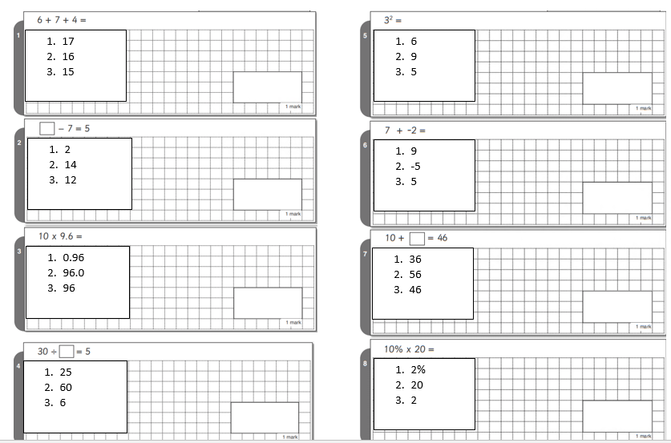

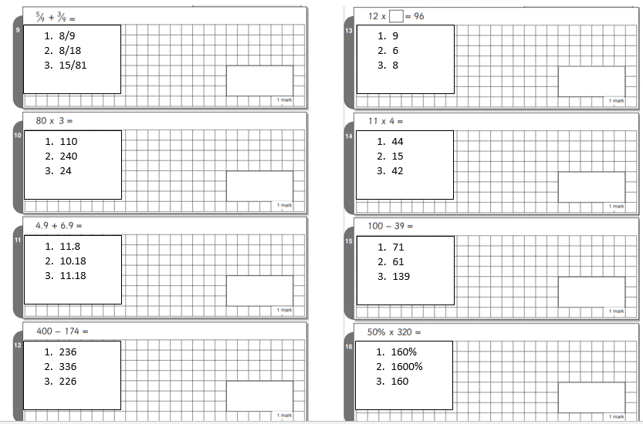
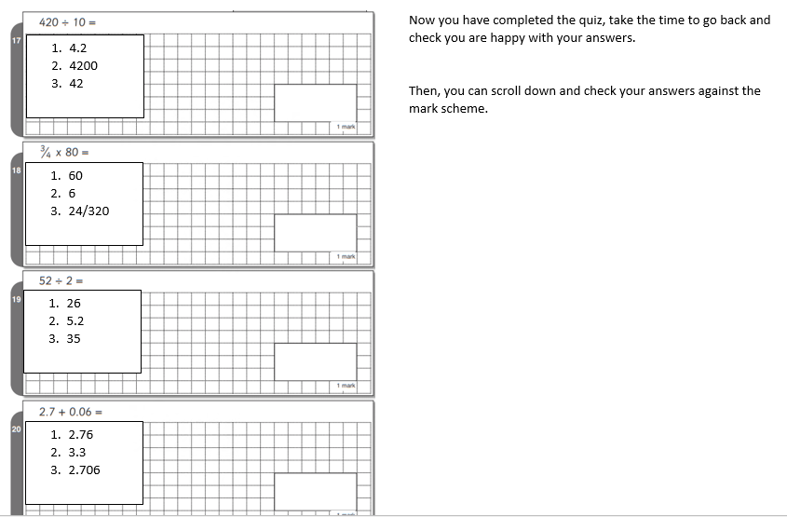

Wednesday – Arithmetic – Answers
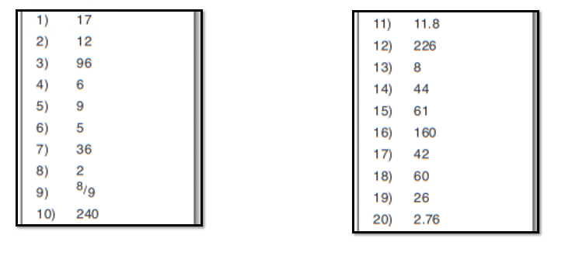

Wednesday – Fauvism
Les Fauves (French for The Wild Beasts) was the name of a group of artists in the early 20th century, led by the painters: Henri Matisse and André Derain.
The Fauves were a group of French painters who were influenced by the bright colours used by the Impressionists artists: Vincent van Gogh and Paul Gauguin.
The group was only together for three years, from 1905–1907; however, their influence has continued until the present day, and has influenced many famous artists.
Here are some examples by Henri Matisse. The one in the middle is Matisse’ self-portrait and the one on the right is his wife.
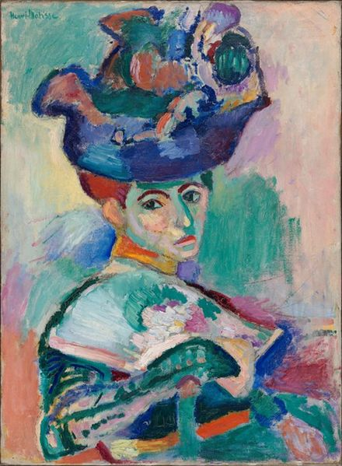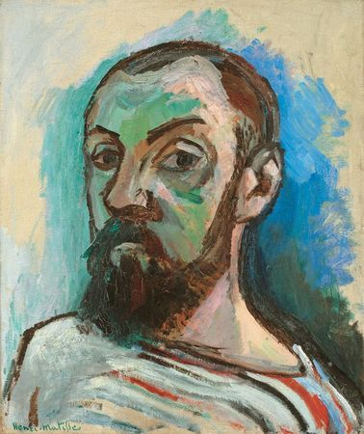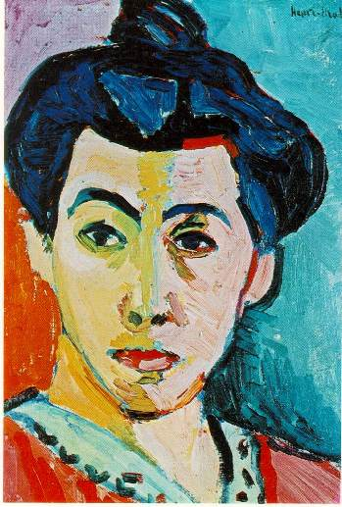
These two paintings were created by a student from Admiral Lord Nelson School!
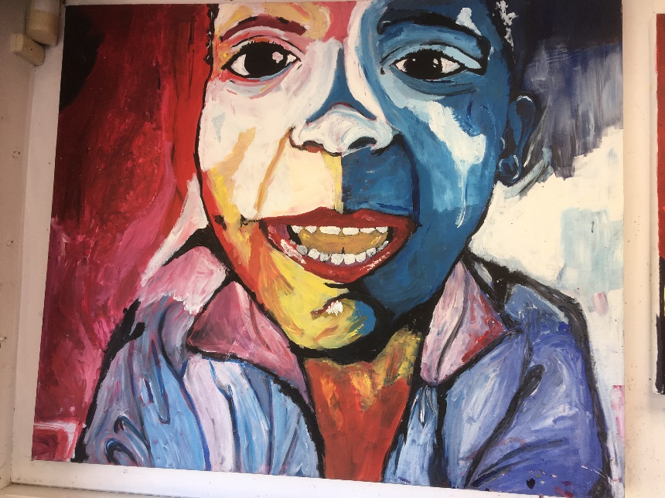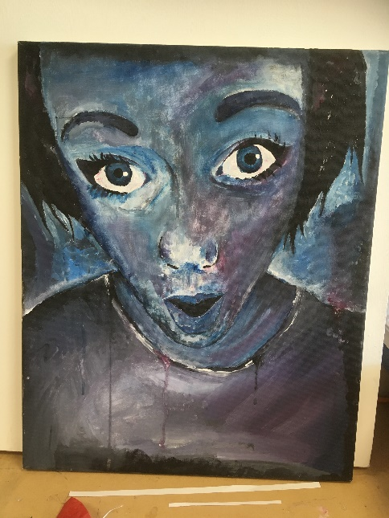
Fauvism paintings use unnatural, exaggerated and sometimes bright colours that are often not what you would expect to see. The colours used are to represent emotion or a particular mood. For example, when painting a portrait of a woman with very dark hair, a fauvist might choose to use blue in the hair to show just how dark it was. He/she might use yellow for the skin instead of a carefully mixed bronze. Shadows might be drawn in greens and purples instead of grey.
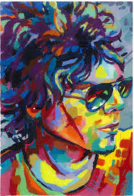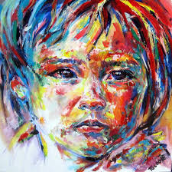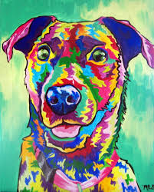
Activity
Create your own fauvism piece of art. Fauvism can be of people or landscapes but we would like you to try a self-portrait or a portrait of someone important to you. You can use paint, crayons, felt tips or even colours from a cut-up magazine…or something else!

Wednesday – Colour Poems

We have used colour to show emotion through our fauvism artwork so why not combine poetry and colour too?! Here is an example:
Colour Poem
Red is an apple.
Red is a cherry.
Red is a rose
And a ripe strawberry.
Blue is the sky,
Blue is the sea.
Blue is a flower
And a juicy blueberry
Yellow is a banana,
Yellow is the sun.
Yellow is a happy face
And a warm sticky bun
Your Activity
Create your own colour poem. You could use it as a way to express your emotions and use other poetic skills you have learnt at school such as:
-alliteration
-rhyme
-onomatopoeia
-metaphors
-similes
-expressive language

Here is another example that uses more poetic techniques:
Red is my heart, bursting bountifully with love for all who care for me,
Red is anger; it can bubble up from nowhere like an explosion of lava
Red is the warmth I feel as sunlight kisses my cheek through the window

Thursday – Spelling
Spelling Quiz 5 – Year 6 Exception Words

Instructions for the reader:
Read the word, then the sentence with the word inserted, then repeat the word. For example:
‘Question 1: The word is symbol. The symbol for love is a red heart. The word is symbol’

At the end of the quiz, you can read all the words again so the children can check their answers.

The child only needs to write the spelling word not the whole sentence but they must make sure they do not use capital letters and their handwriting is clear (we encourage them to print during spelling tests).

- nuisance She was starting to make a of herself.
- prejudice Is it to keep over 70s inside?
- pronunciation It is hard to learn the correct when speaking a foreign language.
- recommend We that you keep 2 metres distance from other people.
- variety There is a large of fruit in the supermarket.
- hindrance An untied shoelace is a to walking.
- interfere She tried not to when he was cooking.
- leisure The centre was closed.
- amateur She was an chef.
- accompany He had to her to the doctors.
- category She entered her drawing in to the 10 to 15 of the competition.
- aggressive The dog was becoming a bit .
- correspond We are going to with schools all over Europe.
- embarrass He liked to his little sister.
- communicate There are lots of ways you can with your friends.

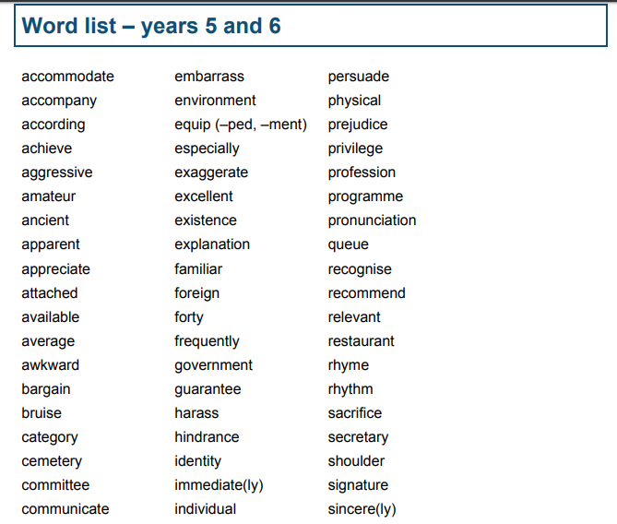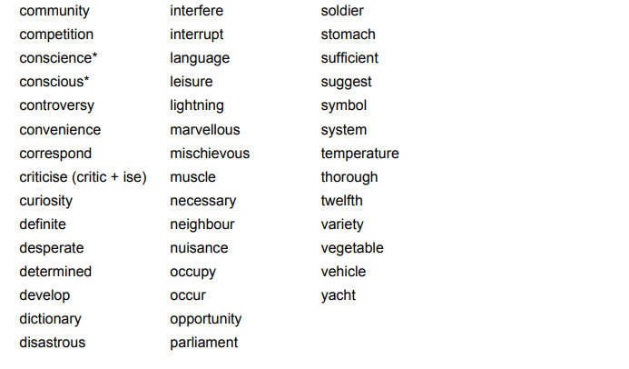

Different ways to learn your spellings

ABC Order:  Write all of your spelling words in alphabetical (ABC) order. | Word Parts:  Write your words. Then use a coloured pencil to divide the words into syllables. | Write each word 5 times.  Say the word as you spell it. | Silly Sentences:  Write 3 or more sentences that use all your spelling words.
Picture words:  Draw a picture and hide your spelling words in the picture. | Shape Words:  s  s p  s p e  s p e l  s p e l l  s p e l l i  s p e l l i n  s p e l l i n g  (or make them boat shaped, wagon shaped, smiley face, etc.) | ”Ransom” Words:  “Write” your words by cutting letters out of a newspaper or magazine and gluing the letters on a piece of paper to spell your words. | Rainbow Words:  Write your spelling words with coloured pencils. Make each letter a different colour.
Scrambled Words:  Write your words. Then write them again with the letters mixed up. | Vowel Spotlight:  Write your words using one colour for the vowels and another colour for the consonants. (vowels: a, e, i, o, u) | Word Search:  Create your own word search with your spelling.  Show the answers to your puzzle. | Flash Cards:  Make and practice with flash cards. Put the word on one side and definition on the other.
Picture & a Story:  Draw a picture defining each word. Write a sentence about your picture using the word. | Explain:  Read each word and explain to your parents what each word means. | Write a Story:  Poem or Song with Words:  Write a story using all your spelling words. Underline the words you used. | Use Technology:  Type out your spelling words (and definitions) on the computer.

Thursday – Pointilism
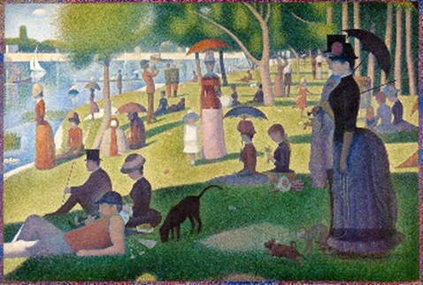
Pointillism is a technique developed late in the 1800’s that uses small distinct dots of colour in patterns to form an image.
This painting is by far the most famous of the Pointillism paintings. It was George Seurat's masterpiece. It is over 6 feet tall and 10 feet wide! Every bit of the painting is done with tiny little dots of pure colour. Seurat worked on it for around two years.
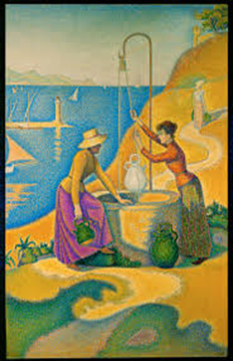
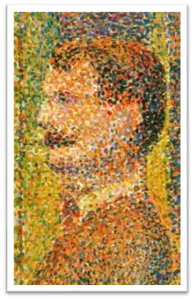

Unlike other art movements, Pointillism has nothing to do with the subject matter of the painting. It is a specific way of applying the paint to the canvas.

Task: Creating Pointillism bookmarks
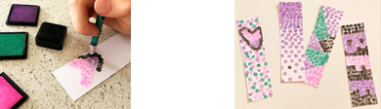
Using card (or whatever material you can find) use the pointillism to create a decorative bookmark.
Step 1: Cut your cardboard into strips to form bookmarks.
Step 2: Choose a colour and stamp small dots of colour on the bookmark. Experiment with creating simple blocks of colour and different shapes.
Step 3: Touch the paper with the tip of the marker to make a small dot. Dots don’t need to be perfect or spaced specifically, just make lots of dots.
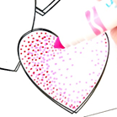
Step 4: To create colour blends, add different colours of dots in the same area. If you want to create shading, start with lighter colours and layer with darker colours on top.
Experiment with:
Spacing the dots closer together and further apart, and noticing the impact this has on the colour.
Stamping in organized rows of dots versus a more random arrangement of dots.

Thursday – History – Timeline of Art
Timeline of Art Movements
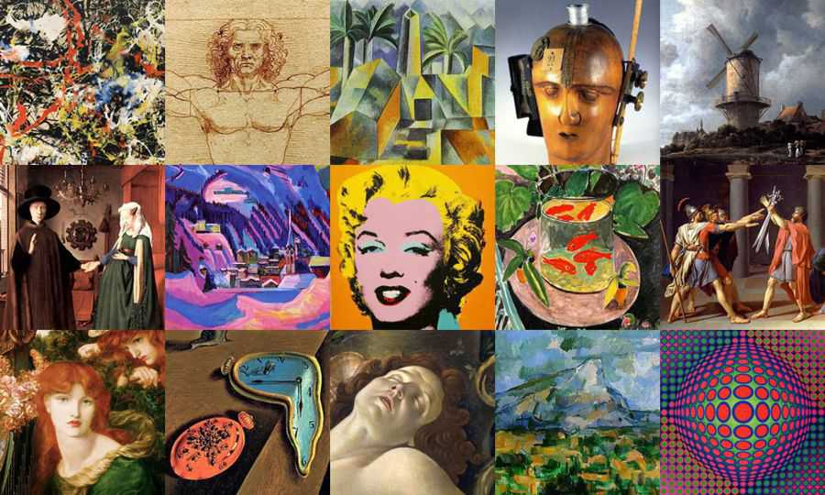
Since man first drew stories on cave walls over 30,000 years ago, art has gone through many periods of change.

In these art periods, certain art movements developed that experiment with different styles. Although these art styles are still used today, each movement has a generally accepted time period.

By the end of this week, you will have learnt about four very different art movements: Pointillism, Pop art, Fauvism and Impressionism.

Task: Using the information and examples below, create a timeline that marks the dates each of these movements. Create the timeline in any way that you like! You could use the pictures below and add them to it to mark the dates of the movement or add other art movements to the timeline.

Fauvism: Fauvism is the style of les Fauves (French for "the wild beasts"), a group of early 20th-century modern artists whose works focused on paint qualities, strong color and emotions. While Fauvism as a style began around 1904 and continued beyond 1910, the movement as such lasted only a few years, 1905–1908, and had three exhibitions.
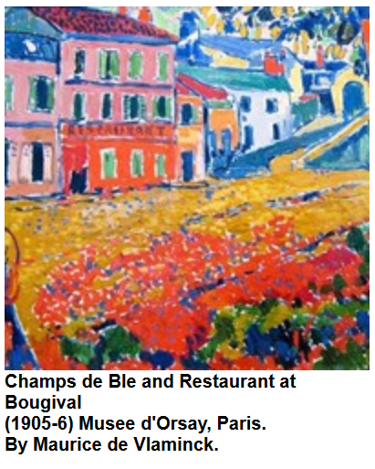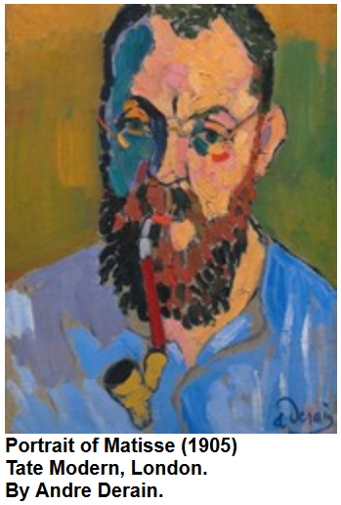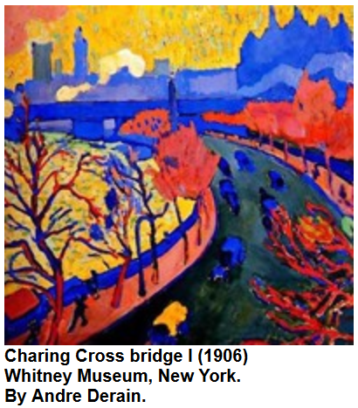

Pop Art: Pop Art, which generally is believed to have started in 1955, is art made from commercial items and cultural icons such as product labels, advertisements, movie stars and comic strips. In a way, Pop Art was a reaction to the seriousness of Abstract Expressionist Art as it focused on fun and entertaining subjects. This movement, which ended around 1972, was made popular by Andy Warhol and Roy Lictenstein
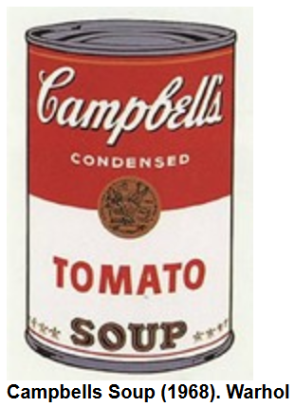.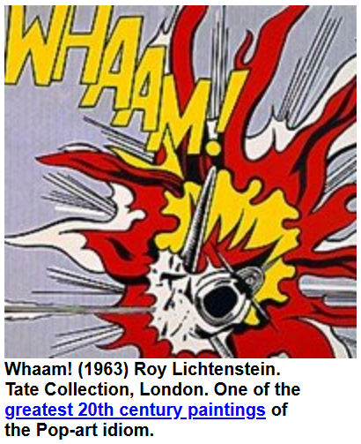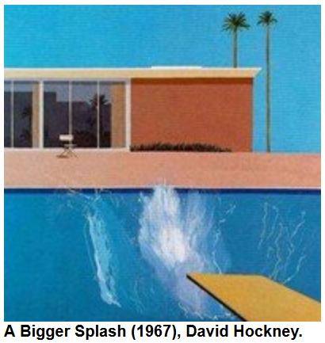

Impressionism: Impressionism can be considered the first distinctly modern movement in painting. Developing in Paris in 1867, its influence spread throughout Europe and eventually the United States.The Impressionists wanted to capture a moment in time and they were more concerned with the light and color of the moment than with the details of objects they were painting. They used rapid brush strokes and often used unmixed color to save time. This movement is thought to have ended in 1892 although, like Pointillism, Impressionism led to other art movements and is still practiced today.

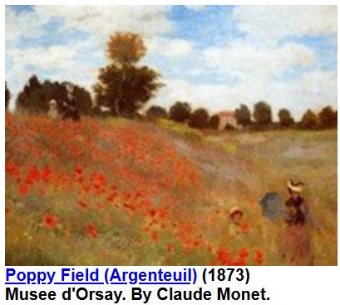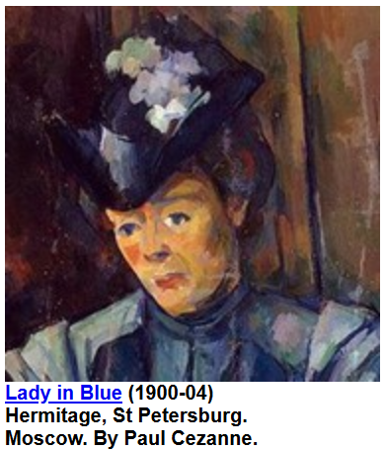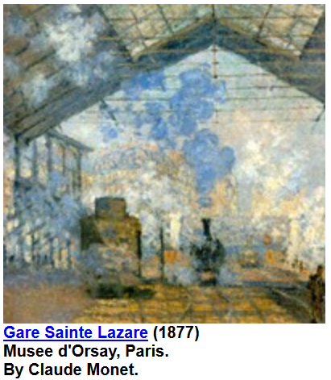

Pointillism: Pointillism is often considered part of the Post-impressionist movement. Starting in 1884, it was primarily invented by painters George Seurat and Paul Signac. While Impressionists used small dabs of paint as part of their technique, Pointillism took this to the next level using only small dots of pure color to compose an entire painting. Although the movement ended in 1900, the techniques and concepts were used by other artists, such as Andy Warhol in the Pop Art movement.
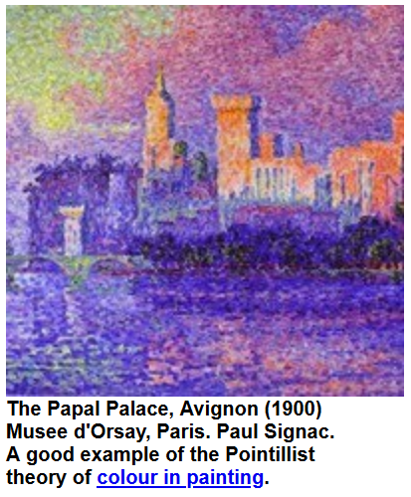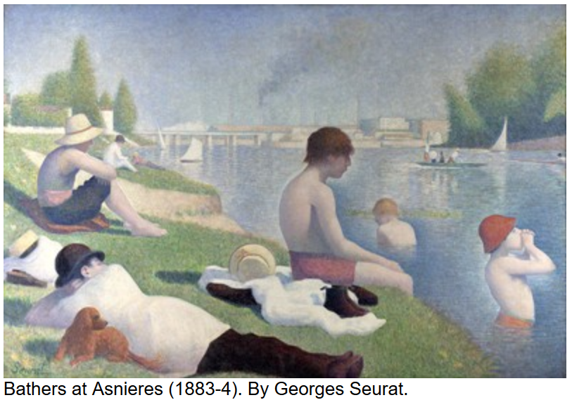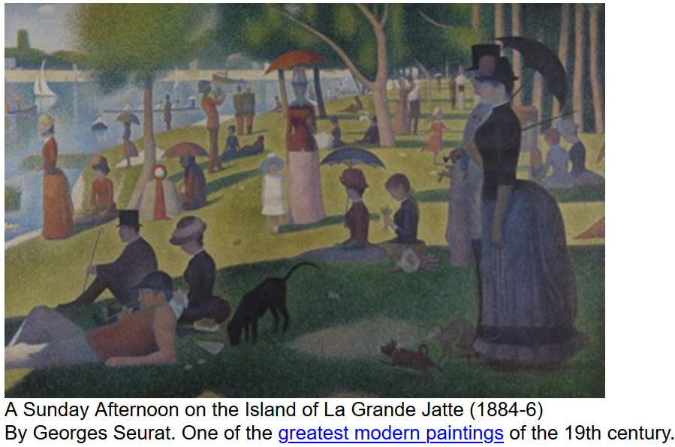

Friday – Catch up and Chill
Today is the day to take part in any of the activities above if you hadn’t had a chance yet. Instead, you may have some ideas of your own! No matter what you choose to do today, make sure you relax and take some time for you!
