Monday – International Project – Dream Catcher
This week, the children around the world taking part in our international project are each creating dream catchers to hang in their bedrooms. Some of you may be worrying more at this time and you may have trouble sleeping. Legend has it that dream catchers can help you sleep better by keeping bad dreams away.
So, this week, your task is to create your very own dream catcher! You can make these out of various materials - just use what you have. I like the natural ones made from twigs! I've attached some information about what dream catchers are and where they originated and here are some examples.
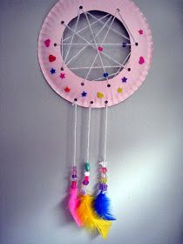
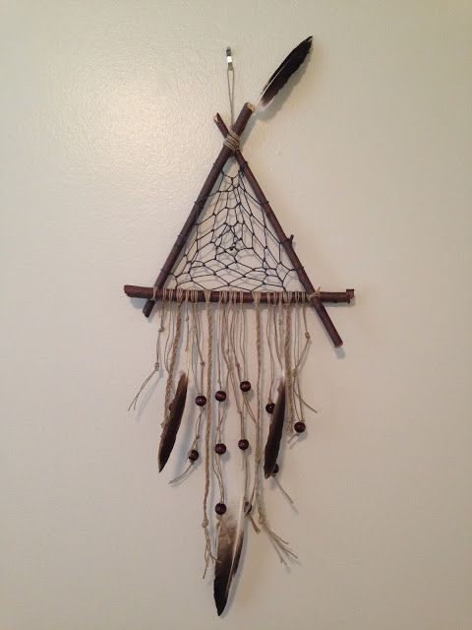
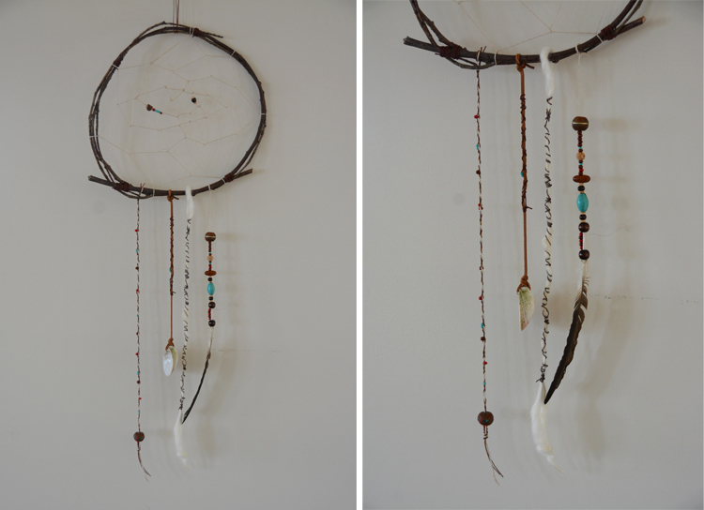

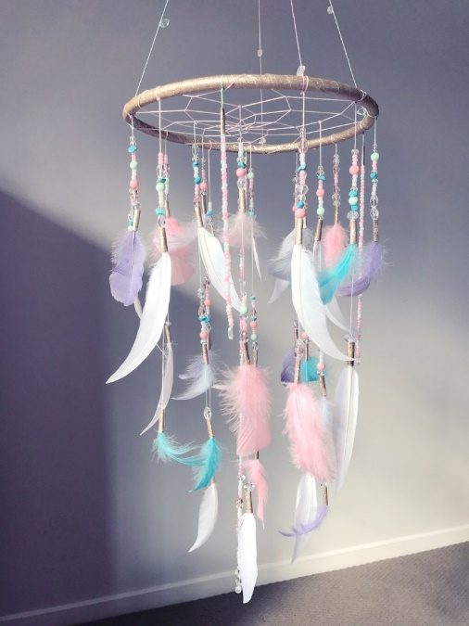
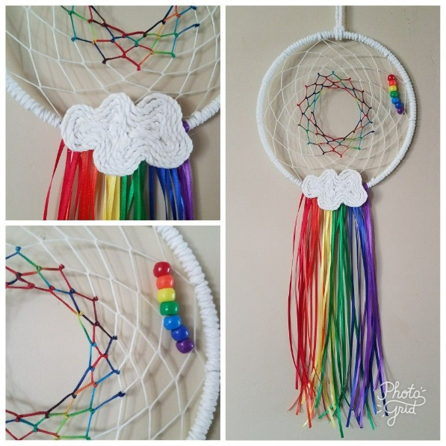
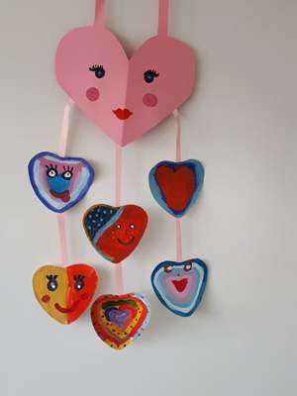

Ojibwa Indians in Olden Times
Dream catchers were designed to "catch" evil spirits, tangle them up, before they could enter your dreams. They were made with an open weave so the good dreams could get through. Dream catchers were woven by the grandfathers and grandmothers. They were hung above a sleeping baby.
Good Dreams: The Ojibwa believed that good dreams are light as air. Good dreams can wander gently through the night, and make their way down to a sleeping child, through the feathers and twigs of a dream catcher.
Bad Dreams: But there is nothing gentle about a bad dream. Bad dreams are violent and rambunctious. They plunge about in the night air, and dart down towards a sleeping baby. The dream catchers catches them in its web. The bad dreams are tangled in the catcher. There they stay, trapped, until morning, when the sun rises and sends them away.
As other tribes heard about Ojibwa dream catchers, they adopted the idea. Today, many Native American artists make beautiful dream catchers to sell, to share, and to keep.

