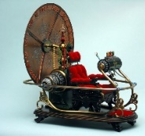
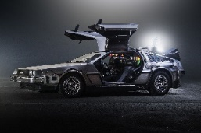
Year 4 - Home Learning Tasks
WB: 22.06.20
Our theme for this half term will be the concept of ‘change’.
This week we are exploring changes over time, looking back at some inventions old and new, exploring how places change and exploring language.
 | Activity 1 | Activity 2 | Activity 3 | Activity 4 – Away from the screen
Monday | Introduction  What are these objects?  Take a look at the pictures and complete the quiz. | Game Changer  Explore how a popular video game was born, has stood the test of time and then have a go at some unplugged coding. | Home entertainment  Learn all about how home entertainment has changed over the years. Then draw and label a console and take a look at the different types of advertising. | Times tables away from screen- Board game
Tuesday | Times tables practise  Practise your 8 times table with Miss Thompson’s video then have a go at the 8 times table mazes. Colour in the 8 times table to find the pathway out of the maze. There are songs and games to play too! | Fashion  Read about how fashion has changed throughout this century and previous centuries. Which is your favourite era? Why? | Defending the harbour – changes throughout history  Explore a local landmark and find out how it has been used over the past 1,700 years. Is it a castle? A jail? A tourist attraction? Use your geography and history skills to find out more. | Fashion  After reading about how fashion has changed over the centuries, now it’s your turn to design an outfit of our choice. You could take inspiration from your favourite eras.
Wednesday | The English Language  Read the information about each period of time carefully and order the boxes then draw a timeline in your book and summarise the main points of the changes in English language. | A changing language  How has the meaning of words changed over time? Explore words that have changed their meanings. How many can you find? | Cars – an evolving form of transport  Find out how cars have changed since they were invented. What is the same/ different? Using the graph, to answer questions about the number of cars in the UK. | Times table fortune teller  Learn how to make a time tables fortune teller which will help you practise your times tables.
Thursday | Alexander Bell  Today, you will be learning all about a famous scientist and inventor called Alexander Graham Bell. There is a video to watch and information to read before answering a quiz on google classroom. Then have a go at making your own string telephone. | History of communication  The history of the telephone – Read the information and then use it to create a timeline of the history of the telephone. | Outcome - Reflection  Reflect on your learning this week:  What do you think change is?  Can you link your thinking to the learning you have done this week? What about last week? | 8x tables audio test
Friday | Catch up and Chill – Today is the day to take part in any of the activities above if you hadn’t had a chance yet. Instead, you may have some ideas of your own! No matter what you choose to do today, make sure you relax and take some time for you!
These are the details and links to some of the activities posted on Google Classroom this week. Where possible, below you will find the task sheets which will explain the activities in more detail. If you experience any problems, please contact your child’s class teacher via email. Don’t forget you should also be doing at least 15 minutes reading a day – this can be on your own or with/to someone that you live with.
Monday – Activity 1 - Introduction
Quiz – What do you think these objects are?
These objects are different technologies from different time. What do you think they were used for? Answers on the last page of the pack.

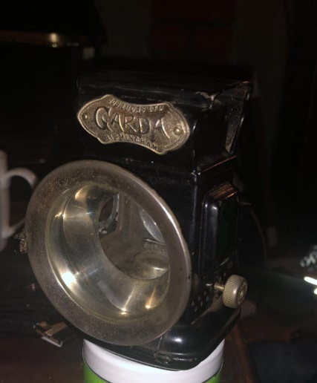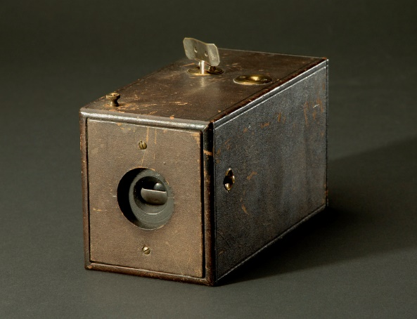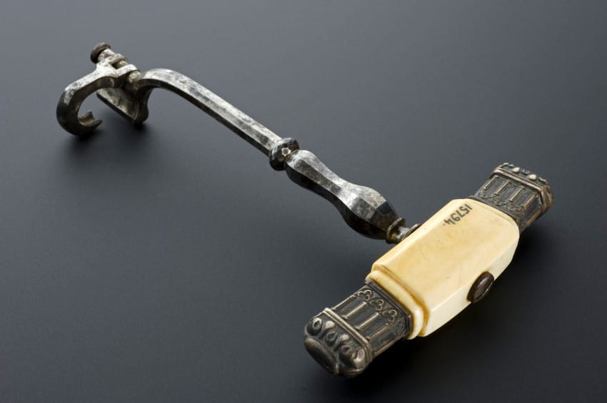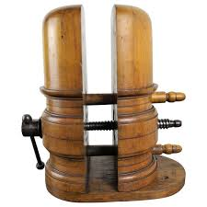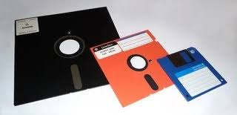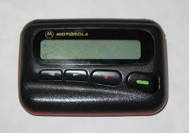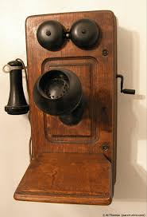

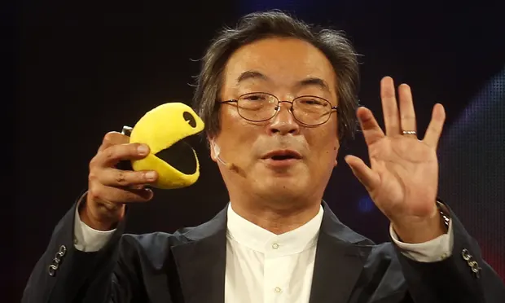
Monday – Activity 2
Who is this man and what did he create? Read the clues below and see if you can figure it out.
- This man is called Toru Iwatani and he is a designer.
- He lives in Japan.
- He was just 24 when he created a game which was inspired by pizza.
* In 1980, two years before Miss Howard was even born, this man tested his creation in public for the first time on the 22nd May at a Cineplex location in Tokyo. People enjoyed it but they said it would never catch on. This year, the game has recently celebrated its 40th ‘birthday’ and is loved by many all over the world.
* To give his creation a name, Toru Iwatani was partly inspired by the onomatopoeic phrase paku paku meaning “chomp chomp” and the kanji symbol for the word taberu meaning “to eat”.
* Since the birth of this iconic character, he has been featured in movies and TV shows, been awarded world records, changed the landscape of gaming and been recognized as a cultural icon.
* In the 1980's cartoon and the later games, this character was a fairly easy-going sort and a dedicated father and husband. While he would often get perplexed by most situations he found himself in, he would always come out on top of them.
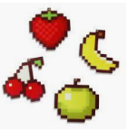
Can you guess who it is yet?
* This character seems to be very good at navigating mazes, due to his extensive time spent in them.
* Toru first created his main character who always seemed to be hungry. His regular meal includes Pac-Dots, Power Pellets, and fruits such as Cherries, Strawberries, and Oranges.
* To make the game more kawaii (“cute”), Iwatani designed extra characters in the form of ghosts – these were brightly coloured and had large doe-eyes.
* These ghosts were also given names - Blinky, Pinky, Inky and Clyde and they each have their own personalities based on AI routines. Blinky constantly chases the main character, Pinky attempts to ambush him, Inky is randomised depending on the main character’s position and Clyde will get close to the player then attempt to flee to the bottom left corner, potentially cutting off escape routes.
* This character made a cameo appearance in Disney's 2012 film Wreck-It Ralph, where he was shown at Fix-It Felix Jr.'s Penthouse party, commemorating his game's 30th anniversary. Later, Ralph loses his temper and accidentally wrecks a cake, pelting this character with bits of it, and he does a jaw drop at Ralph's behaviour.
* He is a yellow, circular creature with a large mouth. He has a long, Pinocchio-like nose and two eyes which are shaped like himself. He is commonly shown with arms and legs in artwork, but he is often limbless within the games themselves. He often wears red boots and orange gloves, and occasionally has a red hat as well
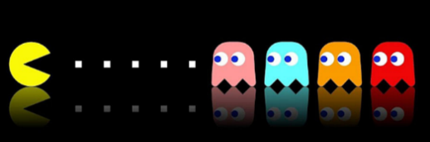
* As teens poured their quarters into Pac-Man machines across the United States, parents openly questioned whether the activity was good for their children’s health. News stories focused on this “new addiction” of young people, while psychologists decried the effect of arcade games on teens’ mental health – this is still a ‘hot topic’ today. This led to a change in the law where arcade opening hours were limited and some even had to enforce age restrictions. Despite these moves, arcade games continued to experience an explosion in popularity in the early ‘80s, spearheaded by this character.
But just who is it? Yes - You’ve guessed it – Pac-Man.
Watch this video to find out more about the ‘birth’ of this iconic gaming character. https://safeyoutube.net/w/QHyL
Since then, Pac-Man has had many moments of fame…can you spot how it’s changed over time, yet remained in immensely popular game for all ages?
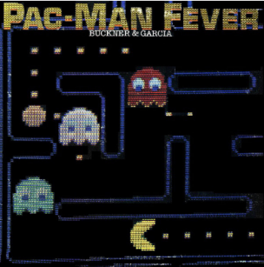 | 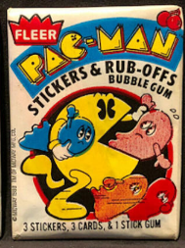 | 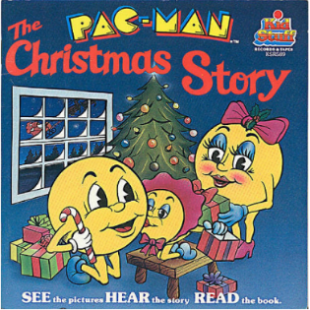
Pac-Man Fever" by Buckner & Garcia (1981)  Vocal duo Buckner & Garcia scored a hit with their novelty song “Pac-Man Fever” in 1981. The track - included on the album of the same name - peaked at No. 9 on the Billboard Hot 100 chart. It also featured many of the familiar sound effects from the arcade game. | Pac-Man Trading Cards (1980)  From 1980-83, the a card-making company created three different sets - one based on the original arcade game, one centred on Ms. Pac-Man and a third based on the Super Pac-Man game. In addition to the trading cards, packets came with stickers, rub-off game pieces and a stick of gum. | Kid Stuff Books and Records (1980)  A company called Kid Stuff Records, specialized in storybooks that came with 45 RPM records that narrated the story, allowing you to read and listen along at the same time. They released nine Pac-Man-related book and record sets between 1980-84, including ‘The Pac-Man Christmas Story.’
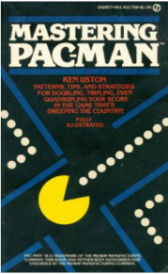 | 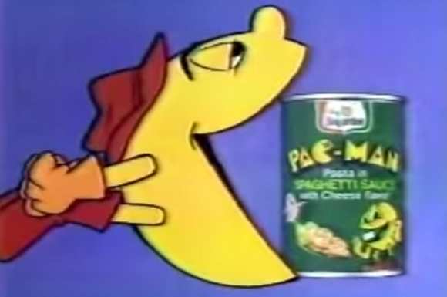 | 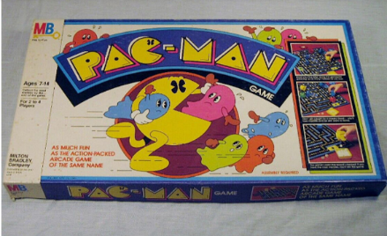
'Mastering Pac-Man' (1981)  As Pac-Man became the most popular video game on Earth, people quickly looked for ways to capitalize on the phenomenon. Many books and magazine articles professed they’d give players an extra edge, offering strategies on how to rack up high scores in the game. One popular release was 'Mastering Pac-Man,' penned by Ken Uston. | Pac-Man Pasta  Tinned-food powerhouse Chef Boyardee released Pac-Man pasta in the early ‘80s. The quick-fix meals were available in three varieties: cheese, meatballs and chicken. Each of the flavours included an abundance of small pasta bites, formed in the shape of Pac-Man and Ms. Pac-Man. | Pac-Man the Board Game (1982)  Pac-Man was turned into a traditional dice-and-game-piece affair. Players would take turns moving around the board, collecting as many pellets as they could, while avoiding ghosts along the way. Many other Pac-Man games would follow - including a card game, Ms. Pac-Man board game and a magnetic maze. None would match the popularity of the arcade version.
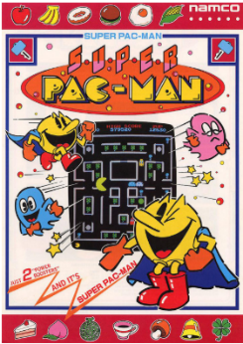 | 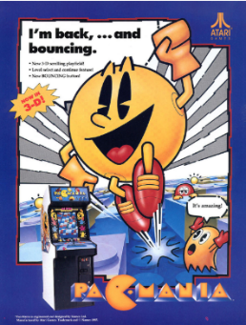 | 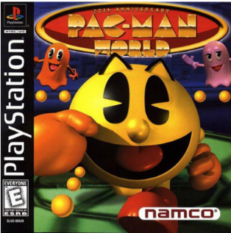
Super Pac-Man (1982)  Instead of eating the familiar little white dots, Super Pac-Man found the character munching on various fruits. The maze and ghosts still remained, but instead of power pellets, Pac-Man now had the chance to consume super power pellets. These transformed the yellow hero, making him grow in size and allowing him to briefly become invincible. | Pac-Mania (1987)  The classic game with some modern twists, Pac-Mania still had the mazes, ghosts and yellow hero everyone loved. However, for the first time, characters were shown in 3D, rather than the flat images players had been used to seeing. Other enhancements included new abilities for Pac-Man, including being able to jump over the ghosts instead of just running away from them. | Pac-Man World (1999)  As technology evolved, so did Pac-Man. On the 20th anniversary of the character’s creation, Pac-Man World was introduced to the masses. The game’s plot showed the ghosts crashing Pac-Man’s birthday party and kidnapping his friends. The yellow hero’s goal is to rescue them and bring them home. The game offered the clearest 3D animation yet, with Pac-Man venturing into outer space, boarding pirate ships and even uncovering ancient ruins. The character also had more abilities than ever, able to jump, attack, use tools and more.
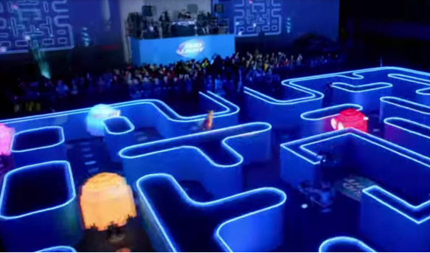 | 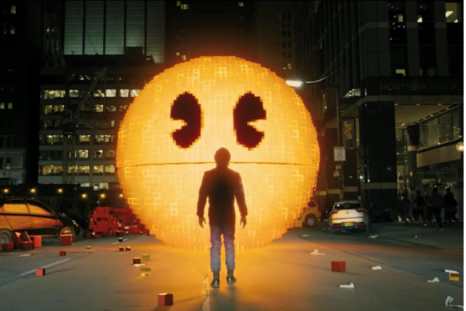 | 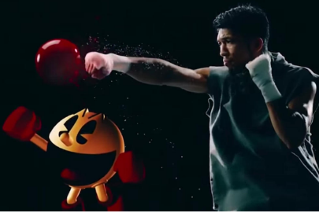
Real Life Pac-Man  Many events have brought Pac-Man to the real world. In 2004, a group of students staged Pac-Manhattan, a game in which players, dressed as either ghosts or Pac-Man, chased each other through the streets of New York. In 2015, Bud Light created a massive Pac-Man game as part of its Super Bowl commercial. | Pixels' (2015)  The 2015 film 'Pixels' told the story of aliens who, after misinterpreting classic video-game feeds beamed into space during the ‘80s, invade Earth using technology based on the games’ characters. Adam Sandler, Peter Dinklage and Josh Gad were among the film’s stars, with a giant Pac-Man representing one of the movie’s biggest alien forms. It did well at the box office, pulling in more than $240 million. | Tokyo Olympics Promo (2016)  At the conclusion of the 2016 Summer Olympics, videos were released promoting the 2020 Games in Tokyo. Naturally, these promos included shots of the famous city and Japan’s successful athletes, but several of the country’s cultural icons also made appearances. Among them Pac-Man, who is seen boxing in one clip, and is later featured racing his ghost nemeses on the Olympic track.
More recently, a group called Immersive Gaming Event Company had planned to tour a life-sized Pac-Mac inspired maze throughout the U.S. in 2020, but those plans were dashed by the coronavirus pandemic.
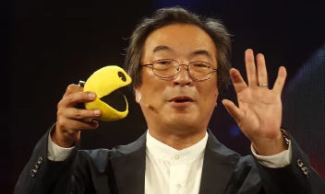
Questions to think about: How did Pac-Man evolve (change over time)? Was every change successful? What do you think made Pac-Man so successful that he has been able to stand the test of time? Discuss this with the people at home and write a reflection in your home learning book.
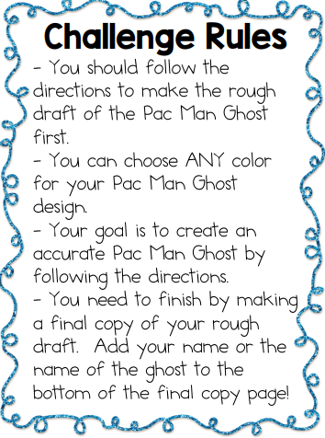
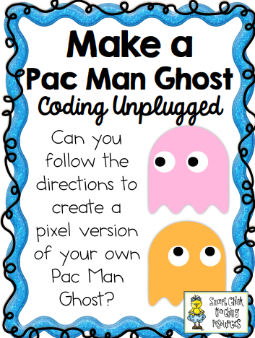
TASK: Computing, gaming and technology doesn’t need to all be screen based.

You will need:
- something to colour with e.g. felt tips, crayons, colouring pencils
- The coding instruction sheet
- Final copy sheet (see below)

Follow the instructions given to create your own Pac-Man ghost. Once you are complete, as a challenge, you can have a go at creating your own character for a Pac-Man game. Don’t forget to create the coding that goes with it.

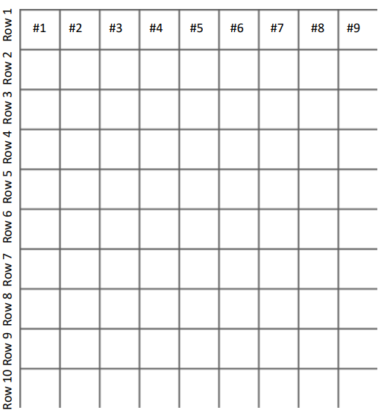
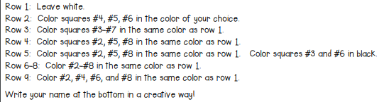

Now reflect on these questions:
* Were you successful with this coding challenge? Why or why not?
* What was the most difficult part of this challenge? Why?
* What was the best idea that you came up with?
* Were you able to accurately create the Pac-Man ghost on your first try? Why or why not?
* What did you learn about coding during this challenge?

Challenge sheet

Monday - Activity 3
How did games consoles change over time?

Read how games consoles have change since the 1970s

Gaming has come a long way since the first console generation in the 1970s.One of the first gaming consoles d was the Magnavox Odyssey in 1972. When you look at today’s gaming, it’s amazing how it changed. Let’s look back…
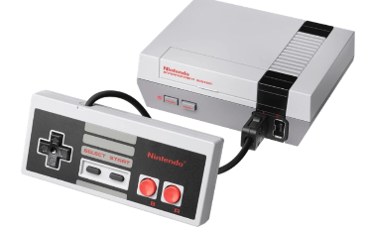
The NES (Nintendo Entertainment System)
Released way back in1983, the NES introduced a new era of gaming.
Featuring high-resolution sprites, alongside a vibrant range of colours, the NES was an instant success with gamers across the globe – with it becoming the highest selling console in the history of North America at the time.
The console featured a pretty great line-up for its day; games such as Super Mario Bros., The Legend of Zelda and Ducktales.

The Game Boy
The freedom to play wherever you want was unimaginable until the Game Boy reared is beautiful, portable head way back in 1989. The handheld had a lot going in its favour: a powerful battery life, a strong launch line-up and a huge range of accessories that made gaming more than just a solo experience.
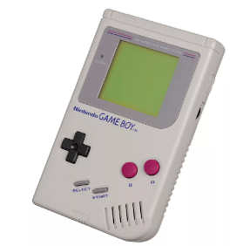
Tetris remains the most popular game on the system, selling over 30 million units. Alongside this, we have classics such as Pokémon Red and Blue (where my personal gaming adventure began), Super Mario Land and Donkey Kong Land, to name but a few.
Link cables allowed you to play against you friends in Tetris, or trade across Pokémon with one another.

PlayStation 2
The PlayStation 2 should go down as one of the ground-breaking consoles of all time. Gracing our homes in 2000, the console formed part of the sixth generation of gaming, alongside the likes of the Gamecube, Xbox and the Dreamcast. On this console, games looked pretty, ran smoothly and offered a fantastic gaming experience.
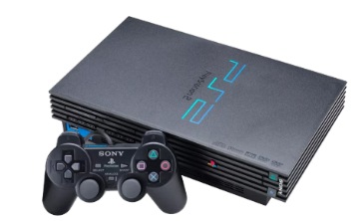
The list of games that came to the console are just as staggering: Grand Theft Auto: San Andreas, Ratchet and Clank, Star Wars: Battlefront II, Dark Cloud, Kingdom Hearts 2 – the list goes on and on.
Another aspect that the PS2 brought to the gaming world was online multiplayer. No longer were you restrained to playing with just those around you; now, you could play with anyone, anywhere in the world.

Xbox 360
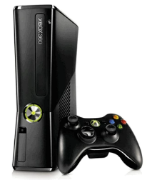
Released in 2005, the Xbox 360 took our gaming experience to the next level. Xbox Live was where the Xbox 360 truly shined; it offered an extremely robust online experience and the ability to download games digitally. Let’s just examine some of the key exclusive titles that came to the console: Crackdown, Gears of War 2, Halo 3, Fable 2 and Banjo-Kazooie – if that’s not enough to convince you of the influence the console had on the culture of gaming, nothing will.

PC

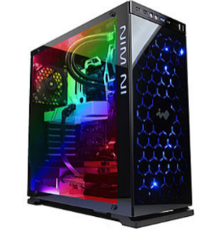
So, before any one come at us for placing this in a list of ‘consoles’, let’s explain this. PC gaming is huge, no one can doubt that – with platforms such as Steam and Origin, PC gaming has to be respected as one of the biggest communities of players. So we really need to justify why this is appearing on a list on consoles, right?
So, why are we classing it as a console? Well, in short it kind of is. Not in the same way as anything else on this list, but it is still a portal through which to play games. PCs can be viewed as a multimedia console, one that not only allows you to play games, but surf the web, create music, photography and much more.

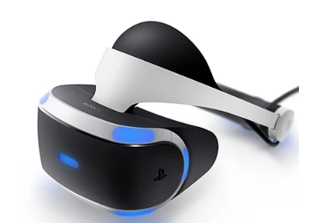
VR
Again, VR isn’t a console but it’s a piece of hardware that changes how we play and enjoy our gaming experiences.
These impressive pieces of hardware make you the controller. It turns our idea of gaming on its head – no longer are we watching our games through a TV screen, we are actually immersed into the worlds that game developers have created. It really is space-age stuff.
There’s some amazing worlds out there that we can now experience first-hand.

Nintendo Switch
Portable gaming isn’t anything new; we explored the popularity of that in our study on the Game Boy, however the Nintendo Switch takes portability and blows it out of the water.
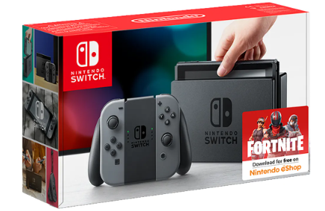
The Switch is both a home console as well as a handheld. You can literally play the game on your TV screen, pull the console out of its docking station and play on the game, effortlessly.
The Switch delivers an absolutely stunning gaming experience. Legend of Zelda: Breath of the Wild completely blew me away with its art style, and tempting storyline. If this is what we can expect from the Nintendo Switch in the future then this is guaranteed to be an instant classic.

Xbox One X
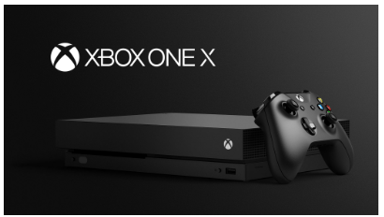
Now it’s time to look to the future, and what a future it is. The Xbox One X hasn’t even landed yet and it’s already creating massive shockwaves in the gaming world. Advertised as the most powerful games console ever, the Xbox One X will deliver some of the most beautiful visuals, gameplay and worlds to date.
There’s a whole list of games that it can play including the likes of Forza Horizon 7, Crackdown and Middle-earth: Shadow of War.

Task: The history of games consoles
You have read the history of games consoles. Now it’s your turn! Design the games console of the future!
Here are some ideas to think about:
- What does it look like?
- What special features does it have that make it different?
- What can players do with it that they can’t do with any other console?
- What games can it play?
- How will players use it?
Activity A
Draw a diagram of the console and label it clearly so that the features are clear. You can do it in your home-learning book. Don’t forget to send us picture!
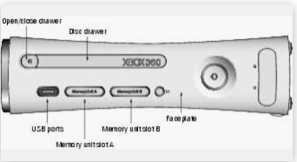
Here are some examples:
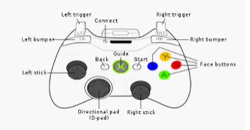
Activity B
Look at some adverts of games consoles over the years. Can you spot what makes each console unique?
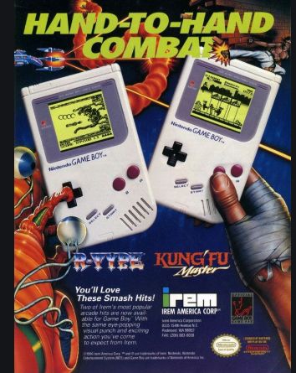

Now, design an advert for your console in your home-learning book. Remember to share some photos!
Now, design an advert for a games magazine to advertise your console.

Monday – Activity 4
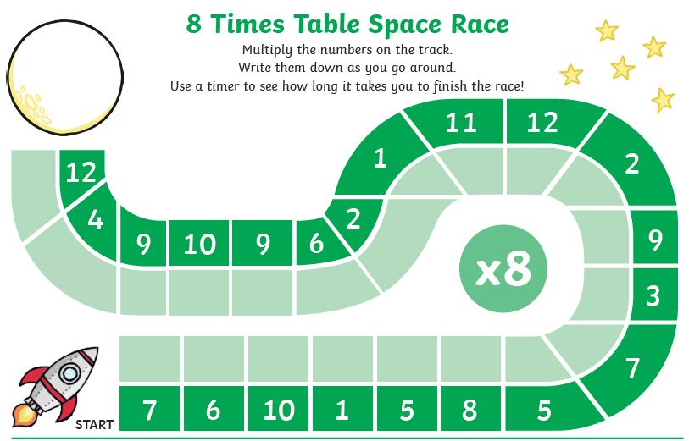
Tuesday – Activity 1 – Times tables
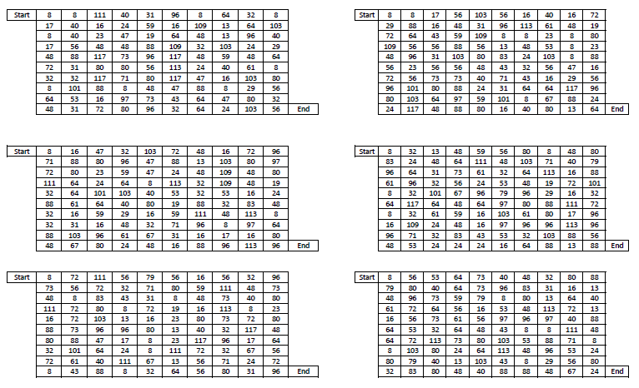
Colour in the 8 times table to find the pathway out of the maze.

Watch the video of Miss Thompson on google classroom and practise your 8 times table through gradually taking away multiples of the 8 times table. You could even make your own counting stick or number line at home!
You can also enjoy the following song: https://safeYouTube.net/w/Be8L
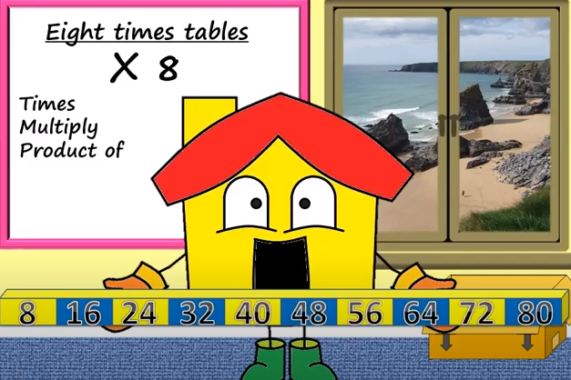
Then you can use the games online to practise:
https://mathsframe.co.uk/en/resources/resource/318/Tommys-Trek-Times-Tables
https://www.topmarks.co.uk/times-tables/coconut-multiples
https://www.topmarks.co.uk/maths-games/hit-the-button
You can also cut out the numbers below, mix them up and see if you can play ‘snap’ or match the calculation back up with the answer.
1 x 8 | 8
2 x 8 | 16
3 x 8 | 24
4 x 8 | 32
5 x 8 | 40
6 x 8 | 48
7 x 8 | 56
8 x 8 | 64
9 x 8 | 72
10 x 8 | 80

Tuesday – Activity 2 - How fashion trends have changed over the years
Trends change all the time, but nowadays you can keep up with the latest styles by watching TV or seeing what your favourite celebrities wear. However this hasn’t always been the case.
Fashion trends change so fast that sometimes it’s hard to keep up. But did you know that looking at old fashion trends can tell you a little bit of history from that time? Seeing what people wore can help you imagine what a place was like 30, 40 or even 100 years ago. Here’s how fashion has changed in the past century:
1920s
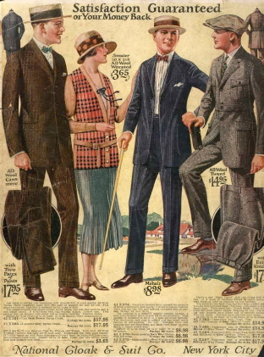
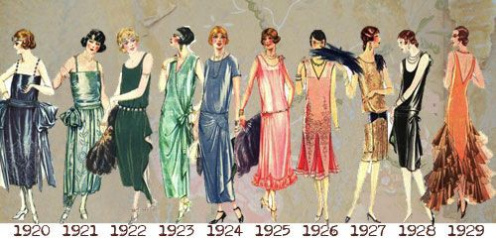
The 1920s were an exciting time in the United States and around the world. World War I was over, people had jobs and money, and women’s rights were changing. In 1919 in the US, women got the right to vote. Overall, people were feeling good, and this showed in the clothes that everyone was wearing. Women dressed in the “flapper” style. This included dresses with fringe, short haircuts, and bright makeup. Men wore suits, suspenders and bowler hats.

1950s
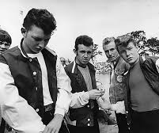
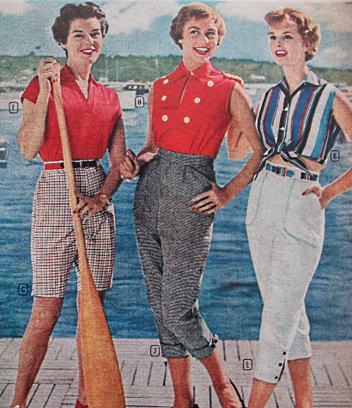
Just like in the 1920s, the style in the 1950s reflected people’s happiness after a war ended. World War II was over, and fashion changed as a result. During this time, women wore dresses that showed off their figure more. Hairstyles changed from the short bob of the 1920s, to a longer style with curls instead. For men, the 1950s brought the “greaser” style. This included men wearing jeans, a white T-shirt, and black leather jackets.

1970s
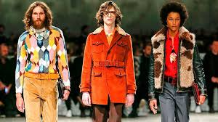
Groovy! The 1970s are known for a lot of activism and the “hippie” movement. Clothing during this time period was very colourful, and included tie-dye, bell-bottom pants, and mini-skirts. For the first time in a long time, both women and men had long hair. Men also started to have moustaches and beards again. The 1970s were all about music and good times, so people’s clothes reflected that.
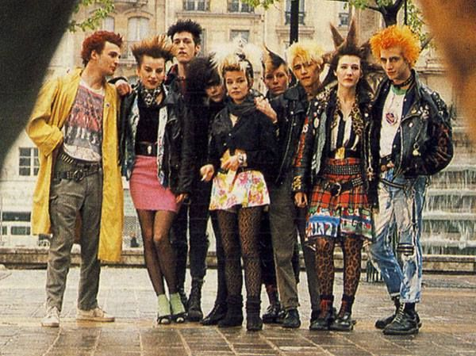
1980s
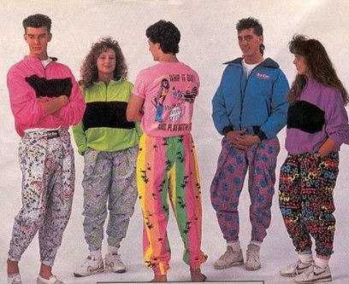
Style in the 1980s was influenced a lot by music. During this time punk rock, rap, and heavy metal music became very popular. Women’s hair and jewellery were big, and their makeup was bright with lots of colours. People involved in the punk rock world wore a lot of black clothing with heavy eyeliner. Both men and women wore a lot of fitness clothes; this included a lot of colourful tights.

1990s
The 1990s were more down-to-earth than the 70s or 80s. Women still had big hair, but makeup was more natural looking. Many people wore jeans and plain collared shirts along with Converse shoes, which became very popular. During this time, a lot of people also started to get more piercings than in other decades.

Present
Today, people dress based on many different influences. Some fashion choices are even based on looks from past decades, like the ones we talked about here. Trends change all the time, but you can keep up with the latest styles by watching TV or seeing what your favourite celebrities wear. Unless you like it your way. In that case, just wear whatever you feel like today!

Why not ask your family members to take a look at pictures of them from their youth.
What did they wear when they were growing up? How has their fashion changed?

Here are some extra links you might want to take a look at to discover the history of fashion.
https://www.vam.ac.uk/collections/fashion
https://safeYouTube.net/w/r0pL
https://safeYouTube.net/w/c1pL
https://safeYouTube.net/w/t1pL

Of course fashion has been around long before the 1900s. Take a look at the following page to see how fashion has changed over the centuries.
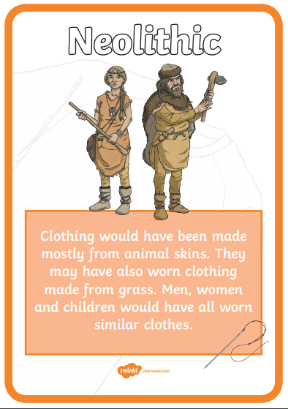
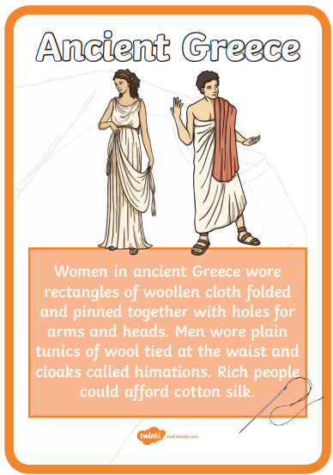
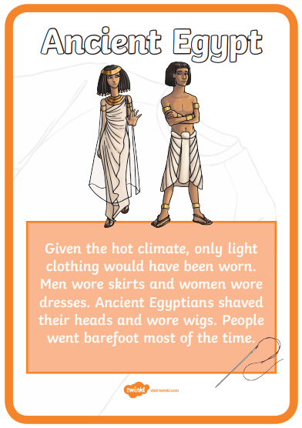
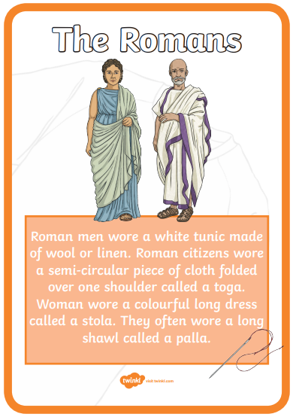
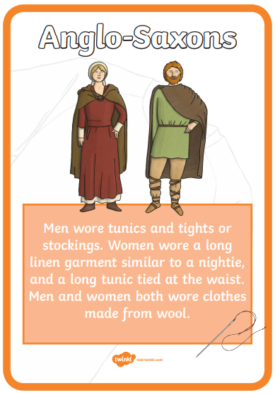
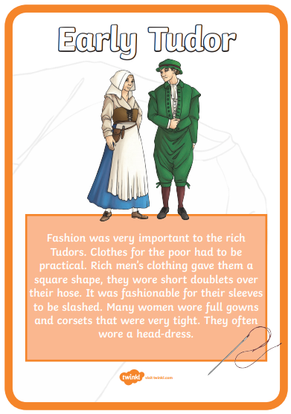
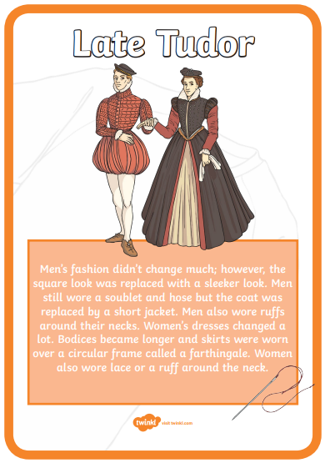
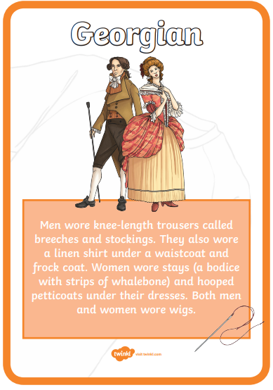
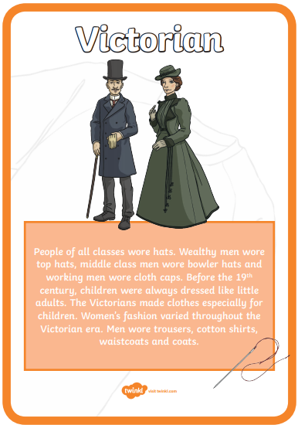

Tuesday Activity 3 – Defending the harbour – Changes throughout history
Not too far from Portsmouth, at the north end of Portsmouth Harbour, lies a place steeped in history – over 1,700 years to be precise. This place was a Roman fort, a Saxon stronghold, a royal castle and eventually a prison! Now it’s a popular tourist attraction, looked after by English Heritage. Can you guess where this place is?
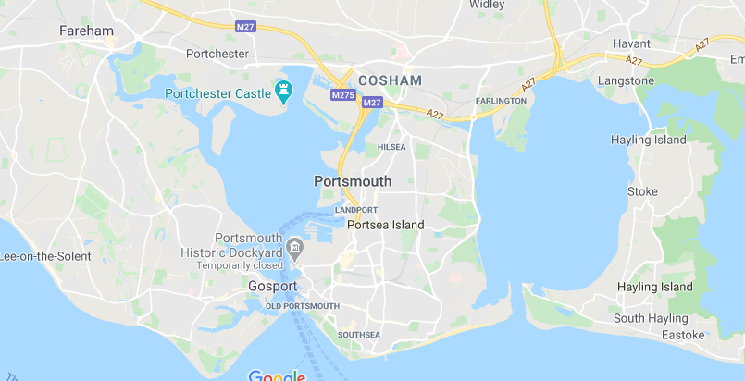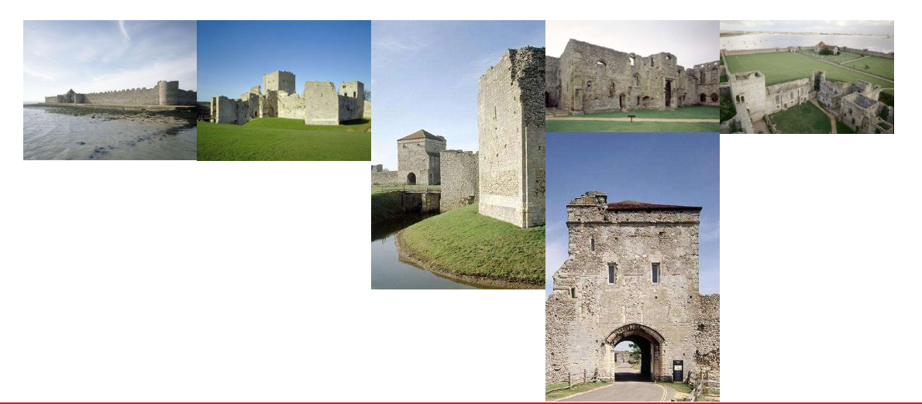
Portchester Castle is a place enjoyed by many but where is it and why is it there? Using the map above and/or Google Maps (https://www.google.co.uk/maps/@50.8100608,-1.0715533,11z ) find and label the following places on your map below using the numbers in the key

Key 1) Portsmouth, 2) Isle of Wight, 3) Portsmouth Harbour, 4) Portchester, 5) The Solent
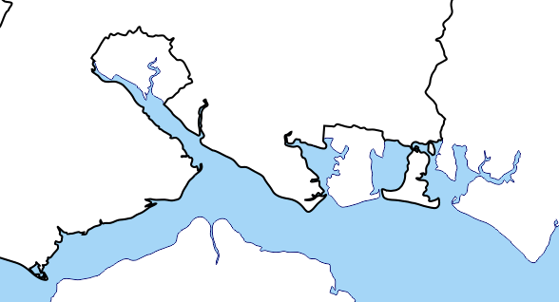
You could also use ‘Street View on Google Maps to explore the area yourself.

The castle was built, by the Romans, on a low-lying spit of land that sticks out into the natural harbour of Portsmouth. It was classed as ‘the perfect place to build a fortress’ to defend this stretch of water. Using the maps above, your knowledge of the local area and through discussions with the people you live with, think about why this was.
…………………………………………………………………………………………………………………………………………………………………………………………………………………………………………………………………………………………………………………………………………………………………………
……………………………………………………………………………………………………………………………………………………………………………………………………………………………………………………………………………………………………………………………………………………………………….
Questions to help you think: What is it close to? If you were an enemy ship sailing up Portsmouth Harbour, what would you see? Where else can you travel to from here? What was a popular mode of transport in the past that would use a location like this?
Let’s find out a little bit more about how this place has changed over time.
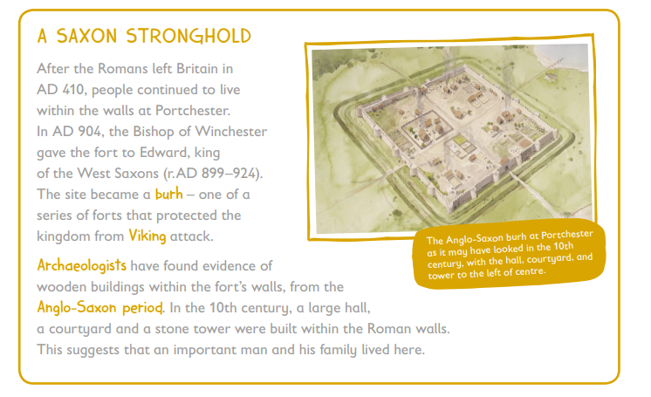
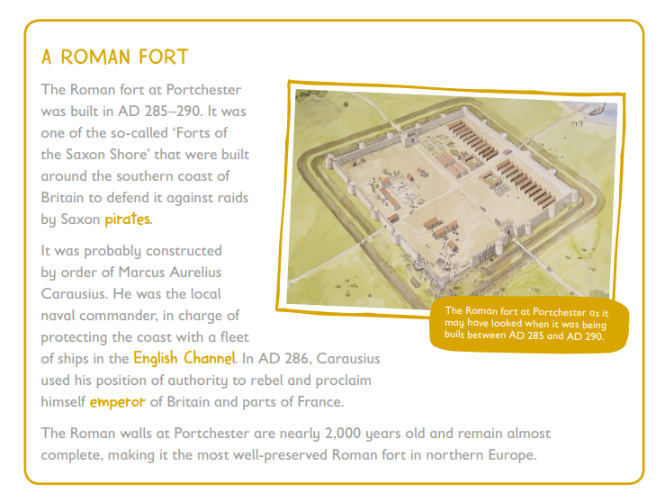

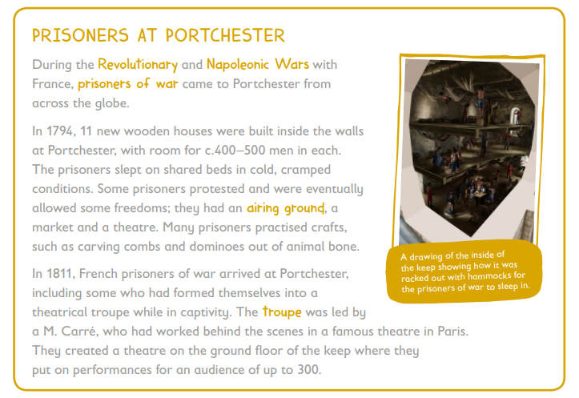
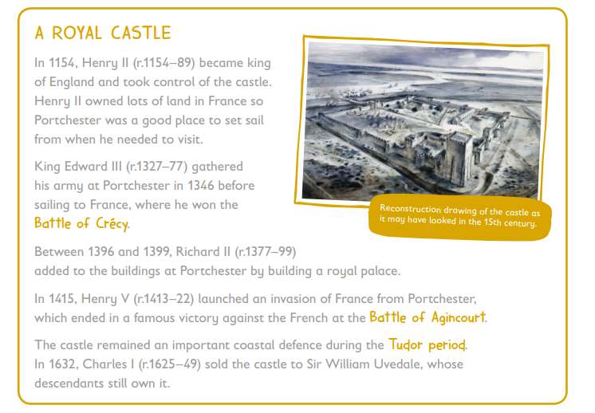
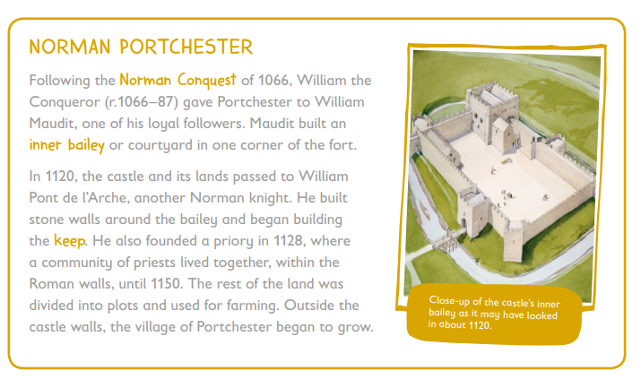
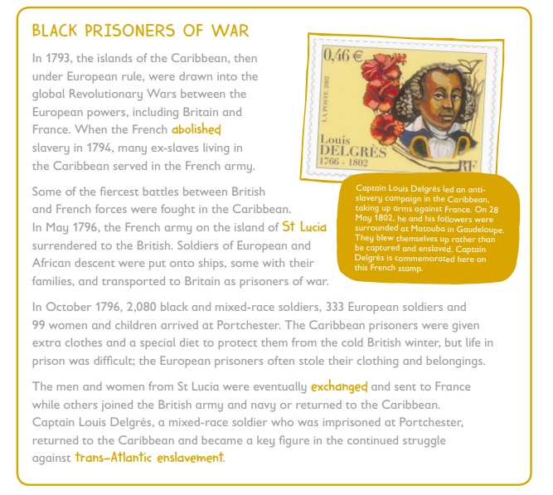

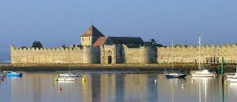
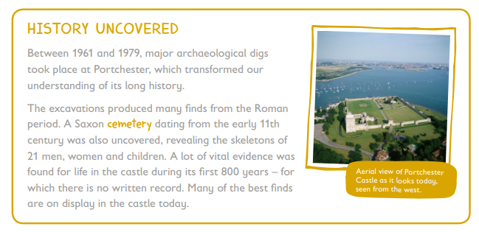
More information about Portchester castle and its fascinating history can be found here and there are more information packs/links available on Google Classroom: https://www.english-heritage.org.uk/visit/places/portchester-castle/history-and-stories/
There is also a timeline and further resources available here under ‘learning resource’ https://www.english-heritage.org.uk/visit/places/portchester-castle/schohttps://www.english-heritage.org.uk/visit/places/portchester-castle/schools/ols/
Thinking about everything you have learnt about Portchester Castle so far, what questions do you have? Use your skills as a Langstone Learner to find out more if you can. There are different links here that you can use or you can follow your own line of enquiry.
Taking the information that you learn, present this information in any way you want to. This could be a fact file, a paragraph of writing, a diary in role of someone who lived during one of the important historical periods, a PowerPoint or Google Slides, a letter to someone describing the building of the castle or your time there as a prisoner. The choice is yours!
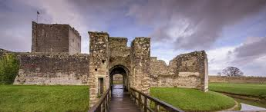
Why not take a safe, socially distanced trip over to Portchester Castle if you can. You can visit the grounds and in August, English Heritage hope to be able to re-open the Saxon part of the castle with the keep. There is a cost for this but the grounds are free to visit and explore. On Google Classroom we have attached an activity pack you may want to use if you visit.
You can also take a virtual tour and find out more by clicking this link: https://artsandculture.google.com/u/0/exhibit/portchester-castle-from-roman-fort-to-prisoner-of-war-depot/EAIy0_hNEznxLA

Tuesday Activity 4 - Design Time
Now that you have found out how fashion has changed throughout the last century as well as how clothing has changed throughout past centuries, it is your turn to get creative.
Your task is to design your own male or female outfit based on one of the eras you have read about. Remember fashion can take inspiration from one era and transform it into a new fashion. There are no rules.

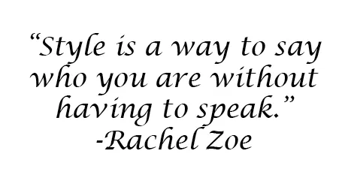

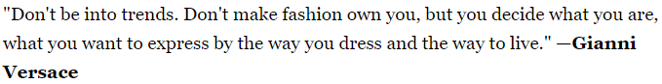

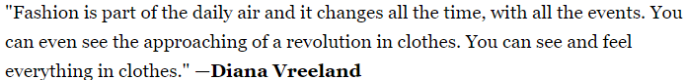

Wednesday – Activity 1
The Timeline of English Language
Language is always changing. ... Language also varies across time. Generation by generation, pronunciations (how we say words) evolve, new words are borrowed or invented, the meaning of old words change or disappear.
Task:
Read the information about each period of time carefully and order the boxes. You can cut them out, number them or write the order in your home learning book. The first one is ‘The Celts and the last one is ‘Modern Language until 2000 AD.
Once you have ordered them, draw a timeline in your book and summarise the main points of the changes in English language like this:

The Timeline of English Language

600 BC
Celts
They spoke the first languages on The British Isles like: Welsh and Gaelic.
Words: Corgi (little dog) and Whisky (water of life)

Modern English
Have been influenced by MANY different languages and is still changing and developing by us!

2000

Wednesday Activity 2
How did the meanings of words change over time?
Link the ‘olden time meaning’ to the modern word.
Modern Word | What it meant long ago
- nice | - a ball of yarn
- silly | - have nothing
- clue | - feeling fearful
- naughty | - blessed
- eerie | - flicking
- spinster (an unmarried woman) | - foolish
- bachelor | - someone who spins
- flirt | - a frightful figure
- guy | - solid food
- meat | - a young knight

(The answers are on the last page.)
Now that you are aware that the meaning of words have changed over time, you can add to the timeline of activity one.
Some words have gained another meaning like surf:
– surf the internet … only used to mean- surf the waves

and
web (the world wide web) only used to mean- a spider’s web).

We have also created new words that never existed like:
selfie and emoji
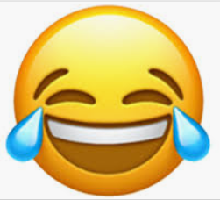

Task:
Talk to members of your family or a partner (if you are at school) and list some new words that either gained another meaning (like surf and web) or were newly created (like selfie and emoji) and explain how they came to be a new word. How many can you find?
Now, create another box to add to the timeline and explain how words changed since the year 2000.

Timeline of
English Language …
Modern English continues…

2020

Answers to: ‘How did the meanings of words change over time?’

- Nice: This word used to mean “silly, foolish, simple.” Far from the compliment it is today!
- Silly: Meanwhile, silly went in the opposite direction: in its earliest uses, it referred to things worthy or blessed; from there it came to refer to the weak and vulnerable, and more recently to those who are foolish.
- Clue: Centuries ago, a clue (or clew) was a ball of yarn.
- Naughty: Long ago, if you were naughty, you had naught or nothing. Then it came to mean evil or immoral, and now you are just badly behaved.
- Eerie: Before the word eerie described things that cause fear, it used to describe people feeling fear — as in one could feel faint and eerie.
- Spinster: As it sounds, spinsters used to be women who spun before it came to mean “unmarried woman.
- Bachelor: A bachelor was a young knight before the word came to refer to someone who had achieved the lowest degree at a university. It has also been used for unmarried men.
- Flirt: Some 500 years ago, flirting was flicking something away or flicking open a fan. Now it involves playing with people’s emotions.
- Guy: It comes from the name of Guy Fawkes, who was part of a failed attempt to blow up Parliament in 1605. Folks used to burn an image of him, a “Guy Fawkes” or a “guy,” and from there it came to refer to a frightful figure. Later, it has come to refer to men in general.
- Meat: Have you ever wondered about the expression “meat and drink”? It comes from an older meaning of the word meat that refers to food in general — solid food of a variety of kinds (not just animal flesh).

Wednesday Activity 3- The changing of cars over time.
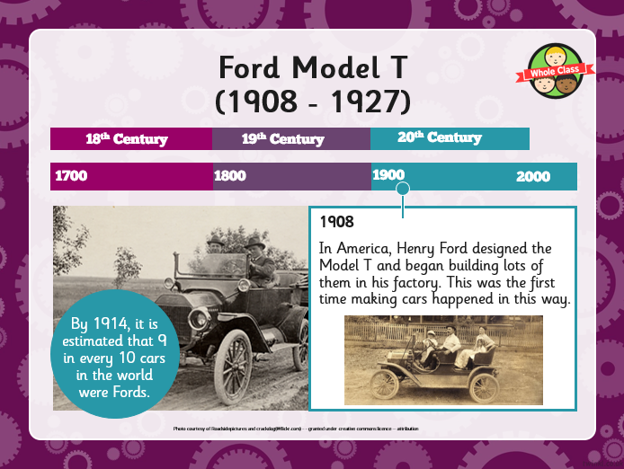
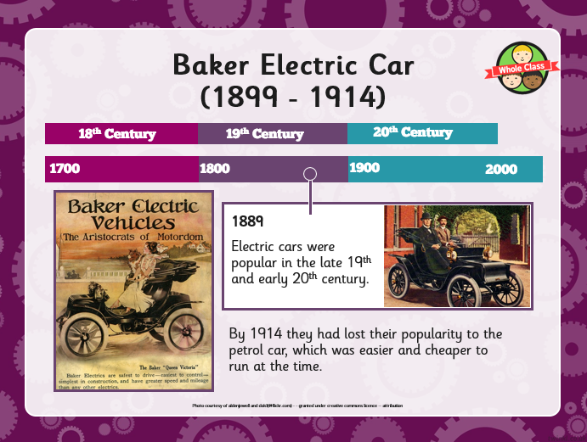
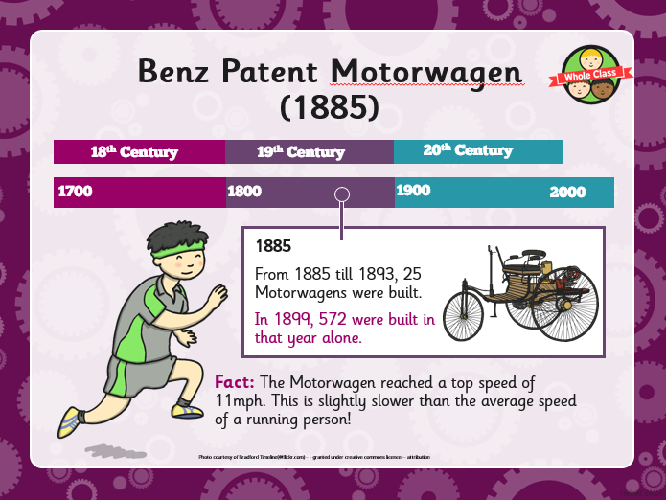
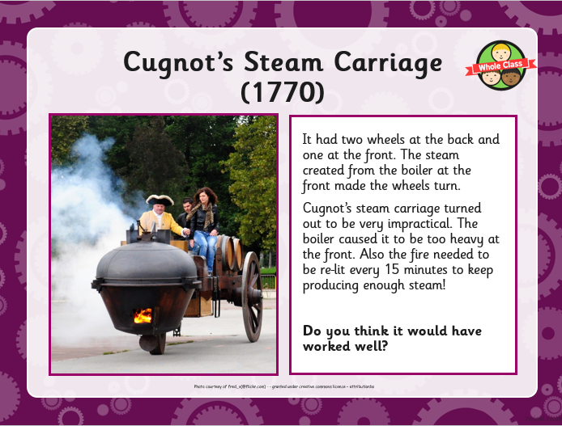
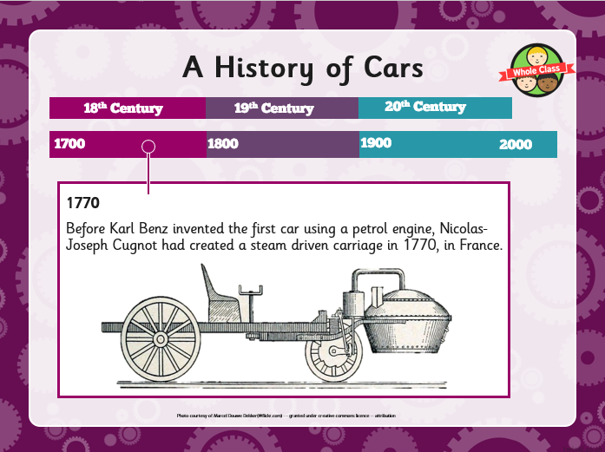
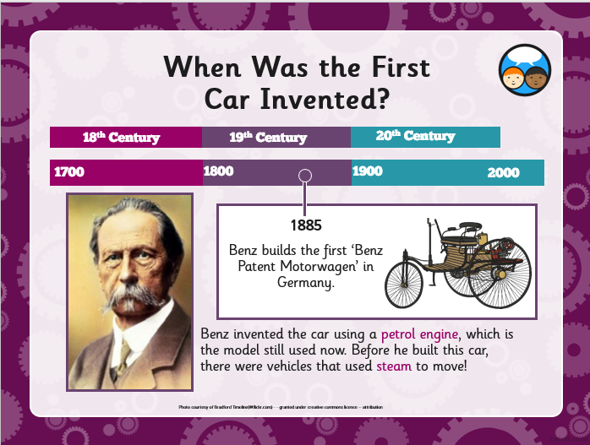
Activity 3a: Find out how cars have changed since they were invented.

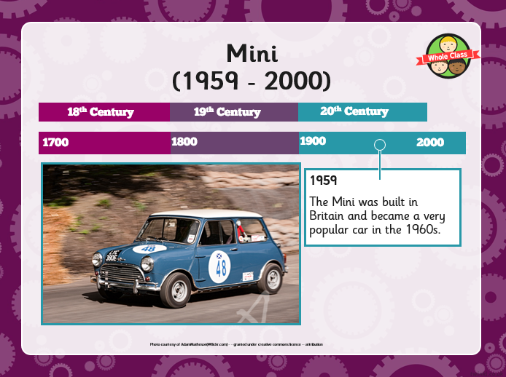
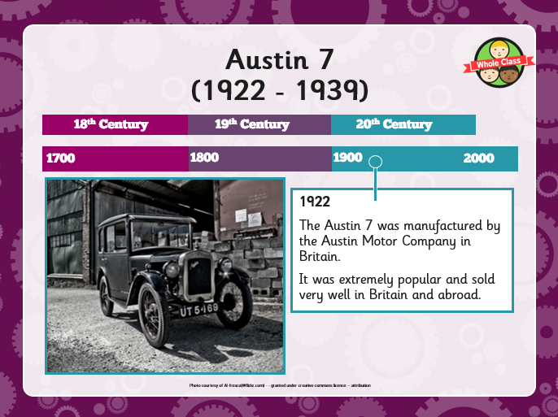
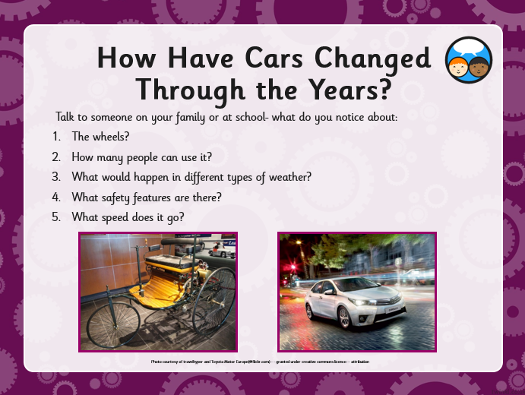
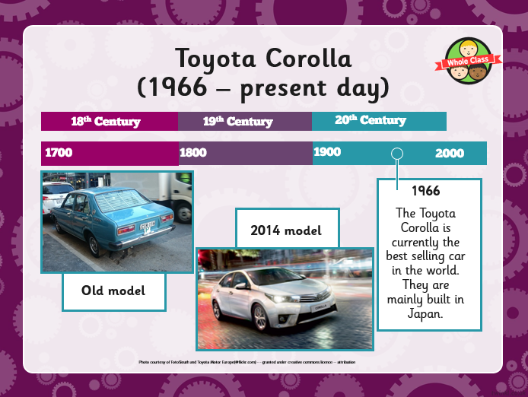
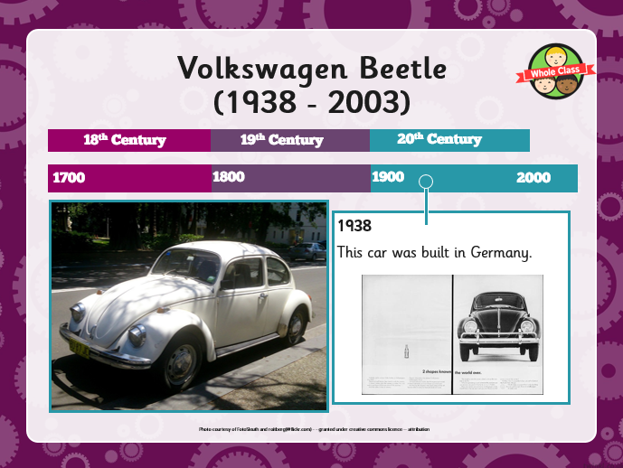

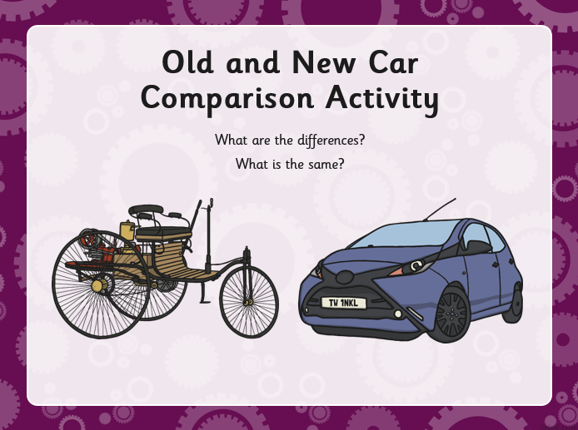

Complete the labelling activity below then use your diagram to explain how the first car invented is different from modern day cars (You can use activity sheet provided or do it in your home-learning book)
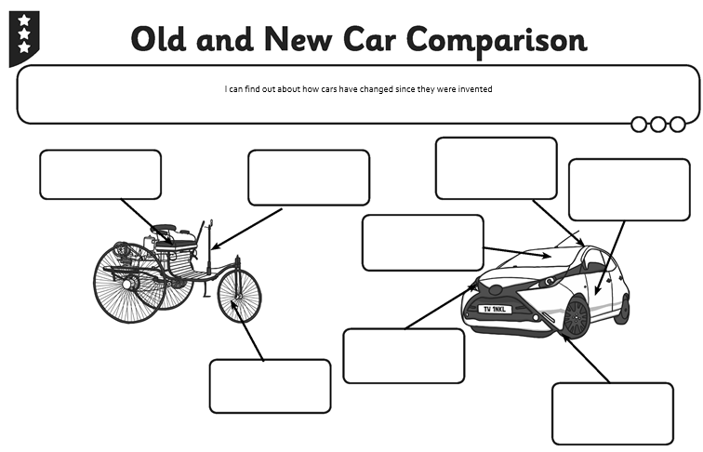

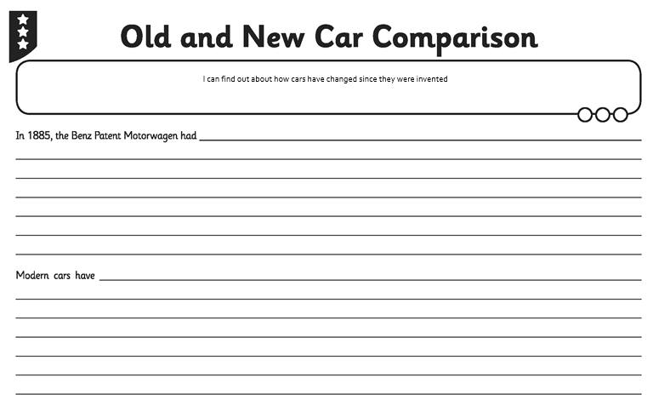

Wednesday Activity 3 - Changing in the number of cars in the UK -Year 3/4
We have been looking at changes in the development of cars in activity 3A. But the amount of cars on UK roads have also changed. Look carefully at the graph showing how the number of licenced cars in the UK changed between 2000 and 2018 then answer the questions by underlining the correct answer.
A graph to show the number (in millions) of licenced cars in the UK.
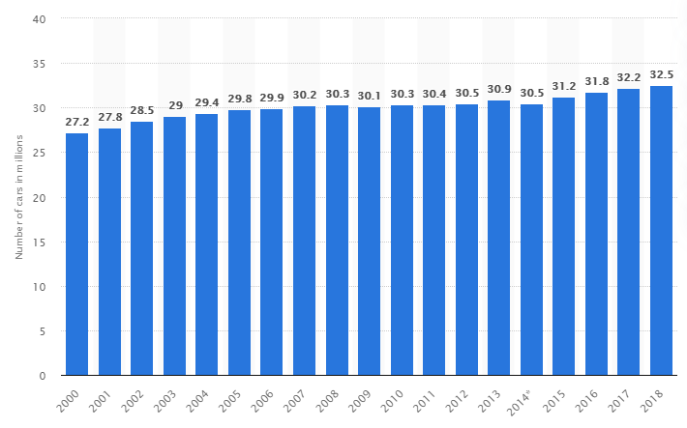

- In which year was there the lowest number of cars in the UK?
- 2000 b. 2006 c. 2014 d. 2018
- When was the highest number of cars in the UK? a. 2000 b. 2006 c. 2014 d. 2018
- The number of cars mostly ____________ over time.
a. increased (went up) b. decreased (went down) c. stayed the same.
- This happened because _____________.
- more cars were stolen b. more people bought cars c. there were more accidents
- In which years were there the same number of cars in the UK?
- 2000 and 2006 b.2005 and 2010 c. 2009 and 2018 d. 2012 and 2014
- How many more cars were there in 2001 than in 2000?
- 0.2 million b. 0.4 million c. 0.6 million d. 0.8 million
- How many less cars were there in 2000 than in 2018?
- 0.3 million b. 2.8 million c. 5.3 million d. 6.1 million
- In __________________ the number of cars decreased (went down)?
- 2006 b. 2008 c.2012 d. 2014
- The reason for this is:
- Many people lost their jobs b. cars became very cheap c. many people were paid lots more money.
- In 2006, there were 29.9 million cars in the UK. Rounded to the nearest million, it is: a. 28 million b. 29 million c. 30 million

Wednesday Activity 3 - Changing in the number of cars in the UK- Answers
- a. 2000
- d. 2018
- a. increased (went up)
- b. more people bought cars
- d. 2012 and 2014
- c. 0.6 million
- c. 5.3 million
- d. 2014
- a. many people lost their jobs
- c. 30 million

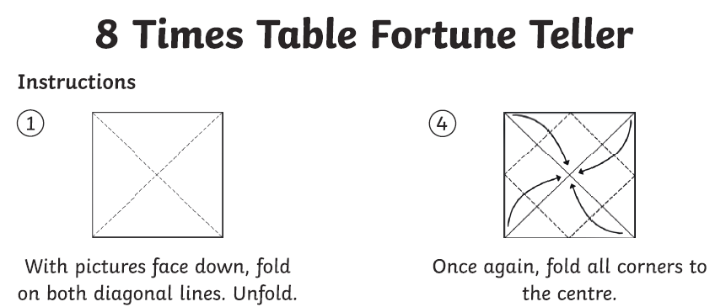
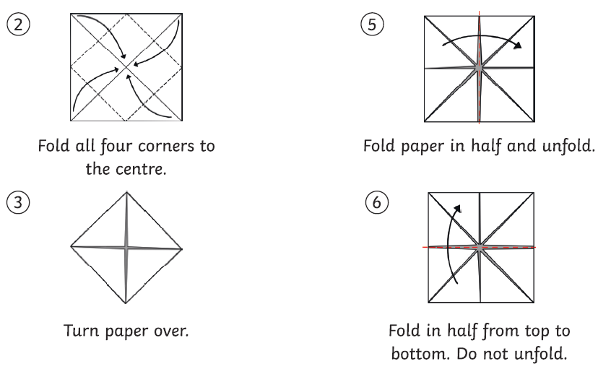
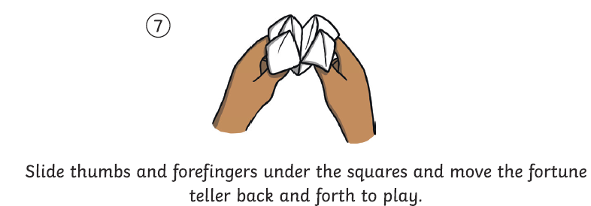
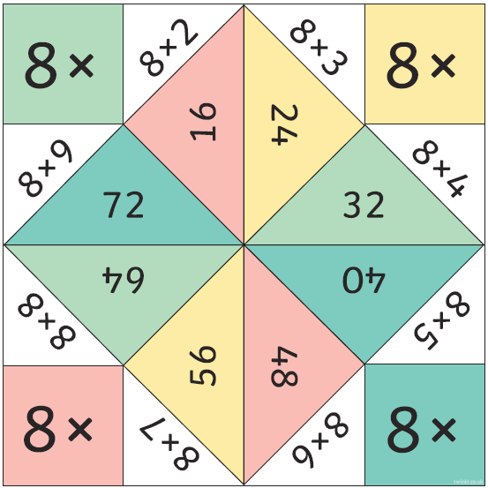

Thursday - Activity 1 – Alexander Graham Bell

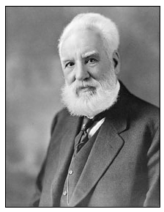
Today, you will be learning all about a famous scientist and inventor called Alexander Graham Bell.
As a boy, Bell was fascinated by sound; he grew up with a mother who was almost deaf, and a father who helped deaf people to speak.
He and his brother came up with a machine that could (almost) replicate the human voice.
When he was asked to work on ways to improve the telegraph machine, Bell hit upon another idea.
He thought that rather than sending a code along an electrical wire, it might be possible to send the actual sound of a human voice along a wire.
With the help of a man called Watson they built a device that just might work.
An accident proved him right, and the telephone was born.

Watch the video below to find out more about Alexander Graham Bell and his discoveries.
https://www.bbc.co.uk/teach/class-clips-video/true-stories-alexander-graham-bell/zf7gd6f
From watching the video, note down 3 things that you have learnt about Bell and the invention of the telephone.
- _____________________________________________________________________
_____________________________________________________________________
2) _____________________________________________________________________
_____________________________________________________________________
- _____________________________________________________________________
_________________________________________________________________

Read the information below and then use it to answer the quiz on google classroom.
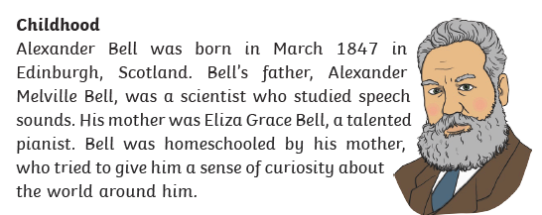
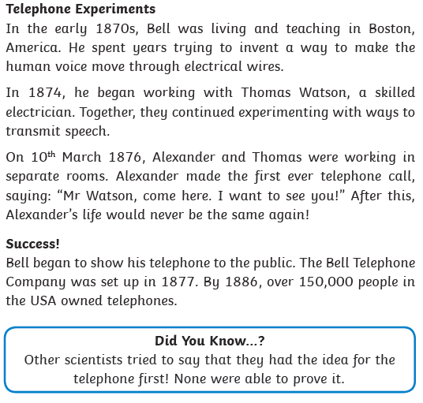

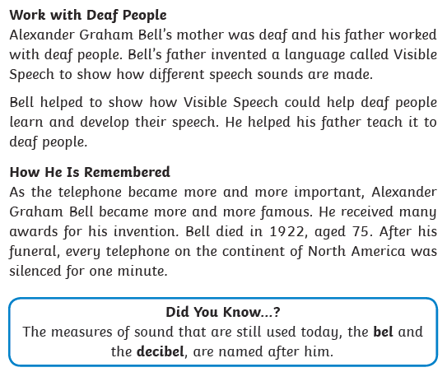

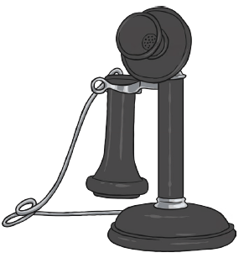

If you would like to find out more about Alexander Graham Bell, click on the links below.
https://www.sciencekids.co.nz/sciencefacts/scientists/alexandergrahambell.html
https://lemelson.mit.edu/resources/alexander-graham-bell
Now have a go at creating your own telephone.
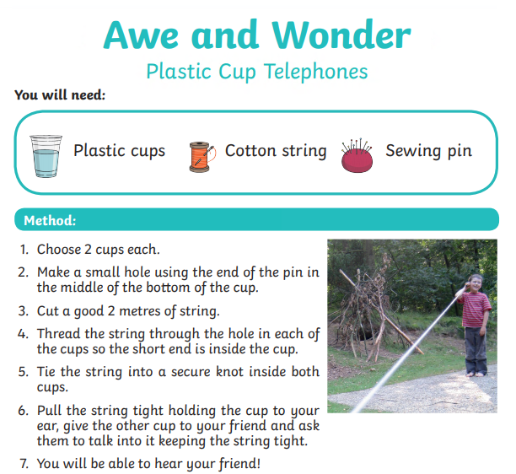
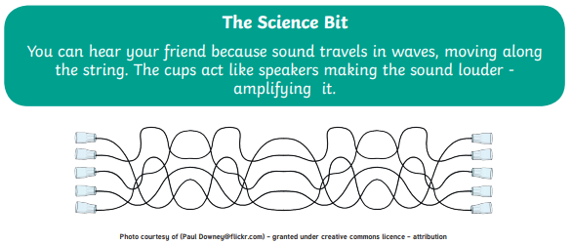

Thursday – Activity 2 – The history of the telephone
We have now found out who invented the telephone so let’s have a look at how that invention has changed over the years.
Read the information below to find out more about how phones have changed over time.
The beginning
Alexander Graham Bell was the one who invented “talking through wires”. The words which he first spoke on the phone were addressed to his assistant Mr Watson “Mr. Watson–come here–I want to see you.”
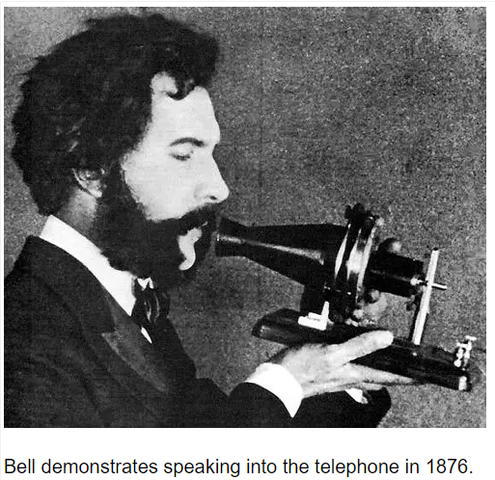
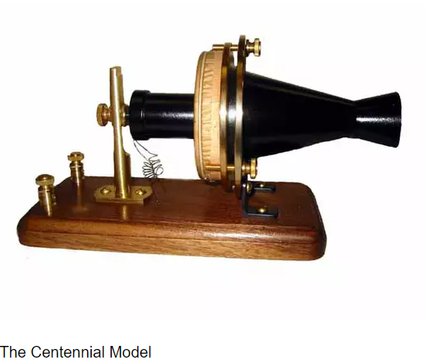
The Centennial Model is so labelled because it was first demonstrated on June 25, 1876 at the Centennial Exhibition in Philadelphia. Bell said to the public that he would show them “something which would speak”.

Telephones in the early 1900s
With the onset of the century, the telephones saw many changes in their basic design and functions. The technology was improving and it reflected directly on telephones as well.
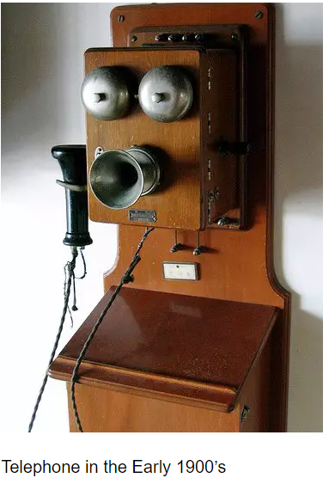
Here is a picture of one of the telephones in the beginning of the 20th century.
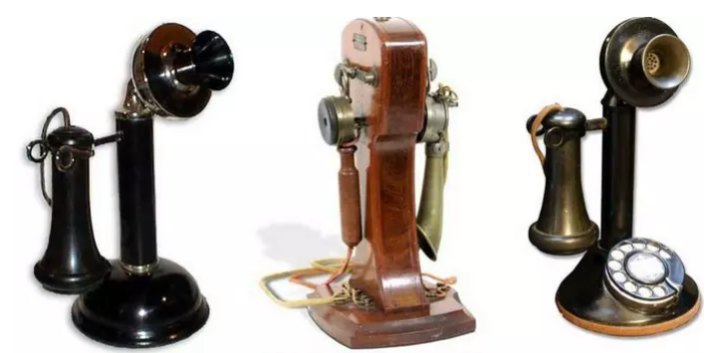

These phones marked the era of the “real” phones, the ones people can associate with today. You must have seen these phones in old movies.
Desk Stands, often called “candlestick” telephones, were the first desk telephones manufactured by Western Electric. The desk stands that were built before the turn of the 20th Century were extremely ornate and are today worth many thousands of dollars.
Telephones from 1950
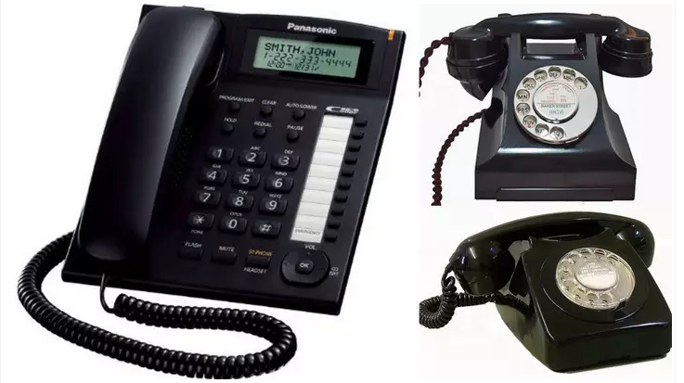
The technology improved further giving way to the telephones we use today. The design of telephones went under a major overhaul to become sleek and stylish.

Rise of mobile phones
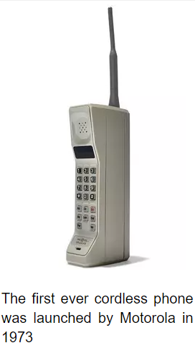
Now that the traditional telephone had developed quite a bit, the idea of “mobile” phones came up. A lot of mobile phone models were made, but the first one which came in the limelight in 1973 was launched by Motorola.
Martin Cooper made the first handheld cellular phone call in public. Walking down the streets of New York, Cooper – the General Manager of Motorola’s communication system division – talked on the phone. The phone is also known as the “Brick” cell phone.

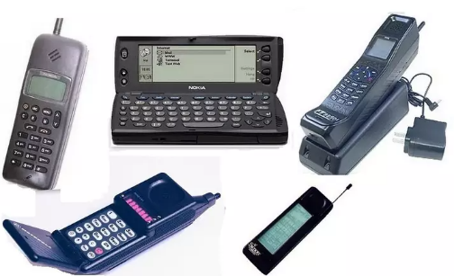
As we entered the millennium, a few companies which manufactured mobile phones, had come to the foreground and the competition to make the best portable calling device was on.

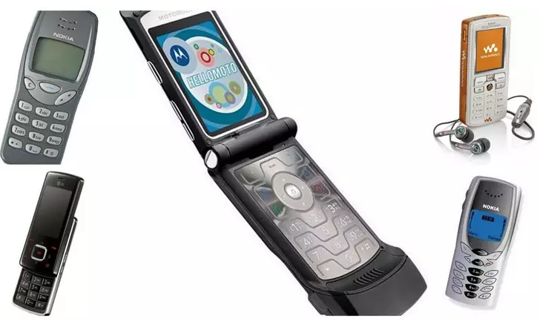
After 2000, mobile phones became cheaper and thus became more easily available to the general public. Although they still were not very common, possessing a mobile phone was no longer a very big deal for people. It was, however, still considered an item of luxury.

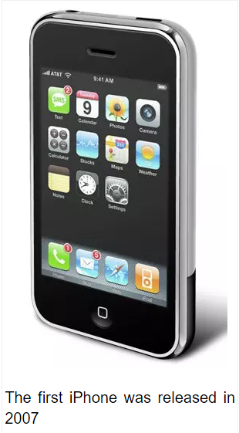
Let the Smart Phone take over
Although the first touchscreen phone was invented in 1992 by IBM, it was the first iPhone which changed the way we used touchscreen mobile phones. It was introduced in the United States on June 29, 2007. It featured quad-band GSM cellular connectivity with GPRS and EDGE support for data transfer.

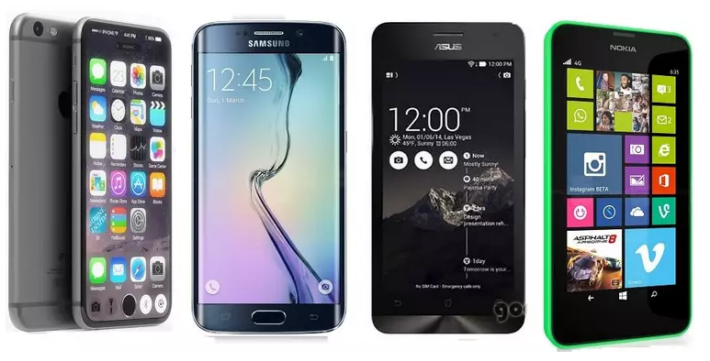
And since then, there has been no stopping the tremendous growth. The number of manufacturers kept growing and so did the mobile phones. This was a period of a tremendous boom in the market of mobile phones.
Today, a phone is no longer a phone! Now you can do almost anything imaginable, by today’s standards, just by tapping your phone a couple of times.

Future calling
There are a number of features which we can expect from the smart phones which will be launched in the future. Augmented Reality is one such feature. It makes available more information for us users by combining computer data to what we see in real life. Flexible screens will also look a lot cooler.
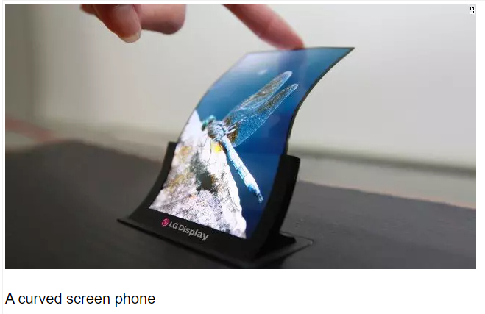
In fact, LG has already announced a flexible, curved smartphone screen. Its first devices to use the new 6-inch OLED screens will be available next year.

Use the information you have read, and your own research, to create a timeline of the changes to telephones since they were first invented. You could cut out and order the pictures below or draw your own.

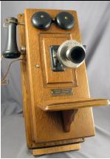 |  | 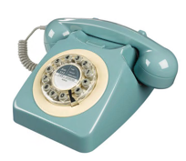
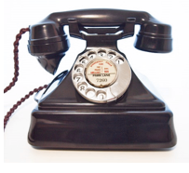 |  | 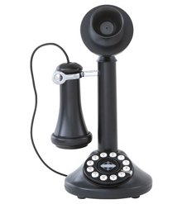
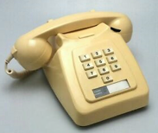 |  | 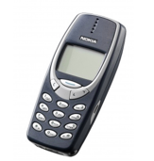

A timeline to show the changes to the telephone since it was first invented

Thursday – Activity 3 – Change Reflection
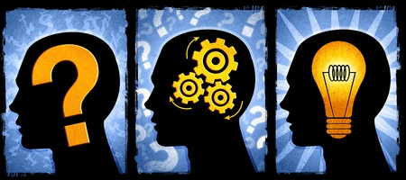
What does your learning this week tell you about change?
Do you think changes that happened years ago are important to you today?
How does change affect what goes on in the world around you?
Can you link your knowledge of changes within history to other aspects of change?
How does this build upon change from last week?

………………………………………………………………………………………………………………………………………………………………………………………………………………………………………………………………………………………………………………………………………………………………………………………………………………………………………
…………………………………………………………………………………………………………………………………………………………………………………………………………………………………………………………………………………………………………………………………………………………………………………………………………………………………………
…………………………………………………………………………………………………………………………………………………………………………………………………………………………………………………………………………………………………………………………………………………………………………………………………………………………………………
…………………………………………………………………………………………………………………………………………………………………………………………………………………………………………………………………………………………………………………………………………………………………………………………………………………………………………
…………………………………………………………………………………………………………………………………………………………………………………………………………………………………………………………………………………………………………………………………………………………………………………………………………………………………………
………………………………………………………………………………………………………………………………………………………………………………………………………………………………………………………………………………………………………………………………………………………………………………………………………………………………………
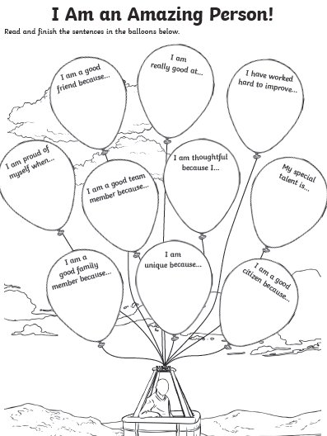

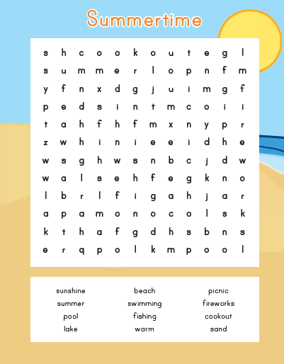

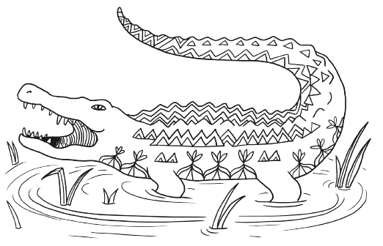

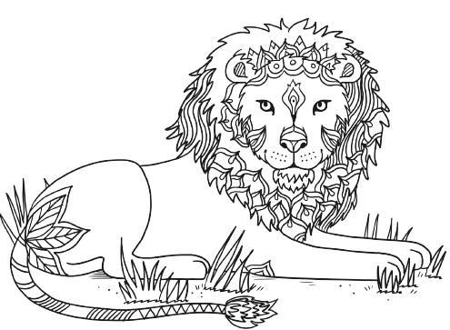
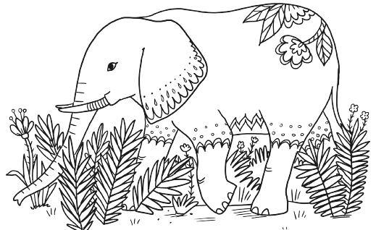

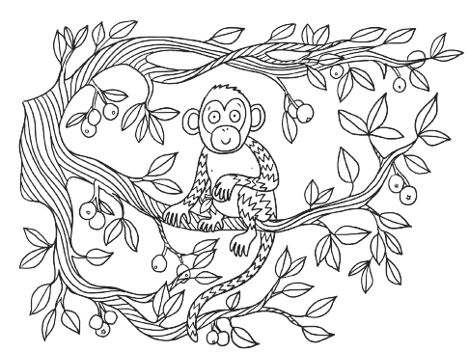
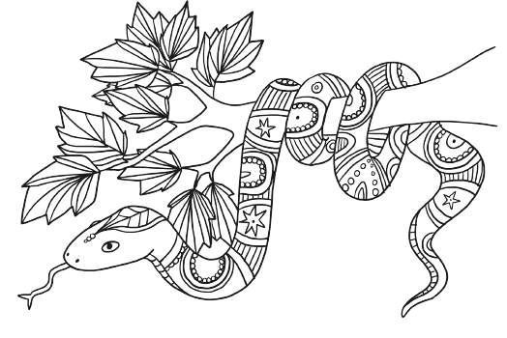

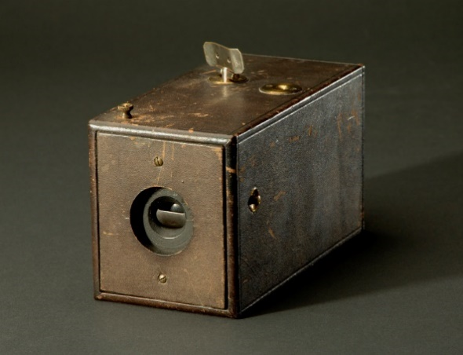
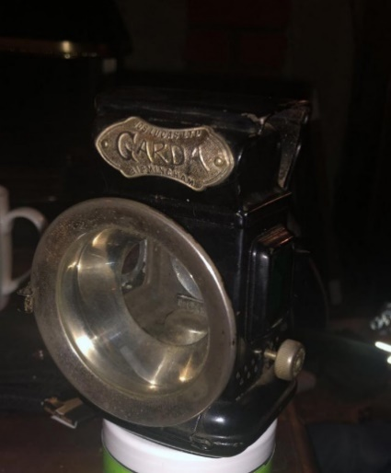

Hat stretcher
Bike Lamp

Camera

Dental tool Pager

Floppy Disc

