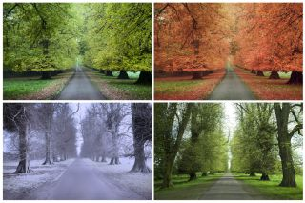
Year 5 - Home Learning Tasks
WB: 08.06.20
Our theme for this half term will be the concept of change.
This week we would like you to consider how the seasons change and what this change can look like for us.
 | Activity 1 | Activity 2 | Activity 3 | Fun Time!
Monday | Introduction  Following on the theme of change from last week, find out all about why we have seasons and how the seasons change in Britain! | Science + Geography  We learnt in the previous activity that Britain has 4 very distinct seasons throughout the year. However, is this true for all countries around the world? | Art  Create a piece of art that depicts the four seasons. Reflect on what the physical changes look like for each season? What images would you use to represent each season? What colours would you use and why? | Word Search for the Seasons  Create your own word search for another family to complete all about your chosen season! A blank template can be found below.
Tuesday | Maths - Winter  Snowflake symmetry  See if you can make a snowflake that has 6 lines of symmetry. Can you complete the challenge? | Gratitude – Autumn (Harvest)  How many fruits and vegetables can you name and how many do you think are grown in Britain? This is a very thankful time of year. Therefore, reflect on the things/people you are thankful for in your life. | Spring – Action  Each season, brings with it a different set of personality traits in us. After winter, spring is all about action and setting ourselves goals. | Be a Nature Detective  Leaves are changing all the time in colour and when they came out in the seasons. With daily walks being very important for our health,, see if you can identify any of the leaves on your way!  A detective ID sheet can be found below.
Wednesday | Reading- Summer  Examine some Haiku poems about the seasons. Answer some questions about what makes them so special and discover the rules for writing your own one! | Day Explorer  The Day Explorer  Look at the photos and the different parts of the text. What in the world is changing? What can we do to help?  What do you think? | Music  Create your own piece of music that reflects a season to you.What sounds would be best to replicate that season? How do you want your listener to feel when they hear it? | Pressing Flowers  With each season, bring a new variety of life to be found outside. When walking, why not collect some flowers and try your hand at pressing them?  Instructions can be found below.
Thursday | Writing - Summer  Following on from the rules you learnt about Haiku’s yesterday, try writing your very own Haiku for the season of Summer! | Philosophy for Children  Watch the video stimulus and then consider this statement: It’s impossible to change the world.  To what extend to do you agree or disagree?  There are some questions and a ‘word flower’ to help you. | Outcome - Reflection  Reflect on your learning this week:  What do you think change is?  Can you link your thinking to the learning you have done this week?  Reflecting on how your mood changes with the seasons. How do these seasons make you feel? Consider the positives and negatives of seasonal change.  Write responses on our year group Google Doc. | Outdoor Exercise  Exercise does not always have to be completed in the home or at school. Your wellbeing can actually be improved by getting outside, getting fresh air and exercising. Take some of the exercises attached below and try completing them in a garden or a local park!
Friday | Catch up and Chill – Today is the day to take part in any of the activities above if you hadn’t had a chance yet. Instead, you may have some ideas of your own! No matter what you choose to do today, make sure you relax and take some time for you!
These are the details and links to some of the activities posted on Google Classroom this week. Where possible, below you will find the task sheets which will explain the activities in more detail. If you experience any problems, please contact your child’s class teacher via email.

Monday – Activity 1 – Introduction – Why do we have seasons and how do the seasons change in Britain?

Find out about why we have seasons and how the seasons change.

Read the information below and watch the video links. You can then access a quiz on Google Classroom to test your knowledge if you want to.
Why do we have seasons?
Link 1 -https://www.bbc.co.uk/programmes/p04wf449
Link 2 - https://www.youtube.com/watch?v=b25g4nZTHvM

We divide up the year into four seasons: spring, summer, autumn, and winter. Each season lasts 3 months with summer being the warmest season, winter being the coldest, and spring and autumn lying in between.

The seasons have a lot of impact on what happens on the earth. In the spring, animals are born and plants come back to life. Summer is hot and is when kids are usually out of school and we take vacations to the beach. Often crops are harvested at the end of the summer. In autumn the leaves change colors and fall off the trees and school starts again. Winter is cold and it snows in many places. Some animals, like bears, hibernate in the winter while other animals, like birds, migrate to warmer climates.

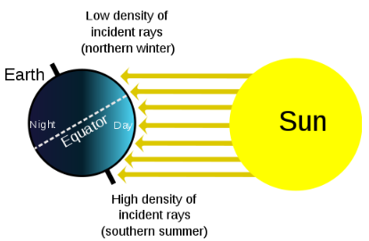
Why do seasons occur?

Seasons are caused because of the Earth's changing relationship to the Sun. The Earth travels around the Sun, called an orbit, once a year or every 365 days. As the Earth orbits the Sun, the amount of sunlight each location on the planet gets every day changes slightly. This change causes the seasons.

The Earth is Tilted

Not only does the Earth revolve around the Sun every year, but the Earth rotates on its axis every 24 hours. This is what we call a day. However, the Earth doesn't rotate in a straight up and down manner relative to the Sun. It is slightly tilted. In scientific terms, the Earth is tilted 23.5 degrees from its orbital plane with the Sun.

Why does our tilt matter?

The tilt has two major effects: the angle of the Sun to the earth and length of the days. For half of the year the Earth is tilted such that the North Pole is more pointed towards the Sun. For the other half the South Pole is pointed at the Sun. When the North Pole is angled toward the Sun, the days on the northern part of the planet (north of the equator) get more sunlight or longer days and shorter nights. With longer days the northern hemisphere heats up and gets summer. As the year progresses, the Earth's tilt changes to where the North Pole is pointing away from the Sun producing winter.

For this reason, seasons north of the Equator are the opposite of seasons south of the Equator. When it's winter in Europe and the United States, it will be summer in Brazil and Australia.

We talked about the length of the day changing, but the angle of the Sun changes as well. In summer the sunlight shines more directly on the earth giving more energy to the Earth's surface and heating it up. During the winter the sunlight hits the Earth at an angle. This gives less energy and doesn't heat the Earth as much.

Longest and Shortest Days

In the Northern Hemisphere the longest day is on June 21st while the longest night is on December 21st. It's just the opposite in the Southern Hemisphere where the longest day is December 21st and the longest night is June 21st. There are two days a year where the day and night is exactly the same. These are September 22nd and March 21st.

How do the seasons change in Britain?
Link 1 - https://www.youtube.com/watch?v=VYpGBtR8Lbs
Link 2 - https://www.bbc.co.uk/bitesize/topics/zkvv4wx/articles/zcx3gk7

The year of the Earth is divided into four seasons. There are four seasons in a year, which are summer, autumn, winter, and spring. The seasons cause significant changes in the weather and our environment. The summer is hot and the winter is cold. Leaves change their colour to pale yellow in the autumn.
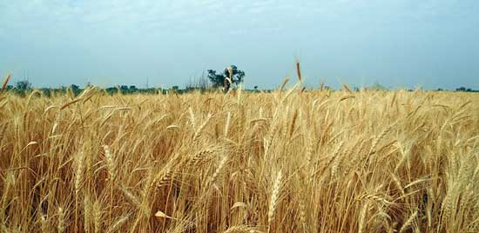
Summer
Summer is hottest among the four seasons. In this seasons, the days are longer than the nights. When summer arrives in the southern hemisphere, then it is winter in the northern hemisphere. Many crops, like wheat, are harvested near the summer end.
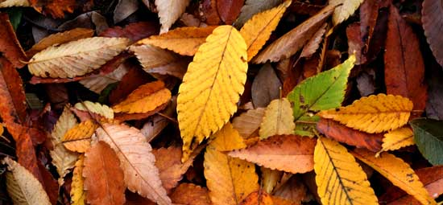
Autumn
Autumn is the conversion period between the summer and the winter. This season arrives as the summer ends. In this season the temperature starts to drop until winter arrives. Leaves of the trees fall and change their colour to pale yellow.
Winter
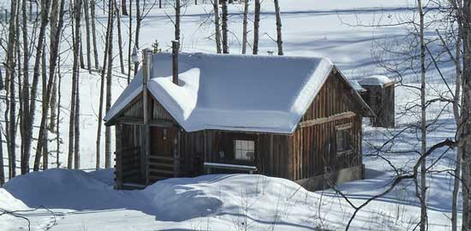
Winter is the coldest season. It snows in many places during the winter. We change our lifestyle to live comfortably in winter. We try to insulate our bodies with coats to keep our bodies warm. Many people enjoy drinking coffee in the winter. The nights of the winter are longer than a day. Many animals migrate from one place to other to reach the warmer areas.

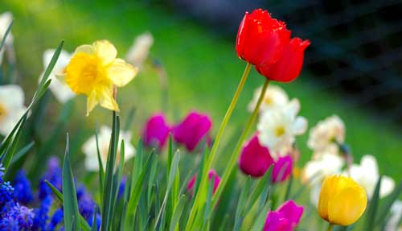
Spring
Much like autumn, spring is the conversion period between summer and winter. But, this time the temperature starts to increase in the spring. It is the very beautiful season among all other. It is sometimes called the season of regrowth. In this season, trees start to grow new leaves and seem to come to their lives again.

Now try the quiz on Google Classroom to test your knowledge.

Reflection – What does each season look like for you?

In each of the 4 boxes below, write or draw objects and feeling that represent each season for you!

Autumn | Winter
Spring | Summer

Monday – Activity 2 – Science and Geography
We learnt in the previous activity that Britain has 4 very distinct seasons throughout the year. The UK is in the mid-latitude area of the world. We live here:
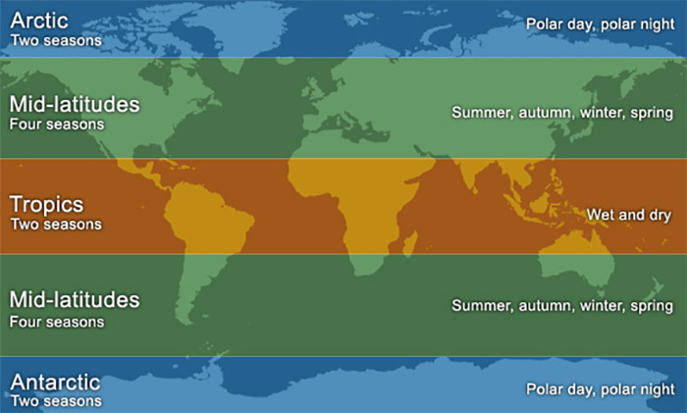
Choose a country from a different area of the world.
What is it like the live in the country?
How does it affect the hours of day and night?
How does it affect animals, plants and the people that live there?
How would you feel if you lived there? Would you prefer or dislike it?

There are many ways that you could present this information.
You could create: a fact file, a PowerPoint Presentation, a blog, a travel brochure.
It is completely up to you how you present it!

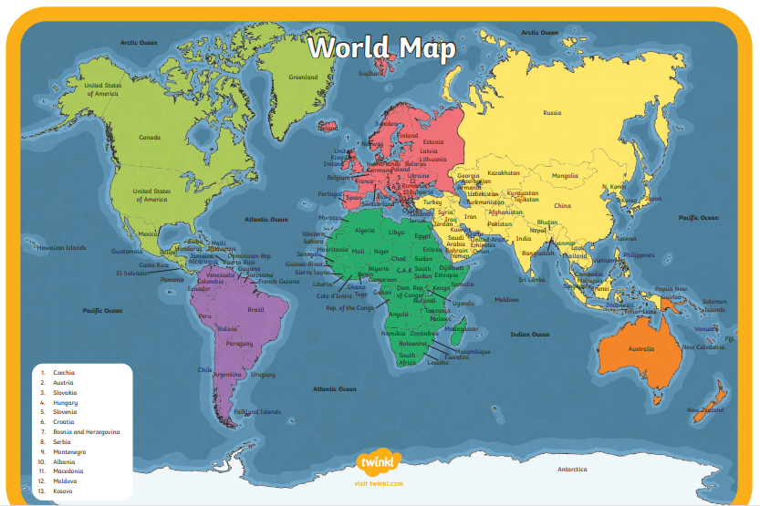
Below, is an example fact file that you could use.
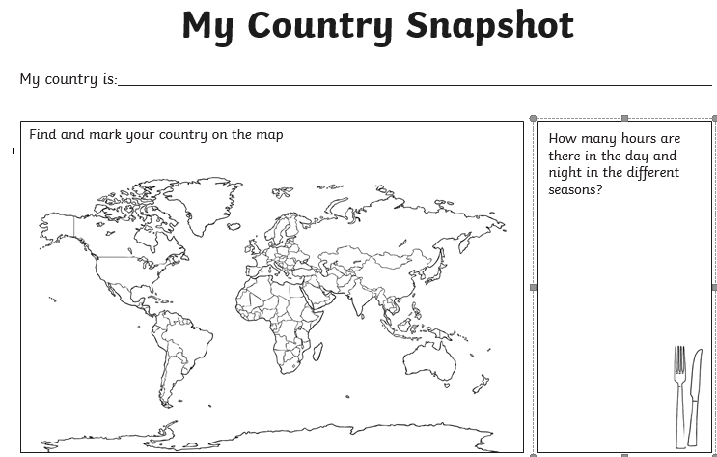
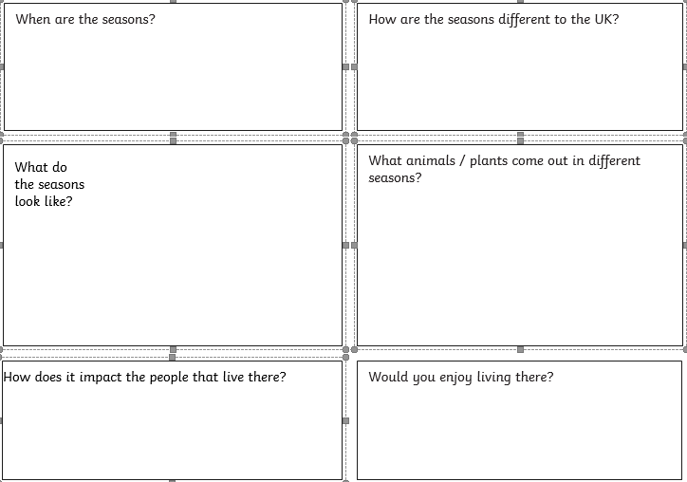

Monday - Activity 3 - Art
Create a piece of art that depicts the four seasons. Reflect on what the physical changes look like for each season? What images would you use to represent each season? What colours would you use and why?
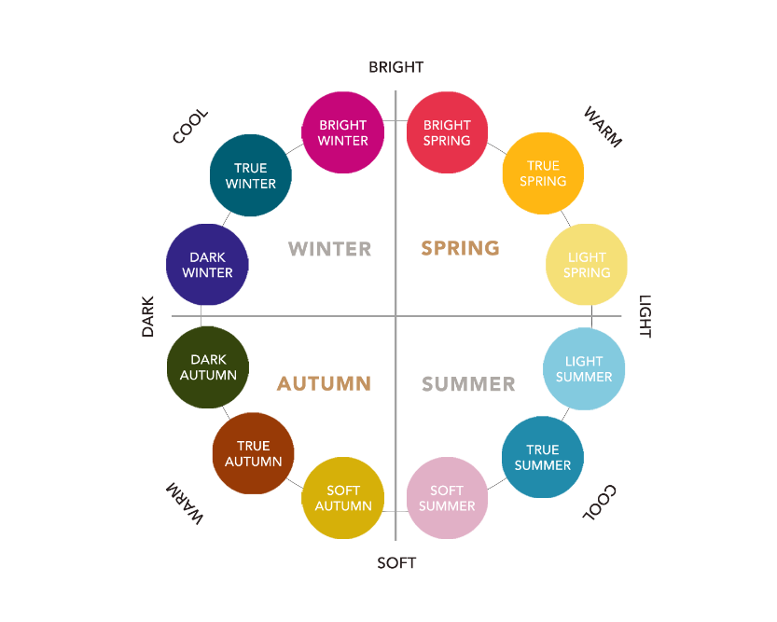
We understand that getting hold of art resources can be challenging.
However you could do a piece of sculptural art! Choose objects around the house/garden to represent the seasons or create a picture.

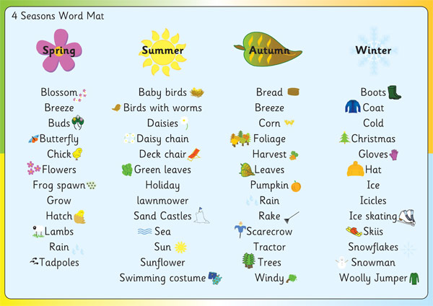

Here are some websites you could use:
https://kinderart.com/category/art-lessons/seasons/

https://www.teachingcave.com/the-arts/ks2/art/

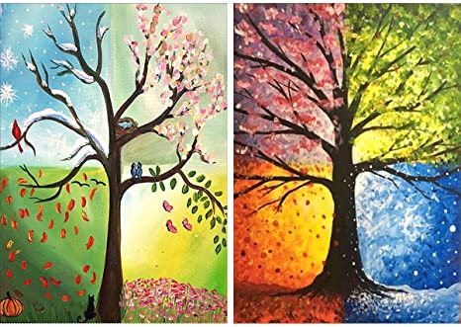

Some more ideas:
You could use old Christmas cards and make a collage. You could use leaves you find in your garden or the park.

Here are some examples:
Summer

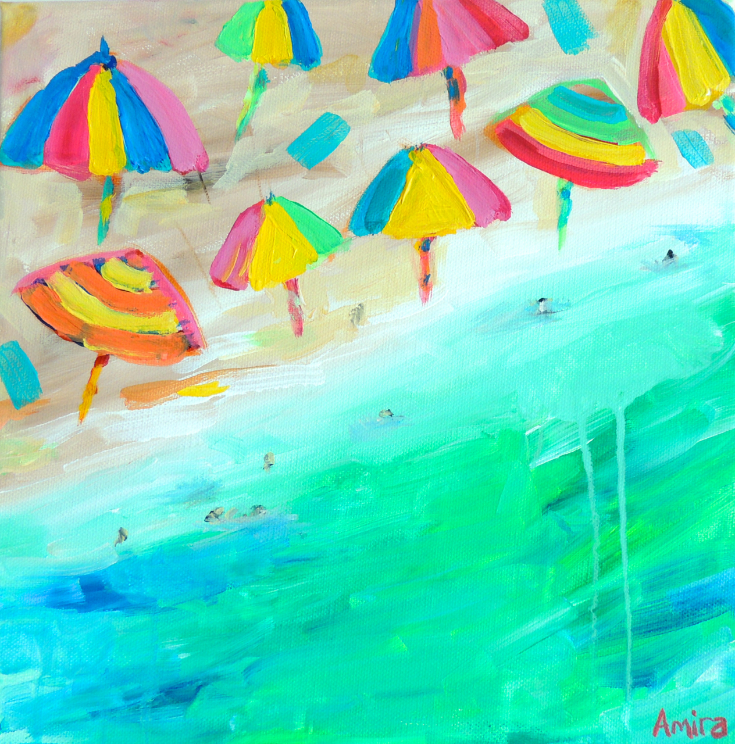
Spring

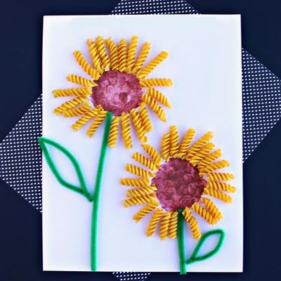

Autumn

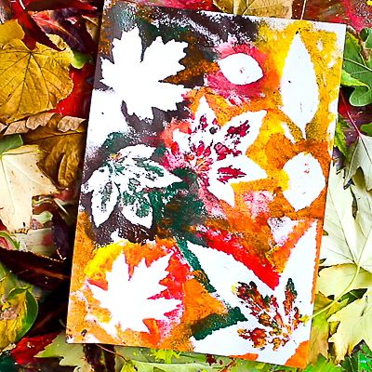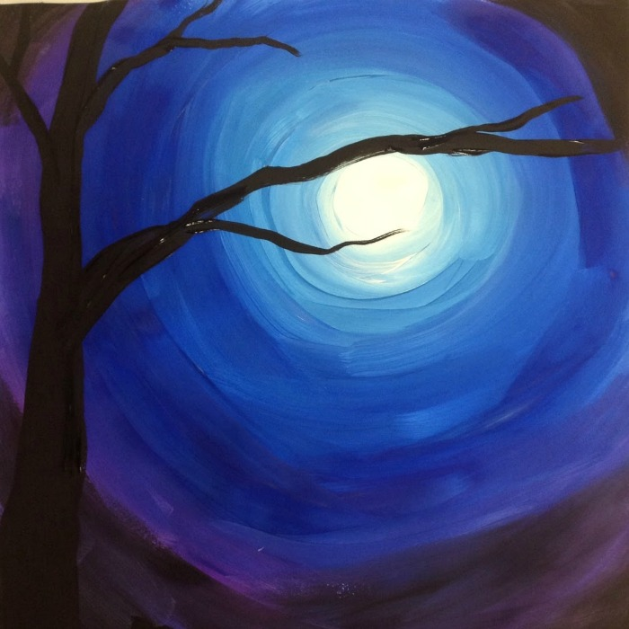
Winter

Monday – Family Fun Time – Word Search
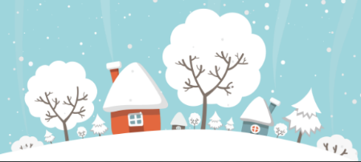

Choose a season and create a word search for it. Then let one of your family members try and complete it!
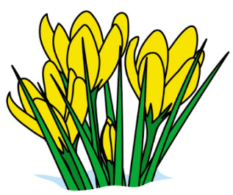
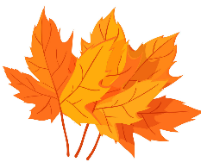
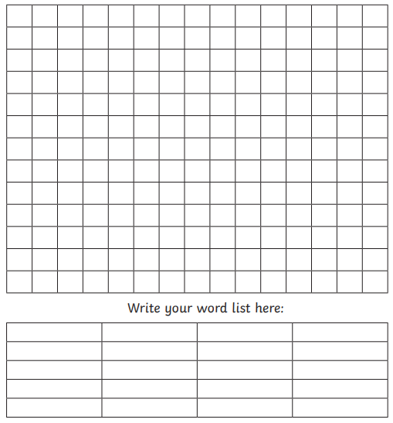
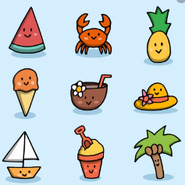

Tuesday – Activity 1 – Maths
What is symmetry?
Link - https://www.bbc.co.uk/bitesize/topics/zrhp34j/articles/z8t72p3
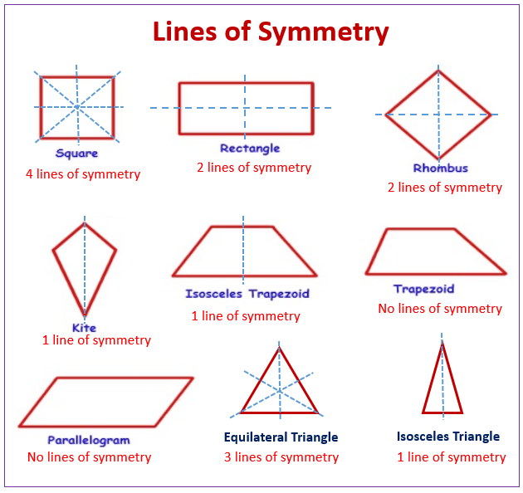
A 2D shape is symmetrical if a line can be drawn through it so that either side of the line looks exactly the same.
The line is called a line of symmetry.
This is sometimes called a 'mirror line' or 'mirror symmetry', because if you put a mirror on the line, the reflection would show the whole shape.
• An isosceles triangle has 1 line of symmetry.
• A square has 4 lines of symmetry.
• A circle has unlimited lines of symmetry!

What do you think of when you think of winter? Snow? A snowflake? One of the marvels of nature is that the tiny ice crystals in snowflakes form a shape with six lines of symmetry. It is actually quite hard to cut out a paper snowflake with six perfect lines of symmetry, but it's a lot of fun to try!

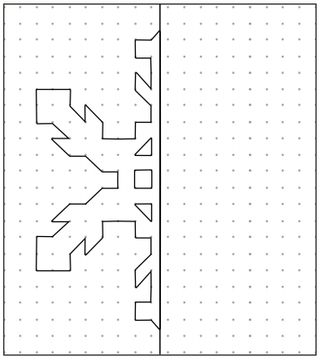

Now try and create your own snowflake. Below is a step by step guide on how to make your own.

Here’s some video links to help!
Link 1 - https://www.youtube.com/watch?v=59dOIF3PMjY
Link 2 - https://www.youtube.com/watch?v=rGep1rwc5gA

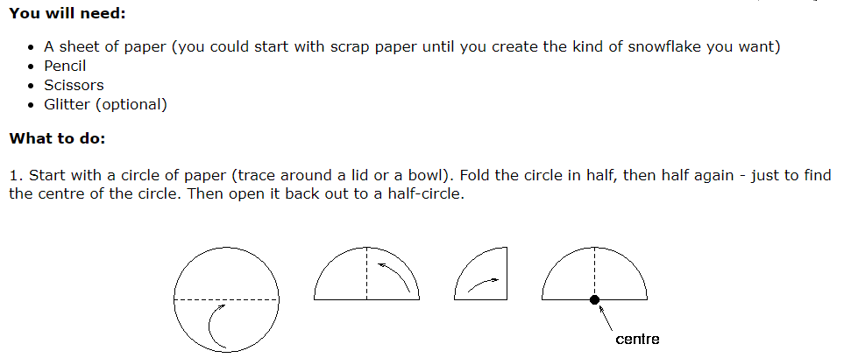
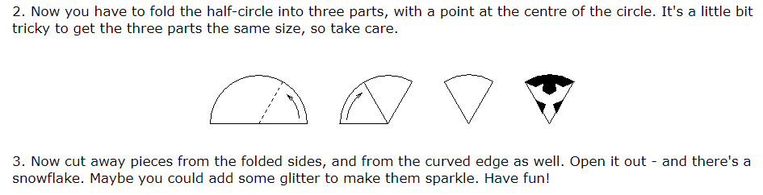
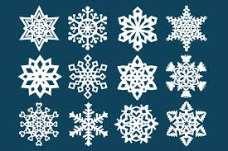
Challenge!
See if you can make each snowflake symmetrical by reflecting the original pattern.
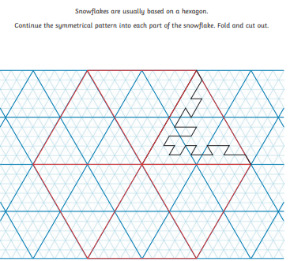
Answer
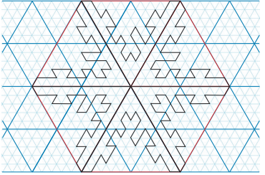

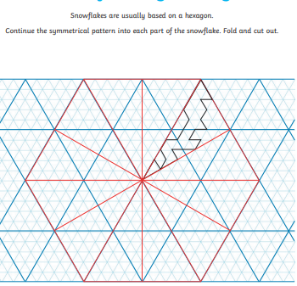
Answer

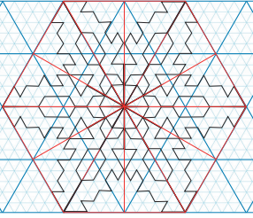

Tuesday – Activity 2 – Harvest
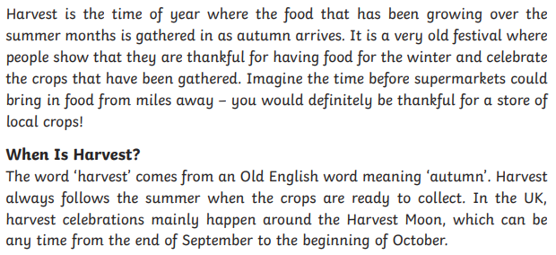
Each season brings change in many ways. Although the summer ending can be very sad, it brings many benefits as we shall find out below!

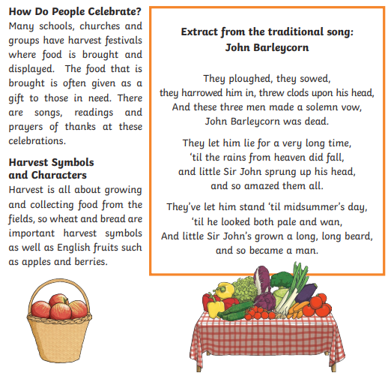

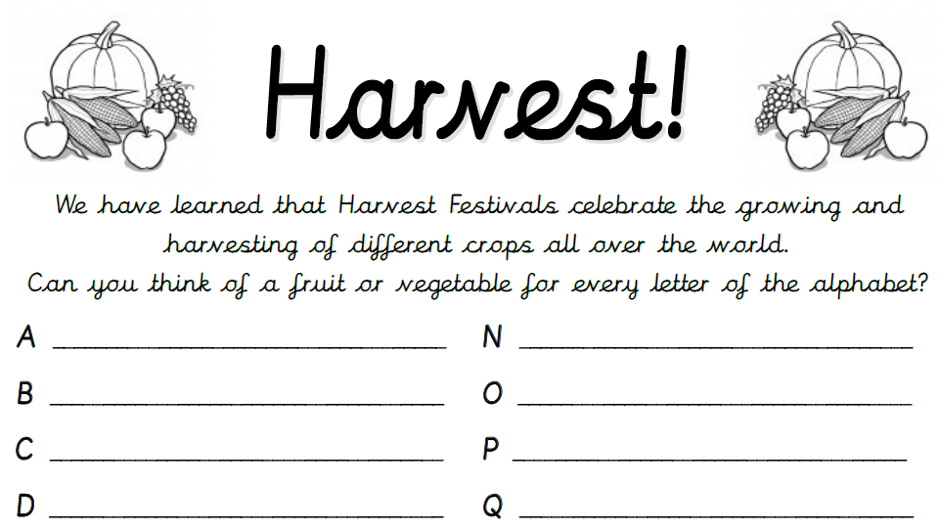

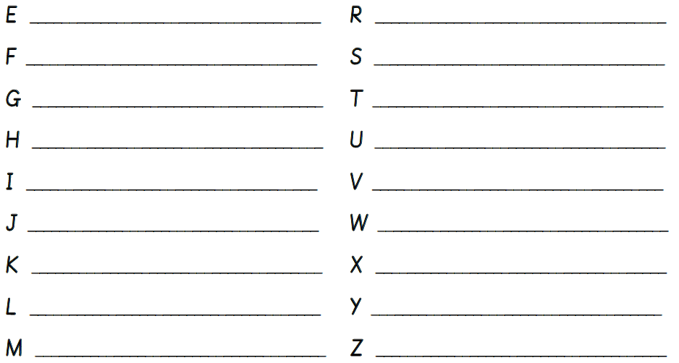

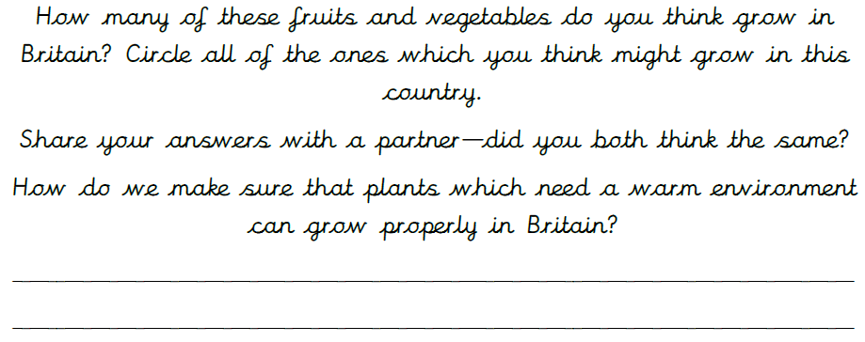

We have learnt that Harvest is seen as a time to be thankful for all the good things in our lives. What are you thankful for? Complete the mind map below with your ideas as words, pictures or both!

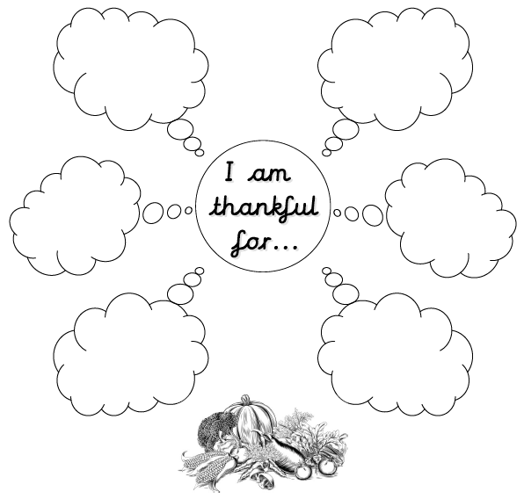

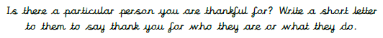

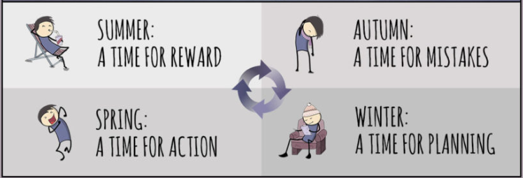
Tuesday – Activity 3 – Goals

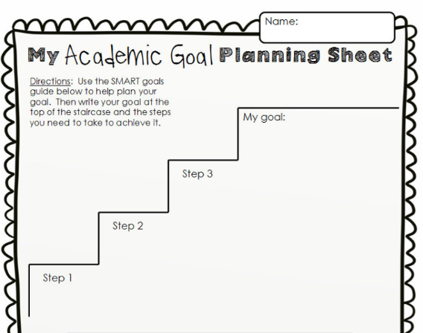
Each season, brings with it a different set of personality traits in us. After winter, spring is all about action and setting ourselves goals. Even though we are experiencing a strange time at the moment, we can still have goals that we want to achieve. Try and set yourself a goal over this period of time or something to aim for by September? Use the sheet below to help you.

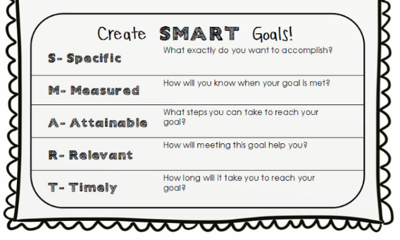

Tuesday – Family Time – Nature Detectives!
Leaves are changing all the time in colour and when they came out in the seasons. With daily walks being very important for our health, see if you can identify any of the leaves on your way!
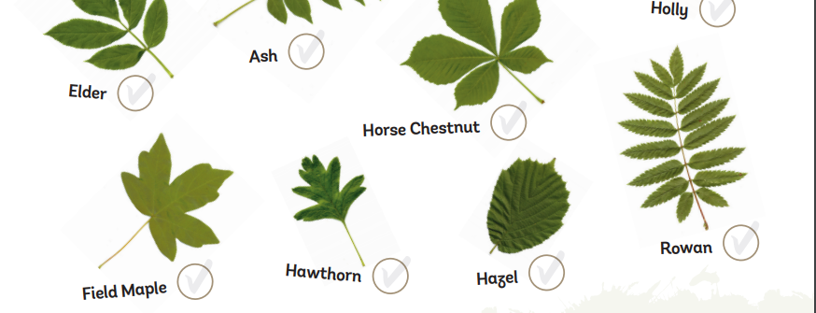
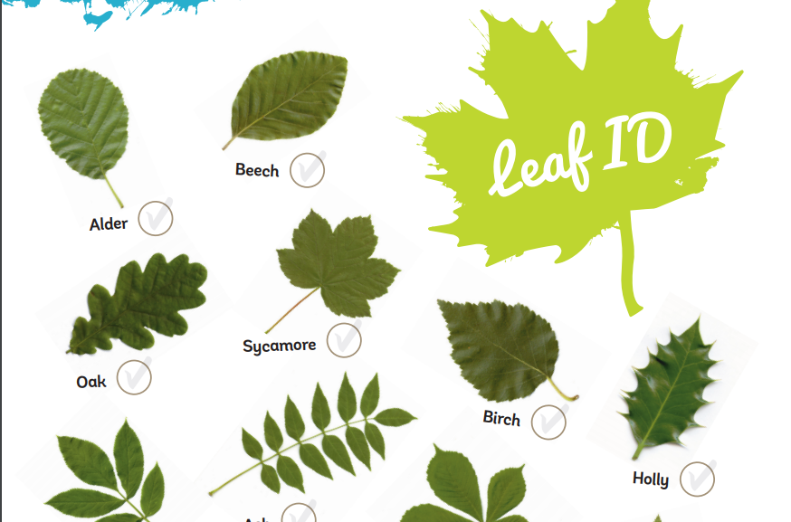

.

Wednesday – Activity 1 – Reading
Haiku poems were a traditional Japanese art form and are still popular today. Read each of the Haiku poems below. Then answer the questions.
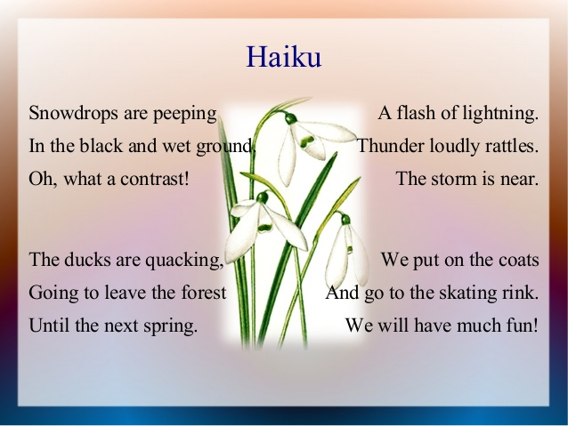
Your answers:
…………………………………………………………………………………………………………
…………………………………………………………………………………………………………
…………………………………………………………………………………………………………
…………………………………………………………………………………………………………
…………………………………………………………………………………………………………
…………………………………………………………………………………………………………
…………………………………………………………………………………………………………
…………………………………………………………………………………………………………
…………………………………………………………………………………………………………
…………………………………………………………………………………………………………

- What are all of these four poems about?
- How many lines does a Haiku have?
- How many syllables does the first and third lines have?
- How many syllables does the second line have?
- Why would someone write a Haiku poem?
- Which Haiku was your favourite and why?

Wednesday – Activity 2 – Picture News
This is a before and after picture.
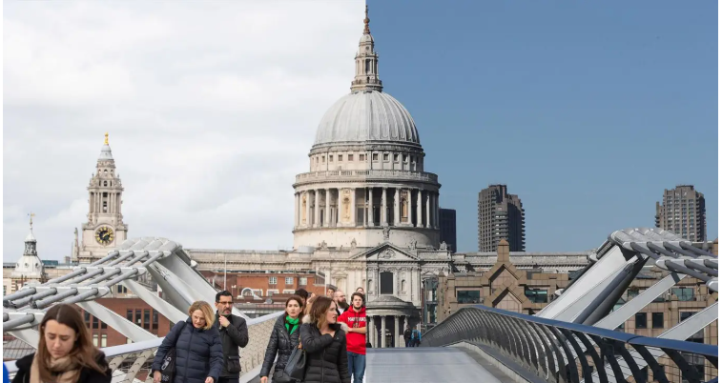
Look really carefully at this picture and discuss it with the people you live with. What do they think? What is a picture of? How does it show change? Why? 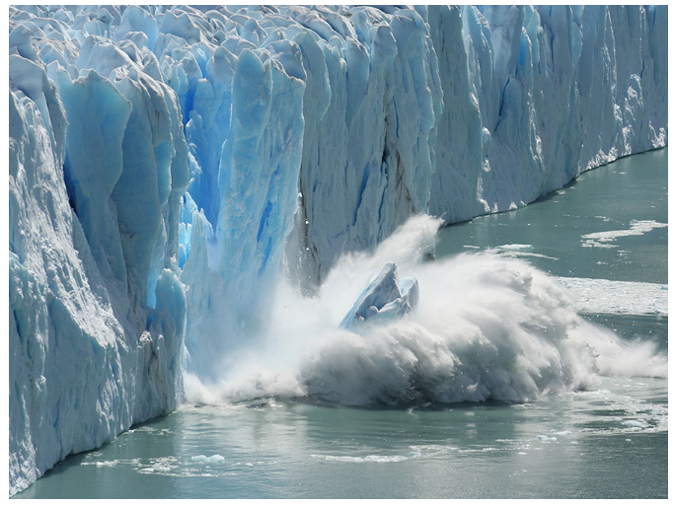
Ice breakers: The Antarctic ice sheet covers an area larger than the US and Mexico combined. © Alamy
Are melting ice caps our most urgent problem? With ice in Antarctica and Greenland melting faster than ever before, scientists warn of catastrophic consequences if we do not act quickly.
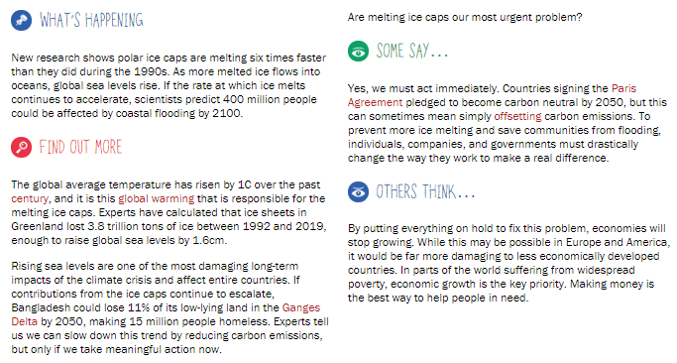
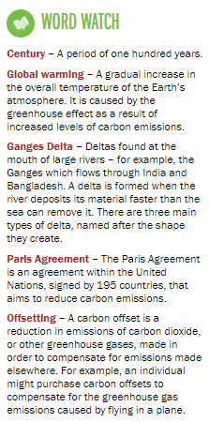
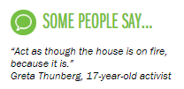

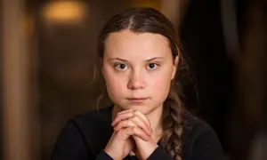

Links about climate change:
Link 1 - https://climatekids.nasa.gov/climate-change-meaning/
Link 2 - https://www.youtube.com/watch?v=Sv7OHfpIRfU

What do you think?
- Is the climate crisis a serious problem?
- What do you think we should do to help it?
- Is it too late to prevent a climate crisis?

Record your thinking below
……………………………………………………………………………………………………………………………………………………………………………………………………………………………………………………………………………………………………………………………………………………………………………………………………………………………………………………………..
………………………………………………………………………………………………………………………………………………………………………………………………………………………………………………………………………………………………………………………………………………………………………………………………………………………………………………………………
………………………………………………………………………………………………………………………………………………………………………………………………………………………………………………………………………………………………………………………………………………………………………………………………………………………………………………………………
………………………………………………………………………………………………………………………………………………………………………………………………………………………………………………………………………………………………………………………………………………………………………………………………………………………………………………………………
………………………………………………………………………………………………………………………………………………………………………………………………………………………………
Other questions/activities to consider:
• Have you been effected by climate change in your life in any way?
• Make a poster telling people about rising sea levels and how we can work together to reduce global warming.

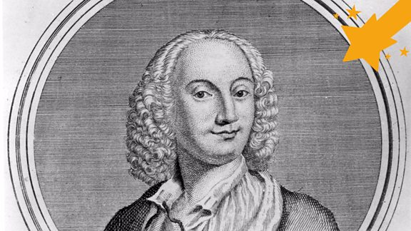
Wednesday – Activity 3

Antonio Vivaldi
Born: 1678
Died: 1741
Nationality: Italian
Around 300 years ago when he wrote The Four Seasons he was one of the first people to compose music that was designed to remind listeners of places and things in the world around them.

Take a listen to some of Antonio’s music here.
https://www.bbc.co.uk/teach/ten-pieces/classical-music-ks2-antonio-vivaldi-winter-from-the-four-seasons/zfvgscw
Do you think he reflected winter the way you would have?
Your mission
Create your own piece of music that reflects a season to you. What sounds would be best to replicate that season? How do you want your listener to feel when they hear it?

If you play an instrument, can you compose your own piece?
However, we know that many of us do not nor own an instrument. Why not try and make your own instruments? Remember, any thing can make a good sound.
e.g a tap dripping, scrunching of newspaper, tapping glasses with water in them
Take a look here for some inspiration to make instrucments:
https://feltmagnet.com/crafts/Music-Instruments-for-Kids-to-Make

Wednesday – Family Time – Flower Pressing
One of the best sights in spring and summer is the variety of flowers that are around. Obviously, we don’t want to pick a flower that someone has taken time to grow so carefully!
Try to choose flowers that have already fallen, found in grass or ask permission. Then have a go at pressing them. The finished result is amazing!
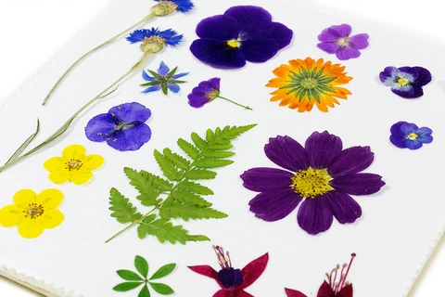
Method
When you get home simply place the petals between some sheets of kitchen roll and carefully put them inside a book. Pile some heavy books on top and leave them for a week or two until they've dried out. You and your kids can then use the pressed petals to make pretty pictures or patterns.
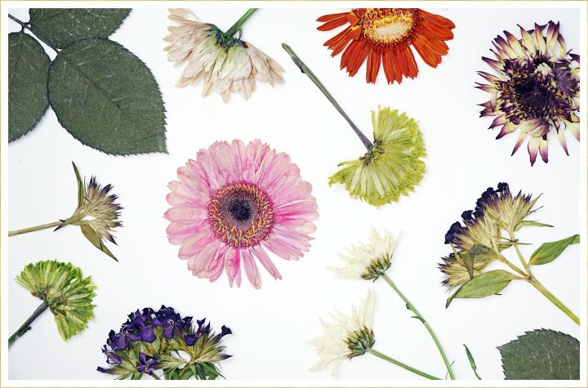

Thursday – Activity 1 – Writing
As you will have found out from the reading yesterday, a Haiku follows certain rules.
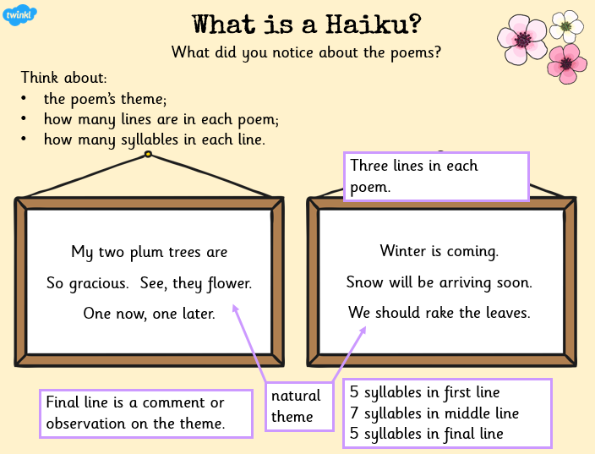
First, think carefully about the season of summer and what it means to you.
What do you wear during this time?
Where do you go?
What happens during the summer months?
What do you see, smell, hear, taste, and feel during these months?
Then brainstorm your ideas that relate to the summer. Consider all the wonderful things that relate to that season for you! See an example below.

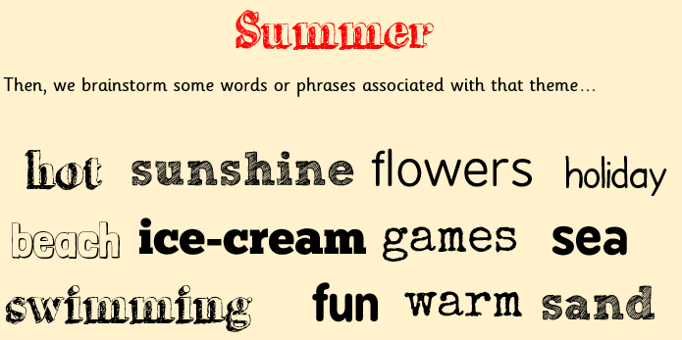

Now, from all the words you have come up with, try and choose some that will link together.
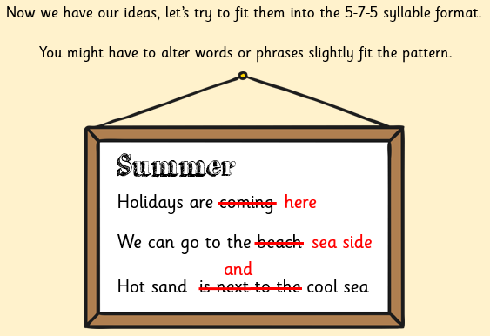
Have a go!
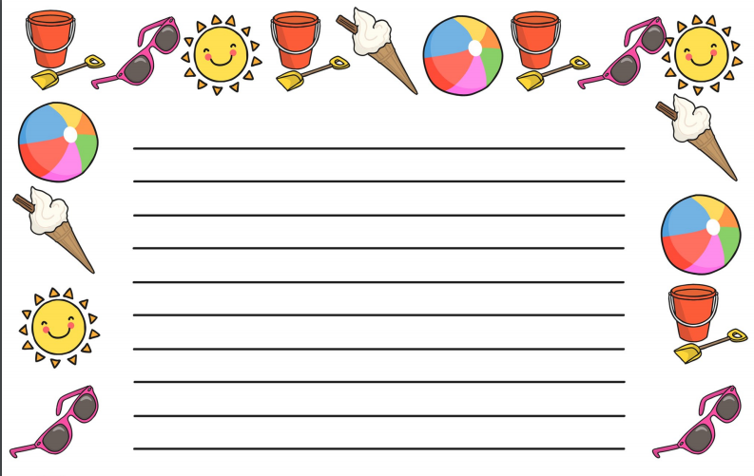

Thursday – Activity 2 – P4C
Watch this video link: https://www.youtube.com/watch?v=4z7gDsSKUmU
Then consider the statement below.

Use the prompts below and your own knowledge the world and the seasons to discuss your thoughts on the statement.
You could discuss this with family at home or call a friend of a relation. Remember it is good to listen to different perspectives and build on other people’s ideas.
Is change ever a good/bad thing?
What is change?
Do you like/dislike change?

If you were prime minister for a day what
changes would you make?
Will the seasons ever change?

What small changes can we make to our own lives to help the world be a better place?
How can we encourage other people to change?

Thursday – Activity 3 – Outcome - Reflection
What does this learning tell you about change?
Do you think change is necessary? Do you think change is important?
Can you link your new knowledge of the seasons to change?
Reflect on how your mood changes with the seasons. How do these seasons make you feel? Consider the positives and negatives of seasonal change.

………………………………………………………………………………………………………………………………………………………………………………………………………………………………………………………………………………………………………………………………………………………………………………
………………………………………………………………………………………………………………………………………………………………………………………………………………………………………………………………………………………………………………………………………………………………………………
………………………………………………………………………………………………………………………………………………………………………………………………………………………………………………………………………………………………………………………………………………………………………………
………………………………………………………………………………………………………………………………………………………………………………………………………………………………………………………………………………………………………………………………………………………………………………
………………………………………………………………………………………………………………………………………………………………………………………………………………………………………………………………………………………………………………………………………………………………………………
………………………………………………………………………………………………………………………………………………………………………………………………………………………………………………………………………………………………………………………………………………………………………………

Thursday – Family Time
Outdoor Exercise
Exercise does not always have to be completed in the home or at school. Your wellbeing can actually be improved by getting outside, getting fresh air and exercising. Take some of the exercises attached below and try completing them in a garden or a local park!
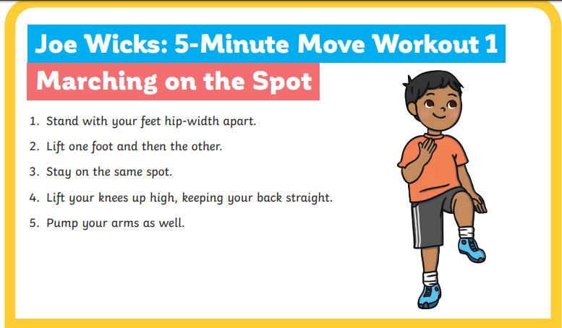

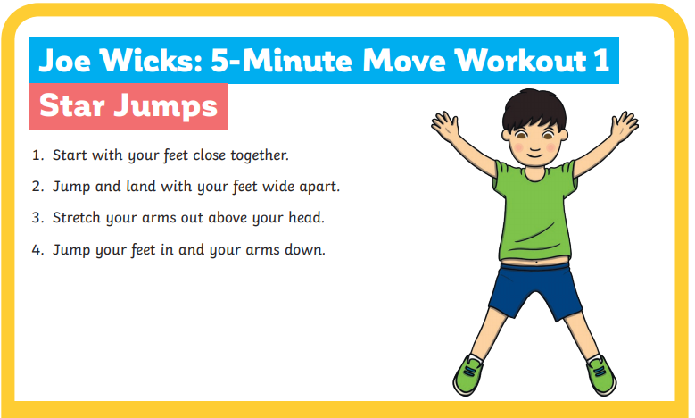

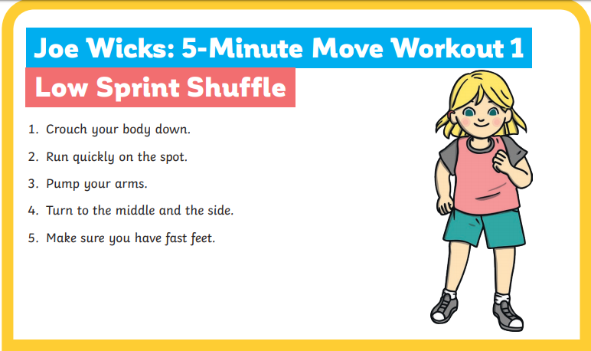

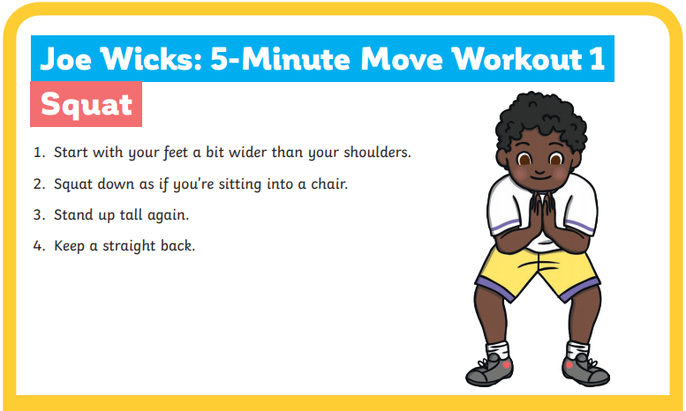

Enjoy!

Friday – Catch Up and Relax Time!

Go on a nature walk and try these name 5
things cards…
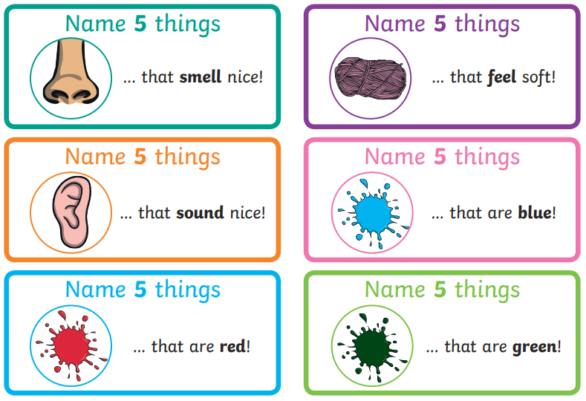
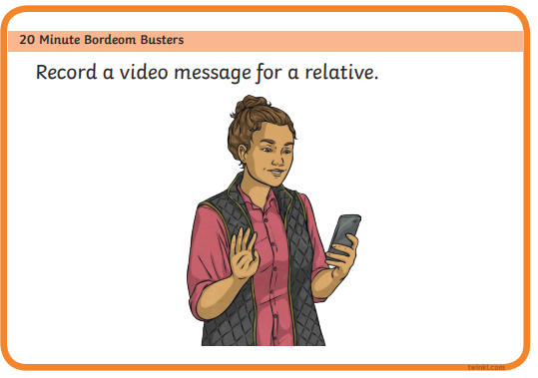

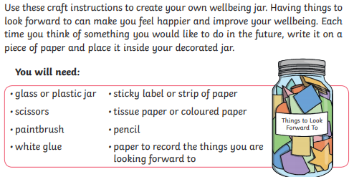
Wellbeing jar
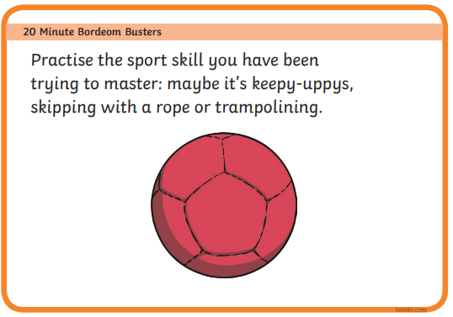
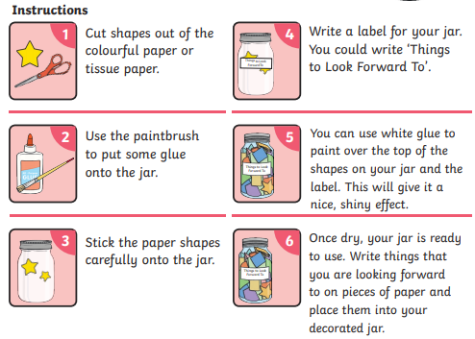

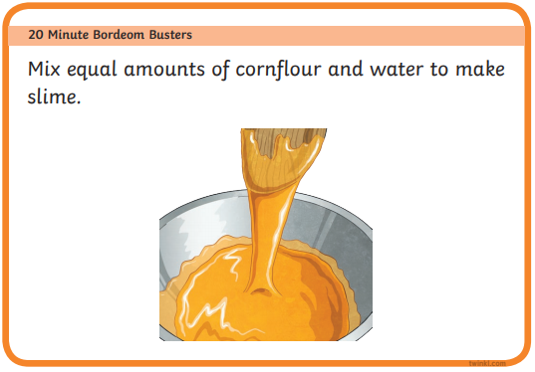

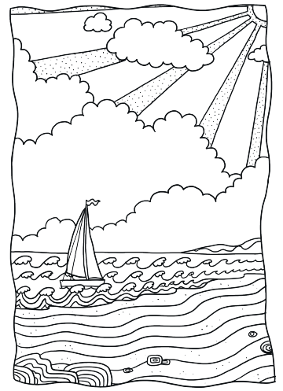

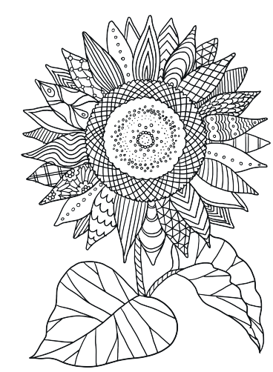

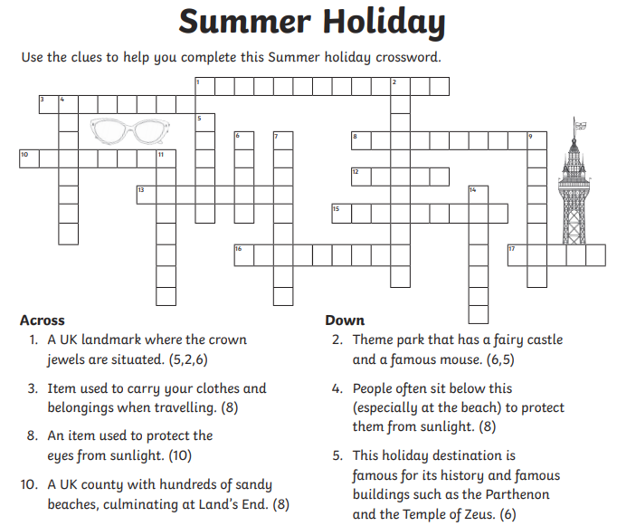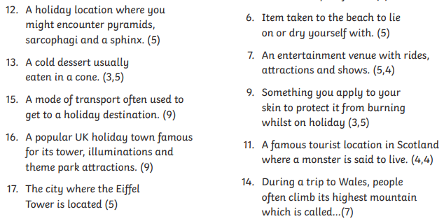

Answers
