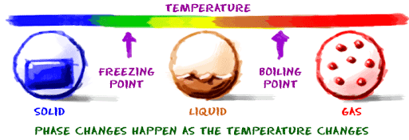
Year 5 - Home Learning Tasks
WB: 15.06.20
Our theme for this half term will be the concept of ‘change’.
From the water cycle to stars in our night sky, this week we will be exploring different changes which occur in the world around us and exploring the Science behind them!
 | Activity 1 | Activity 2 | Activity 3 | Away From Screen Time!
Monday | Climate Change 1 – What is climate change and how does it impact us in the UK? Read the information and watch the videos to discover the answers. | Water Cycle – Let’s Get Creative!  Learn about the different stages of the water cycle before creating your very own model/version through Scratch. | Let’s Investigate!  Go outside into your garden or to the local park. Pour some water on the ground to make a puddle and observe how it changes. | Practise your 2 and 4 x tables.  Can you increase your speed?  Do you notice any patterns between them?  Try taking the quiz at the end of the week – on Google Classroom!
Tuesday | Fibonacci Sequences- Read the information about the Fibonacci Sequence and why it is important in nature, then go on a Fibonacci hunt outside! | Climate Change Art – Explore some different protest art and the meaning behind them before creating your own to inspire others to help stop climate change. | P4C: Is it wrong to interfere with nature whilst trying to save it?  Consider your point of view before and after reading the article included. | Create your own word search using the vocabulary that you have learnt in the past 2 days.
Wednesday | Phases of the Moon - How does our view of the moon change over the course of each month? | Thinking Challenge The Day Explorer - Read the article around the latest invention of a manned, reusable rocket. Does this make space travel a reality for all? Read the text before considering the question: ‘Should humans go and live in space?’ | Stars and Constellations - Discover more about our night sky and how this can change throughout the year. Then come up with your own constellation of stars and a story behind it. | Wait until it gets dark and see if you can spot any of the constellations that are in our night sky this time of year!
Thursday | Famous Scientists and How They Changes Our Lives – Research some of the discoveries different famous scientists have made before choosing how to present your research | Reversible and Irreversible Changes – Discover about these different types of changes in Science and see if you can classify | Outcome - Reflection  Reflect on your learning this week:  What do you think change is?  Can you link your thinking to the learning you have done this week? What about last week? | Get active and try some of the exercises included. You could even complete them in a garden or a local park!  Could you create one of your own?
Friday | Catch up and Chill – Today is the day to take part in any of the activities above if you hadn’t had a chance yet. Instead, you may have some ideas of your own! No matter what you choose to do today, make sure you relax and take some time for you!
These are the details and links to some of the activities posted on Google Classroom this week. Where possible, below you will find the task sheets which will explain the activities in more detail. If you experience any problems, please contact your child’s class teacher via email.

Monday – Activity 1 – What is climate change?
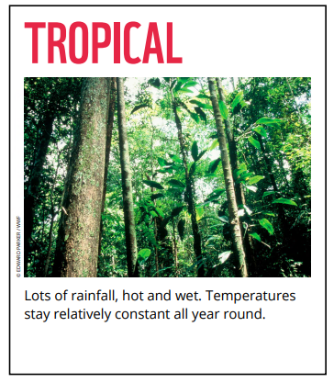
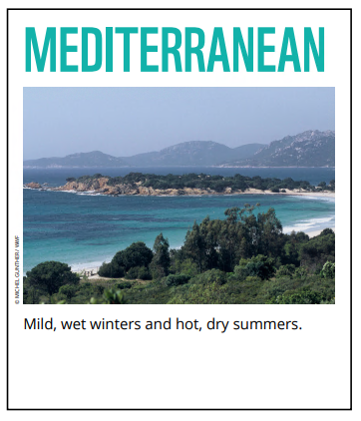
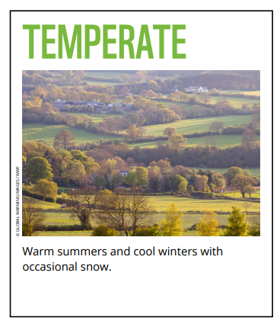
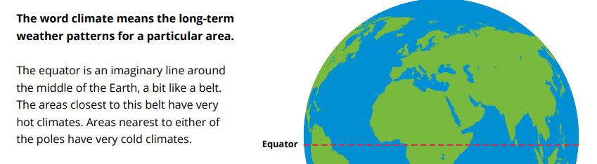
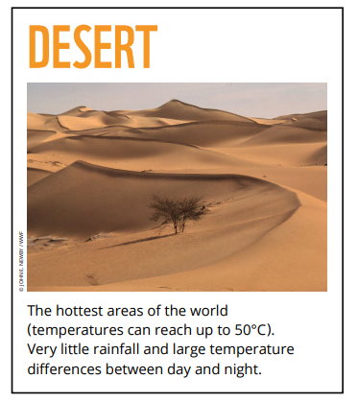
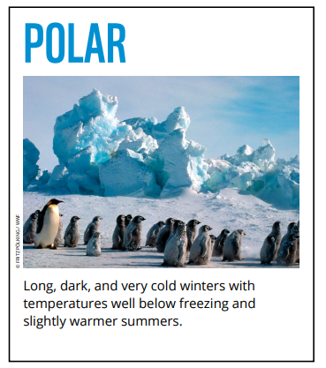
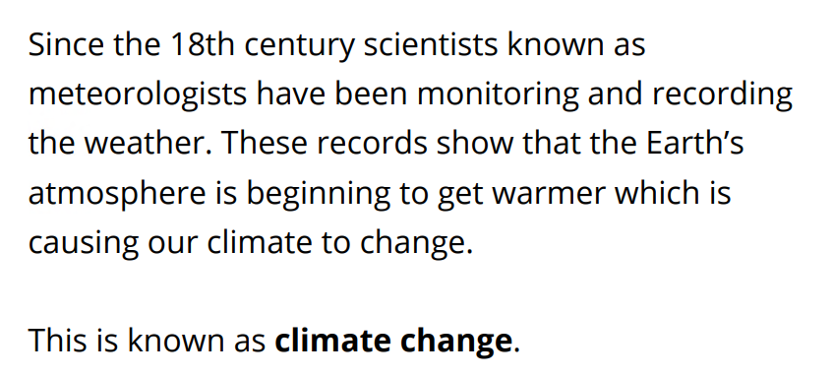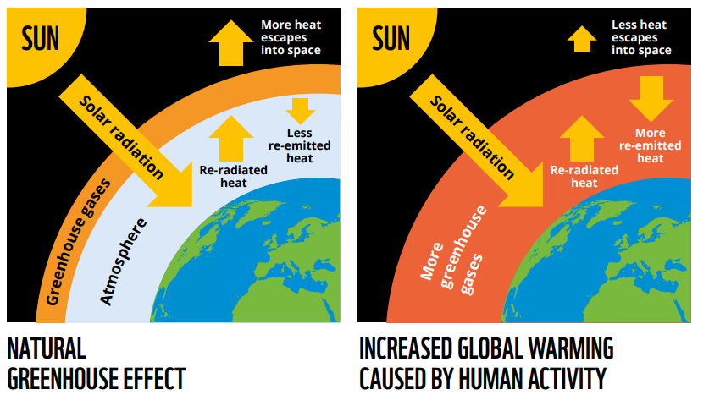
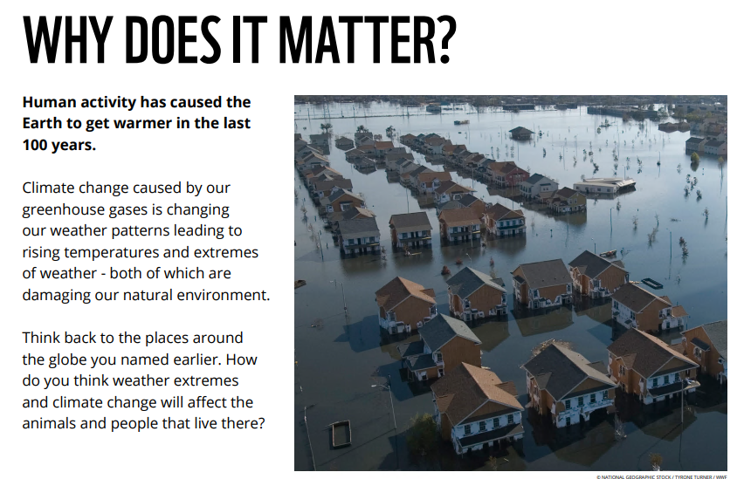
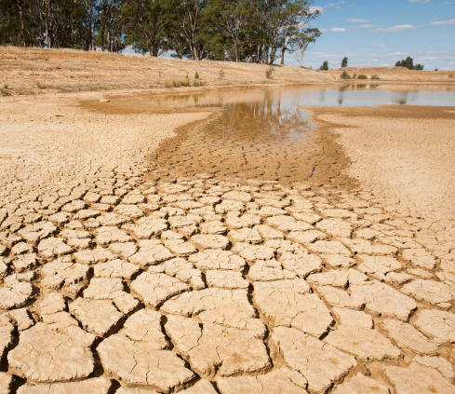
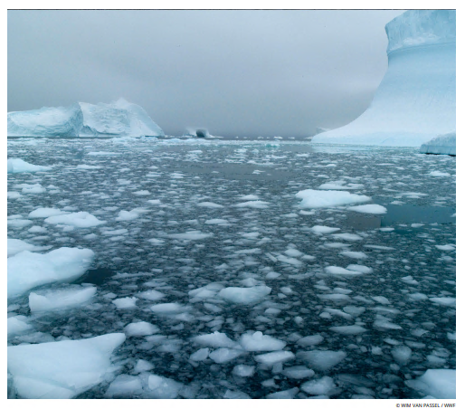
What is happening here?
How does this make you feel?
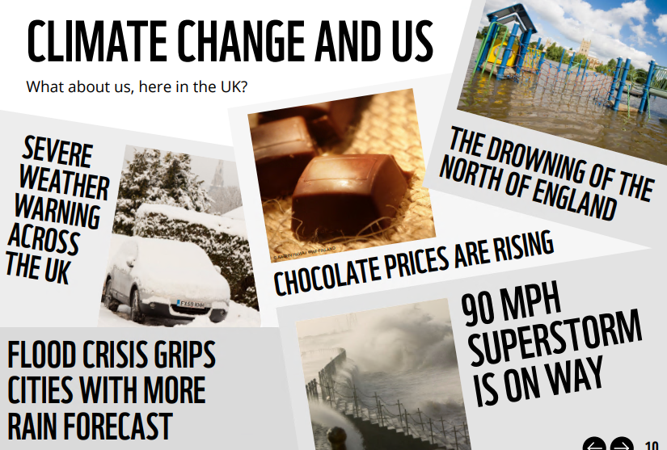
Climate Change affects us all…
Now complete a quiz on climate change through the following link (or log on to google classroom):
https://forms.gle/n61qRWicVfzJeEQs9

Monday – Activity 2 – Water Cycle
Pour yourself a glass of water and take a sip. Did you know that the water you’ve just swallowed is the same water that wooly mammoths, King Tutankhamun and the first humans drank? That’s because Earth has been recycling water for over 4 billion years!
Learn about the 4 stages of the water cycle through watching the clip: https://www.bbc.co.uk/bitesize/topics/zkgg87h/articles/z3wpp39
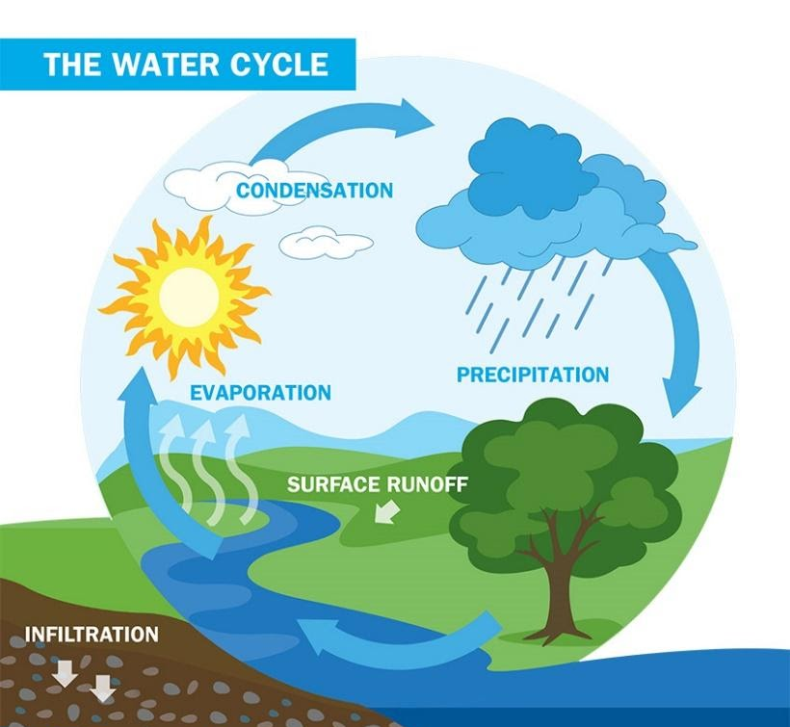
Now create your own version of the water cycle to demonstrate your knowledge of the different stages.
This could be a model, spin wheel, or you could use Scratch to show the different stages.
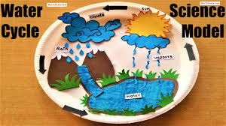
Scratch online program: https://scratch.mit.edu/projects/editor/?tutorial=getStarted
Add this water cycle in a bag to the window to watch the water evaporate and then condense on the side of the bag.

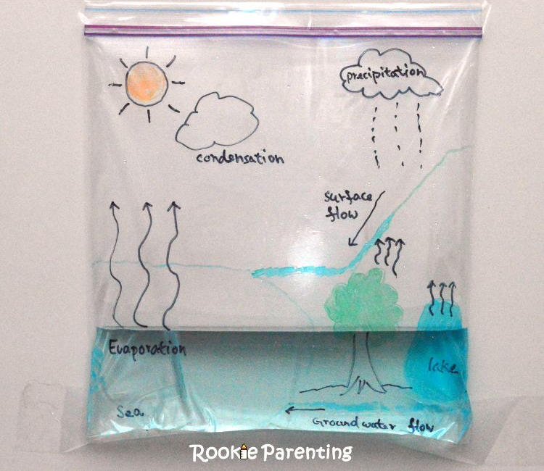

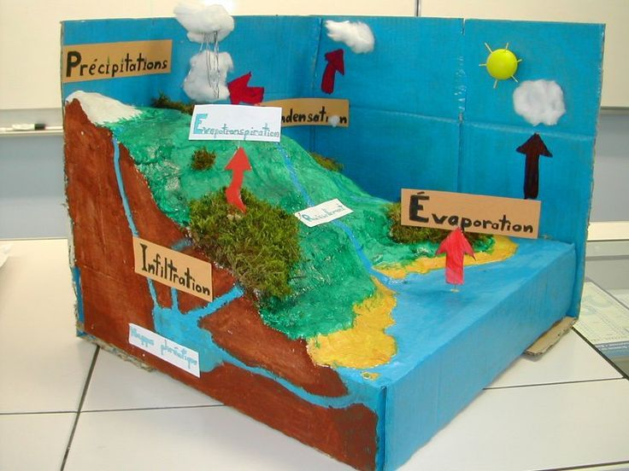

Some information all about the water cycle…
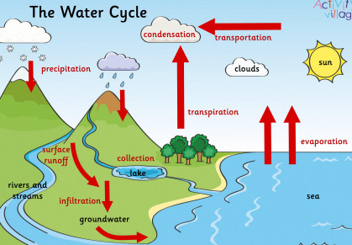
The world’s water moves between lakes, rivers, oceans, the atmosphere and the land in an ongoing cycle called – you guessed it! – the water cycle. As it goes through this continuous system, it can be a liquid (water), a gas (vapour) or a solid (ice).

Evaporation
Energy from the sun heats up the surface of the Earth, causing the temperature of the water in our rivers, lakes and oceans to rise. When this happens, some of the water “evaporates” into the air, turning into a gas called “vapour“. Plants and trees also lose water to the atmosphere through their leaves. This process is known as “transpiration“.

Condensation
As water vapour rises up high into the sky, it cools and turns back into a liquid, forming clouds. This process is called “condensation“. Currents high up in the air move these clouds around the globe.

Precipitation
When too much water has condensed, the water droplets in the clouds become too big and heavy for the air to hold them. And so they fall back down to Earth as rain, snow, hail or sleet, a process known as “precipitation“.

Collection
The fallen precipitation is then “collected” in bodies of water – such as rivers, lakes and oceans – from where it will eventually evaporate back into the air, beginning the cycle all over again. How it is collected, depends on where it lands…
- Some will fall directly into lakes, rivers or the sea, from where it will evaporate and begin the cycle all over again.
- If the water falls on vegetation (plants), it may evaporate from leaves back into the air, or trickle down to the ground. Some of this water may then be taken up by the plant roots in the earth.
- In cold climates, the precipitation may build up on land as snow, ice or glaciers. If temperatures rise, the ice will melt to liquid water and then soak into the ground, or flow into rivers or the ocean.
Water that reaches land directly may flow across the ground and collect in the oceans, rivers or lakes. This water is called “surface run-off“. Some of the precipitation will instead soak (or “infiltrate”) into the soil, from where it will slowly move through the ground until eventually reaching a river or the ocean.
And there you have it, gang – the ongoing water cycle!
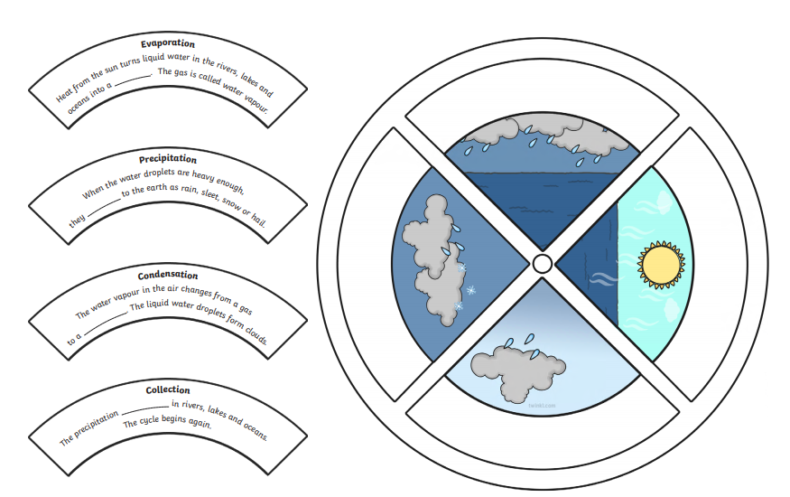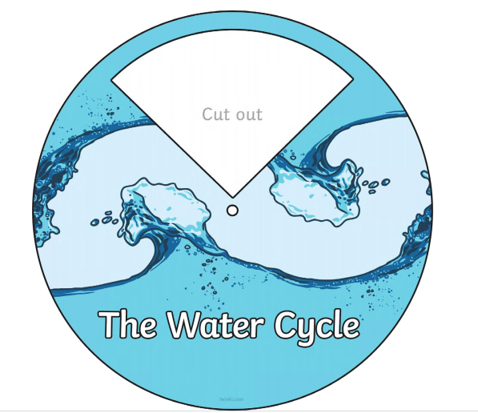

Monday – Activity 3 – Puddle Investigation
Watch this link about what evaporation is:
https://www.bbc.co.uk/bitesize/topics/zkgg87h/articles/zydxmnb

Today we want you to answer the following question:

How does the size of a puddle change over time as a result of evaporation?

Go outside into your garden or walk to the local park. Pour some water on the floor to make a puddle and measure the width of it. If you have chalk, it might be a good idea to draw around it.
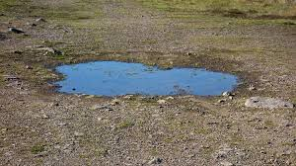

Write a prediction as to what you think will happen. Remember that a good scientist explains their thinking.
………………………………………………………………………………………………………………………………………………………………………………………………………………………………………………………………………………………………………………………………………………………………………………………………………………………………………
…………………………………………………………………………………………………………………………………………………………………………………………………………………………………………………………………………………………………………………………………………………………………………………………………………………………………………
Then check on the puddle every 5 minutes and measure the size of it each time.
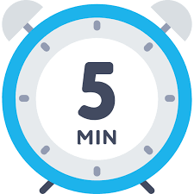
What do you notice? Present your results in your home learning book.
You may choose to draw pictures or draw a results table.
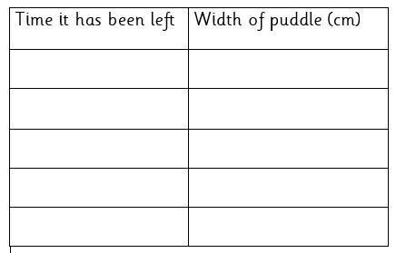

Can you draw a graph to show your results?

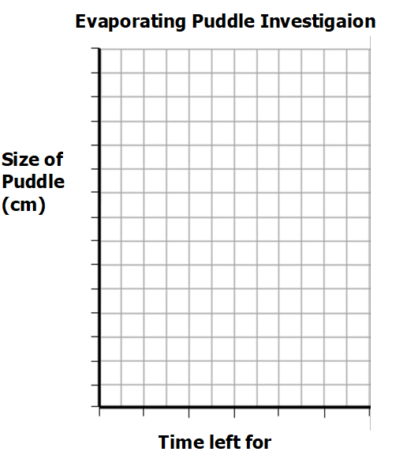

To finish, write a conclusion into your home learning book.
What did you discover in this investigation? How did it link to evaporation?
………………………………………………………………………………………………………………………………………………………………………………………………………………………………………………………………………………………………………………………………………………………………………………………………………………………………………
…………………………………………………………………………………………………………………………………………………………………………………………………………………………………………………………………………………………………………………………………………………………………………………………………………………………………………
…………………………………………………………………………………………………………………………………………………………………………………………………………………………………………………………………………………………………………………………………………………………………………………………………………………………………………
EXTENSION: What other questions does this make you think about? How could you adapt this investigation? For example, could you place puddles in different areas of an outside space and see which evaporates the quickest?
Monday – Practise your 2 and 4 X Tables
It is vital that you can return to school knowing your tables as this knowledge underpins the majority of Mathematics. This week we would like you to practise and memorise your 2 and 4 X tables. Here are some activities you could try below.

Activity 1 – Listen to these songs.
2 X Table - https://www.youtube.com/watch?v=9C4EN7mFHCk
4 X Table - https://www.youtube.com/watch?v=8QU_E0u-tP4

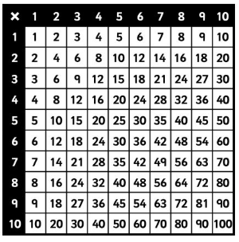
Activity 2 – Look at the multiplication square below. Colour in the 2 and 4 X tables. What do you notice?

I noticed that…

Activity 3 – Multiplication Wheels
You will either need to work out the multiplication or figure our what they have been multiplied by.
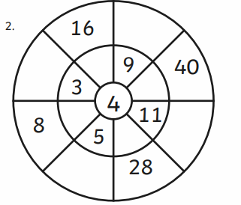
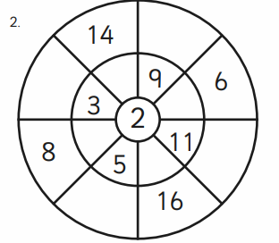

Activity 4 - Multiplication Quiz – OUT on Thursday!!!
Try completing the multiplication quiz at the end of the week by listening to the audio and writing down your answers. Listen for the answers at the end!

Tuesday – Activity 1 - Fibonacci Sequences
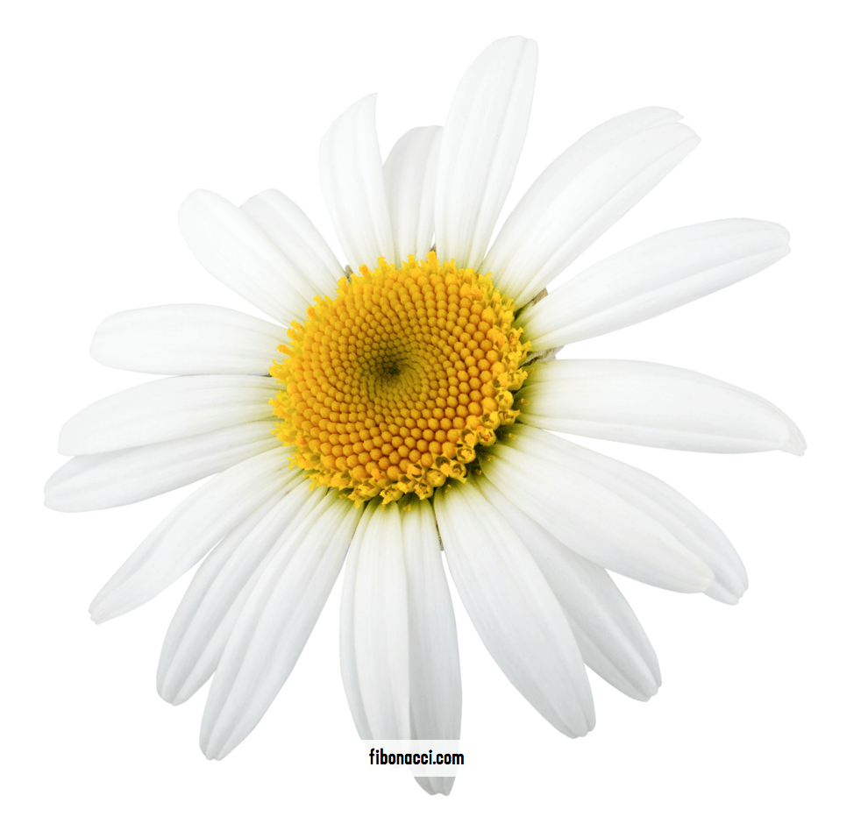
Have you ever pulled the petals off of a daisy? If you look closely at the centre of a daisy, you will find that the yellow centre is not solid. It is made up of sets of spirals that go out from the centre. It’s not just daisies! Nature is all about maths.
Look at the pictures of a pinecone. It has those same kinds of spirals. They don’t go around and around in a circle — they go out like fireworks. Look at the pictures below to see what that looks like. How many spirals go in the clockwise direction (green lines)? How many spirals go in a counter-clockwise direction (yellow lines)? Isn’t that strange? Wouldn’t you expect that they would be the same?
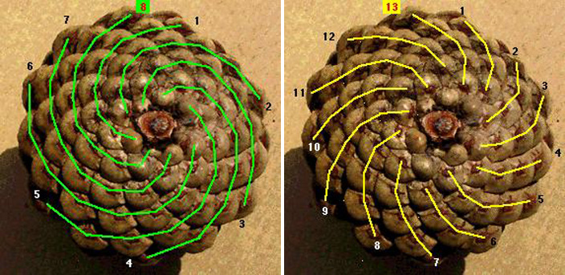
To understand the spirals in pinecones, pineapples, daisies and lots of other things in nature, we have to meet a mathematician named Leonardo de Pisa. Most people call him Fibonacci (pronounced fib-o-nawch-ee). About 800 years ago, he wrote a book in which he included a math problem that went like this:
“A certain man put a pair of rabbits in a place surrounded by a wall. How many pairs of rabbits can be produced from that pair in a year if it is supposed that every month each pair begets a new pair from which the second month on becomes productive?”
Isn’t it strange that they had word problems 800 years ago?! Fibonacci’s work on this problem led him to this sequence of numbers:
0, 1, 1, 2, 3, 5, 8, 13, 21, 34, 55, 89, 144 …
Can you work out what the next number in the sequence will be?
Tuesday – Activity 2 – Protest Art
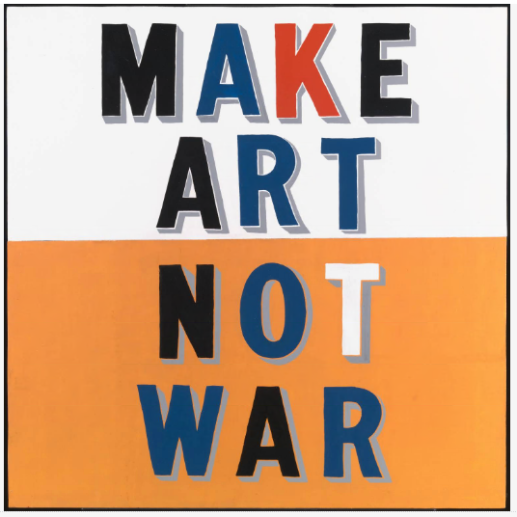 | 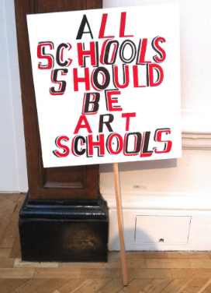
This work was made by the British artist Bob and Roberta Smith in London in 1997. Smith claims that his father, a Second World War veteran and artist, was the original source of this work’s slogan-like statement. The painting is one of a series of similar paintings which also feature slogans encouraging art over violence.  Find out more here: https://www.tate.org.uk/art/artworks/smith-make-art-not-war-t12561#:~:text=Make%20Art%20Not%20War%20is,the%20centre%20of%20the%20composition. | All Schools Should be Art Schools are pieces of work aiming to address the ongoing concern with the ever decreasing role of the arts in schools since Michael Gove's proposed removal of Art from the GCSE core curriculum in England.  See another example and find out more here:  https://www.tate.org.uk/art/artworks/smith-all-schools-should-be-art-schools-t14774
THINK:
What do you notice about these pieces of protest art?
What colours have been used?
What do you notice about the font? Is it easy or hard to read? Why?
Is the message short or long?

How successful do you think the artist has been in getting their message across?
What do you like about the protest art? What could you do to improve it?

…………………………………………………………………………………………………………………………………………………………………………………………………………………………………………………………………………………………………………………………………………………………………………………………………………………………………………
…………………………………………………………………………………………………………………………………………………………………………………………………………………………………………………………………………………………………………………………………………………………………………………………………………………………………………
…………………………………………………………………………………………………………………………………………………………………………………………………………………………………………………………………………………………………………………………………………………………………………………………………………………………………………
Your task:
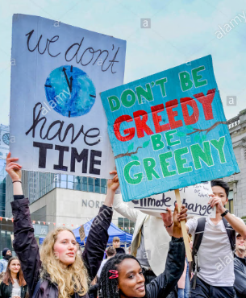
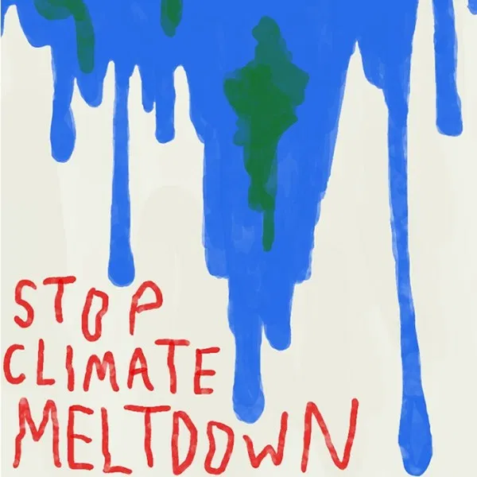
Create some protest art encouraging others to help combat climate change. Remember to use what we have just discovered about how to make protest art successful. For example, make your slogan short and snappy like the ones here!
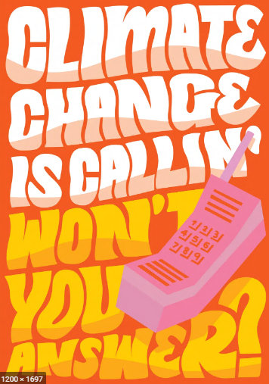
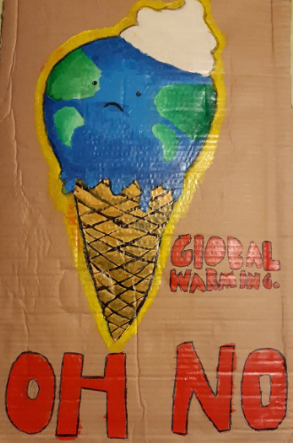
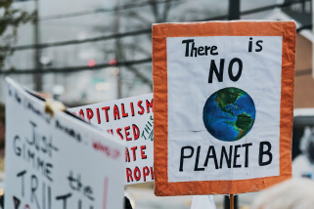

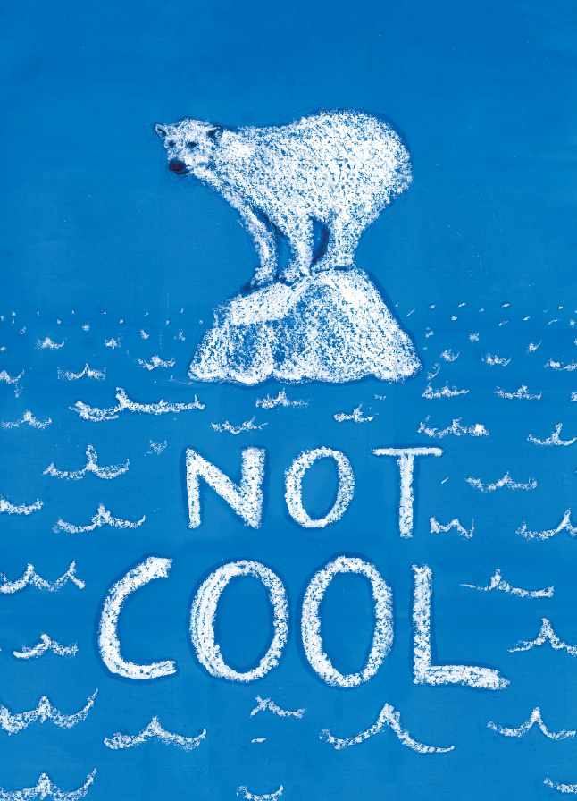

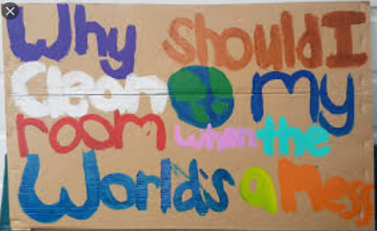

Tuesday – Activity 3 – P4C
Question: Is it wrong to interfere with nature whilst trying to save it?
What is your initial thinking? Is it right to become involved with nature if we are trying to help? Yes or no?
I think ___________________________________________________________________________________
________________________________________________________________________________________
________________________________________________________________________________________
________________________________________________________________________________________
Now read the article below which provides an example of human’s and their plans to ‘interfere’ with nature.
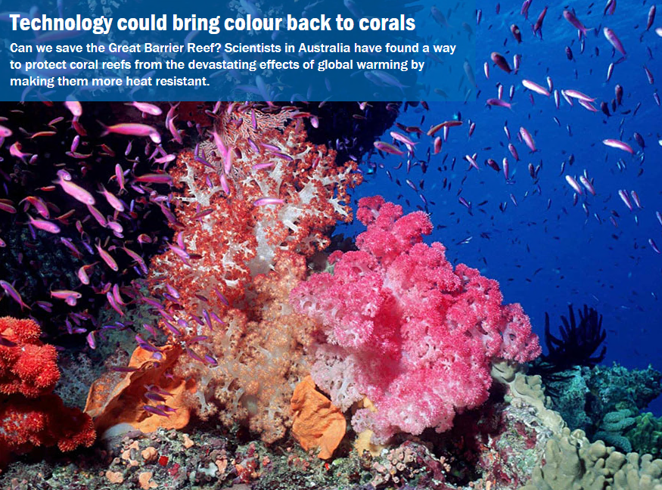

What do you think? Has your view changed or stayed the same? Remember this is just one example! Use the question prompts and pictures below for other points to think about.
You could discuss this with family at home or call a friend of relation. Remember it is good to listen to different perspectives and build on other people’s ideas.
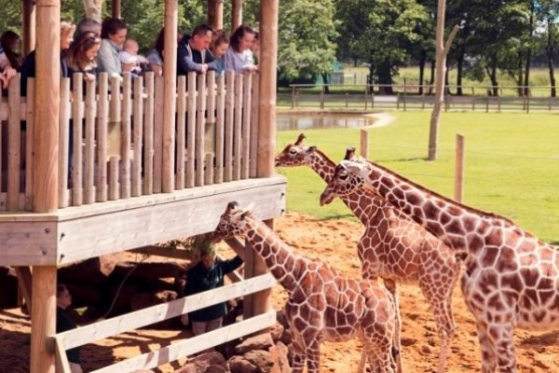
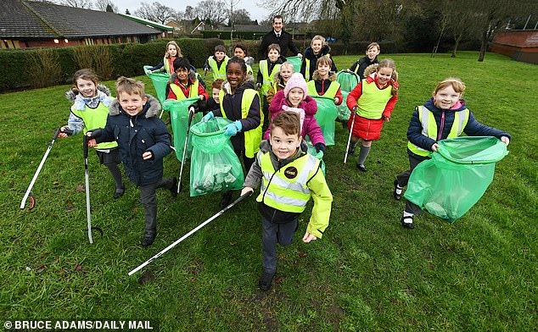
What would happen if we didn’t do anything?
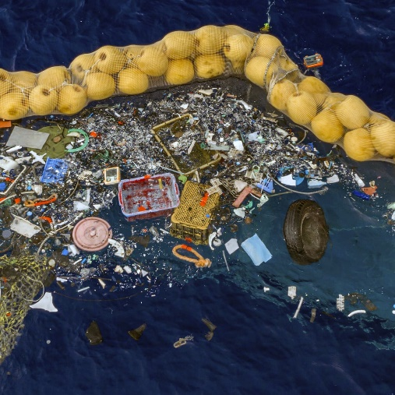
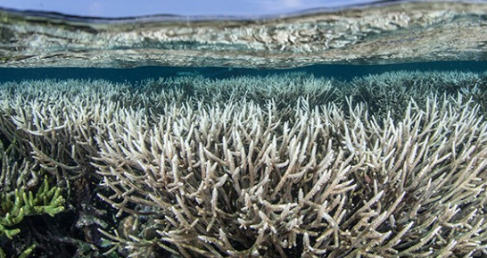
Could interfering cause more problems?

Did we cause the problem in the first place?

Tuesday- Away from screen time- Word Search
Now it’s time for you to create your own word search using some of the vocabulary you have learnt over the last few days. Using the grid below, add in some of the words then fill in the spaces with random letters.
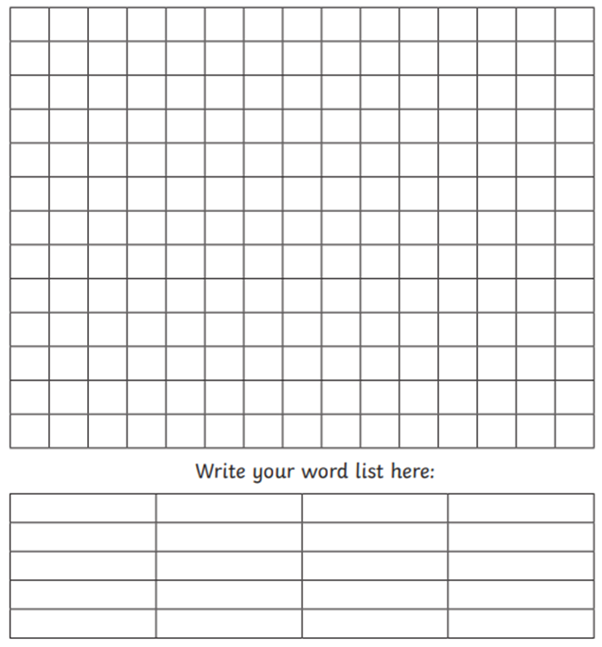
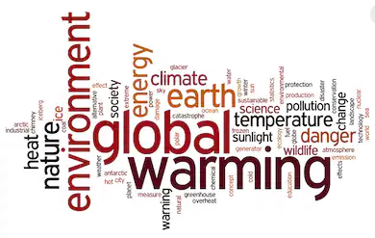
Some of the words you could use are below
- Climate
- Equator
- Desert
- Polar
- Water cycle
- Evaporate
- Energy
- Fibonnaci
Remember you could go forwards, backwards and diagonally!
Wednesday – Activity 1
THE MOON
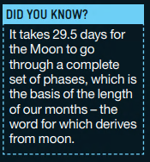
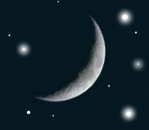
The Moon is our nearest neighbour in space. It is a stark, barrenworld with no atmosphere and measures 2,160 miles across. It lies approximately 239,000 miles from Earth, and is big, bright and easy to find when it is in the night sky. Features such as craters cast impressive shadows when they are close to the terminator, making them much easier to see. The dark patches visible on the Moon’s surface are known as seas (or maria) but are nothing like Earth’s seas. On the Moon they are vast fields of solidified lava from ancient volcanic eruptions.
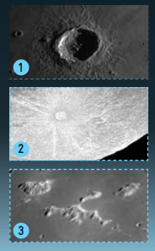
FEATURES OF THE MOON’S SURFACE
1. Craters are the result of impacts by asteroids and comets on the Moon’s surface. The largest craters are hundreds of miles across.
2. Relatively new craters sit in the centre of bright rays, which show up best when the Sun is overhead. These are formed by material blasted out from the impact that formed the crater.
3. There are lots of mountains on the Moon. Some poke up through flat lava as single peaks, while others occur in vast ranges. The Moon has Alps too, as the lunar ranges take their names from those on Earth.

The Moon’s rotation keeps pace with its orbit round the Earth, which means that the same side of the Moon (the near side) faces the Earth at all times. The amount of the illuminated surface we can see from Earth changes as the Moon moves round the Earth and gives us the lunar phases.

Your task is to find out more about the different lunar (moon) phases and why they occur. You could create a picture, complete your very own moon diary, write a nonfiction text explaining the changes or even create your own model - it is up to you!

Useful vocabulary:
New moon, full moon, waxing, waning, crescent, gibbous

Watch this clip as well as using the slides on the next page to find out more about why the Earth’s moon looks different in the night sky:
https://www.stem.org.uk/elibrary/resource/29939
https://www.youtube.com/watch?v=mQwvHn_qkBA

For a bit of fun, use this link here to find out the position of the moon right now. It will also tell you where in the world it is night and where it is day: https://www.timeanddate.com/worldclock/sunearth.html
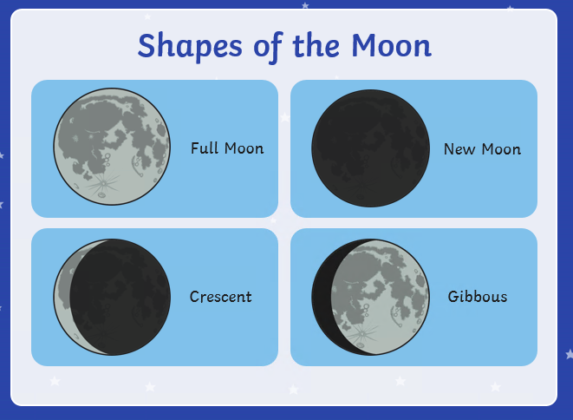

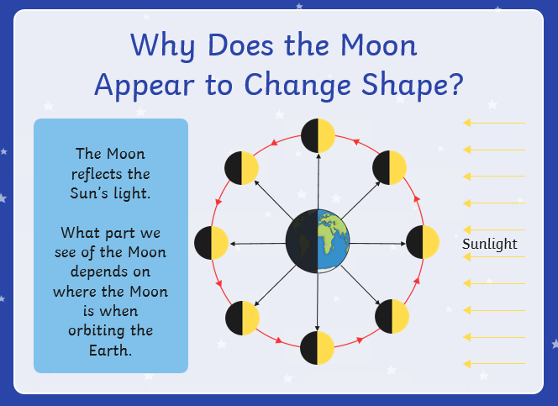

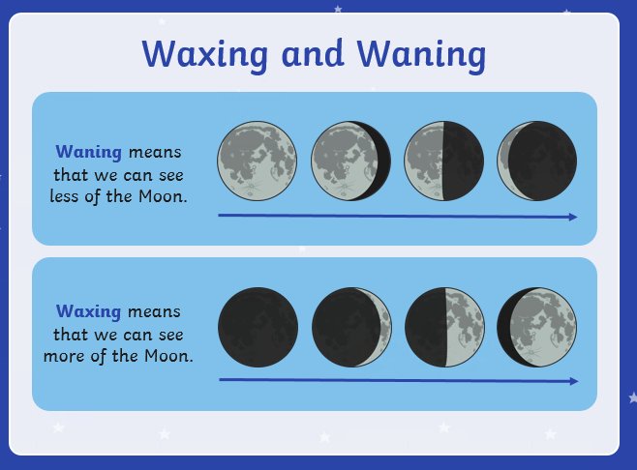

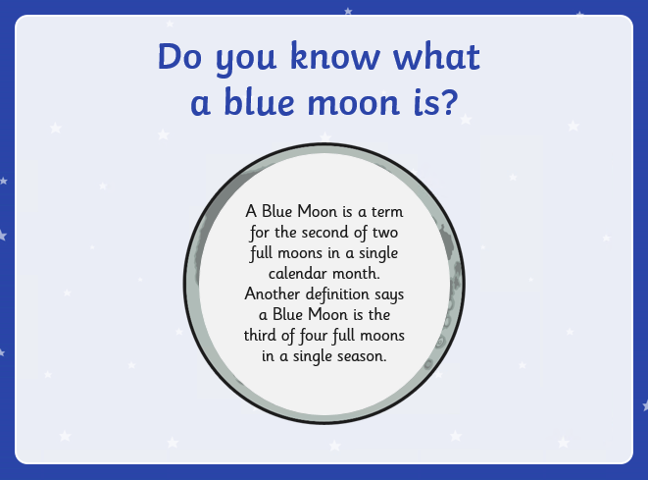

Extension: The Moon is the Earth’s only natural satellite. Apart from Mercury and Venus, all the other planets in the Solar System have their own moons. Find out about other planets and their moons! Did you know Jupiter has 60 moons in total?

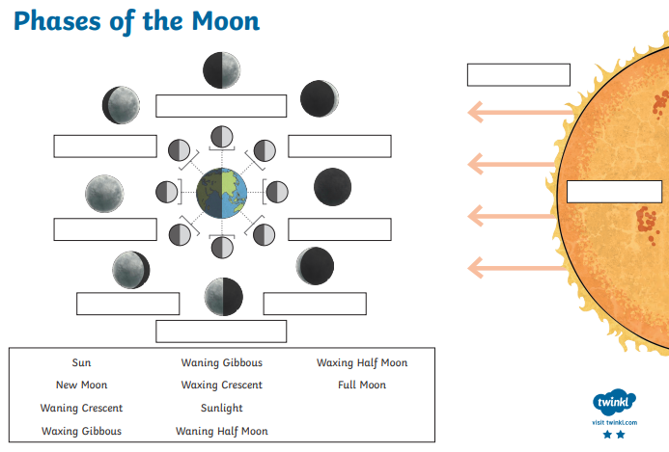
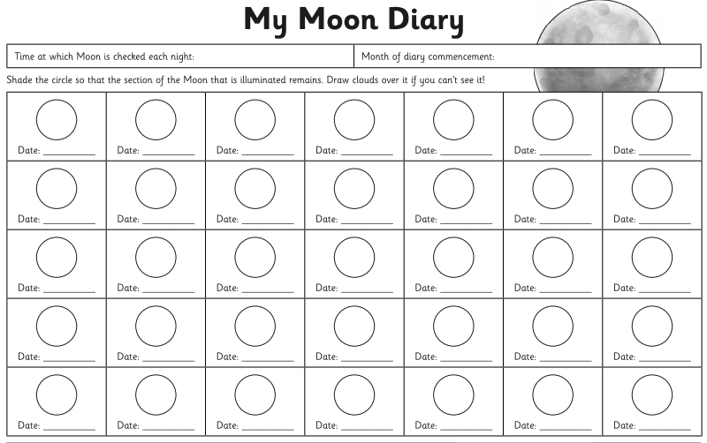
Wednesday – Activity 2 - Thinking Task
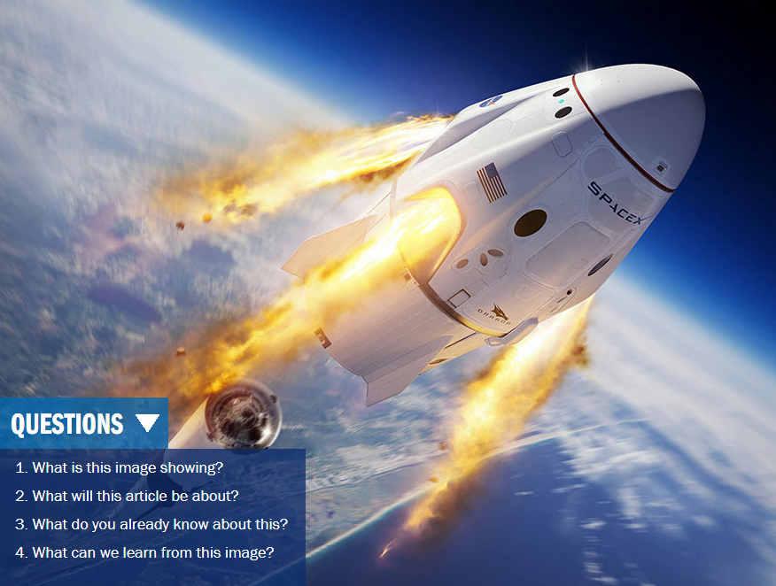

What do you think?
What would be the positives? What challenges would there be? What would happen to Earth?
Record your thinking below:
…………………………………………………………………………………………………………………………………………………………………………………………………………………………………………………………………………………………………………………………………………………………………………………………………………………………………………
…………………………………………………………………………………………………………………………………………………………………………………………………………………………………………………………………………………………………………………………………………………………………………………………………………………………………………
…………………………………………………………………………………………………………………………………………………………………………………………………………………………………………………………………………………………………………………………………………………………………………………………………………………………………………
…………………………………………………………………………………………………………………………………………………………………………………………………………………………………………………………………………………………………………………………………………………………………………………………………………………………………………
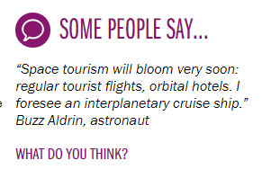
…………………………………………………………………………………………………………………………………………………………………………………………………………………………………………………………………………………………………………………………………………………………………………………………………………………………………………
……………………………………………………………………………………………………………………………………………………………………………………………………………………

Would you go on a holiday to space?
If so, where would you go?

Wednesday – Activity 3 – Stars and Constellations
The stars that you see when you look up at the night sky are very like our own Sun – giant nuclear reactors that shine with incredible power. Our galaxy, known as the Milky Way, is made up of one hundred thousand million stars (roughly), including our own Sun, arranged in a disk shape.

Constellation or Cluster of Stars?
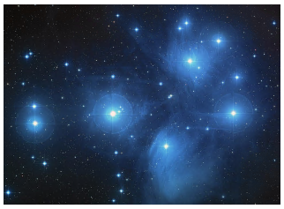
Some stars formed together at the same time, forming clusters. These are natural groups of stars that are physically close to each other in space. One of the most well-known clusters is known as the Seven Sisters (also known as the Pleiades Cluster). An image of the Seven Sisters can be seen on the left. This cluster is actually made up of several hundred stars which all formed together. Many cultures have their own stories about how this cluster of stars came to be in the sky.
A constellation is a group of visible stars that form a pattern when viewed from Earth. They are most often physically unrelated to each other spaced out from each other. The pattern they form may take the shape of an animal, a mythological creature, a man, a woman, or an inanimate object such as a microscope, a compass, or a crown.
How many constellations are there?
The sky was divided up into 88 different constellations in 1922. This included 48 ancient constellations listed by the Greek astronomer Ptolemy as well as 40 new constellations.
Star Maps
The 88 different constellations divide up the entire night sky as seen from all around the Earth. Star maps are made of the brightest stars and the patterns that they make which give rise to the names of the constellations.
The maps of the stars represent the position of the stars as we see them from Earth. The stars in each constellation may not be close to each other at all. Some of them are bright because they are close to Earth while others are bright because they are very large stars.

Today, there is no scientific reason to group the stars. Yet civilizations throughout history have identified constellations which have myths and legends attached to them. Most of the constellation names we know came from the ancient Middle Eastern, Greek, and Roman cultures. They identified clusters of stars as gods, goddesses, animals, and objects of their stories. It is important to understand that these were not the only cultures populating the night sky with characters important to their lives. Cultures all over the world and throughout time — Native American, Asian, and African — have made pictures with those same stars. In some cases the constellations may have had ceremonial or religious significance. In other cases, the star groupings helped to mark the passage of time between planting and harvesting. There are 48 “ancient” constellations and they are the brightest groupings of stars – those observed easily by the unaided eye.

Hemispheres and Seasons
Not all of the constellations are visible from any one point on Earth. The star maps are typically divided into maps for the northern hemisphere and maps for the southern hemisphere. The season of the year can also affect what constellations are visible from where you are located on Earth as we are at a different point in our orbit around the sun so will see a different part of the sky.
How the Stars Came Into Being
A long time ago there lived 4 animals on earth. Each of the animals lived peacefully and in turn Great Spirit rewarded them with eternal sunlight. But one day something new came into the world- fighting and jealousy. Atop a large tree grew a very big and delicious looking fruit and upon seeing it, Bear began climbing the trunk of the tree to retrieve the beautiful thing. Coyote, also seeing the fruit, yearned for it and jumped onto Bear’s back, bringing both animals crashing to the ground. As they began to fight about who the fruit belong to, Eagle flew between the branches of the tree and plucked the fruit from where it sat. As he landed, thinking himself very clever to have won the fruit from the other two, he began to laugh, dropping the fruit from his beak and onto the soft forest floor; so ensued the greatest fight that animal has ever been a part of. So disruptive was this fight that its noise carried high into the sky and into Great Spirit’s ears. Angered by chaos bellow Great Spirit threw his cape upon the world, bringing, for the first time, an immense darkness. A silence immediately fell on the earth below, as the animals stopped their fighting in search of the source of this new thing. Unable to see anything, unable to understand what had happened, but knowing that they had angered Great Spirit, they began fighting once again, accusing one another of their own faults. Finally it was decided that one animal must go to Great Spirit and ask for forgiveness.
“I’ll do it,” said Coyote. “I will swim the widest river and climb the highest mountain and I will yell to Great Spirit, asking for forgiveness.”
And so Coyote set off across the planes of the world, swam the widest river and climbed the highest mountain until he reached its top. And there he stood and yelled to Great Spirit.
“Please forgive us. We have learned our lesson!” But there was no reply. For hours Coyote stood and yelled until his voice became hoarse and tired, emitting nothing but a howl, and so he returned to the others.
Bear laughed at his defeated friend, “You thought you could yell to Great Spirit?” And so Bear set off. Upon reaching the top of the Great Mountain, Bear took in a deep breath, filling his chest with air, and yelled as loud as he could, “Please forgive us, Great Spirit!” But there was no reply. After hours of failed attempts, Bear returned to his friends, grumbling with frustration.
Upon his return, Eagle laughed with joy at his friend’s failure. “Now you will see what a true animal can do.” But no sooner had he began his climb towards the heavens did he become very tired. A rush of death enveloped his body and he returned to earth, choosing his life over the happiness of his friends.
The mightiest of Great Spirit’s animals had fallen and with their realization of this, a severe cold began to inhabit the animals. Then, out of the darkness, they heard a tiny voice, “I can do it.” And from the darkness emerges Hummingbird.
The animals could not believe their eyes- never had they seen this tiny, pathetic creature before. They immediately burst into a fit of laughter. “You will never reach the Great Spirit my little friend,” said Bear. “I am the great warrior of this land and I was unable to make my pleas heard. Stay here where it is safe, for if you set off you will know only defeat.”
But Hummingbird ignored the jests of his fellow animals and began his flight. He flapped his wings and as he reached the Great Spirit’s cape his long beak punctured the fabric, but his body gave way and he fell back down to earth. Looking up into the sky the animals saw little Hummingbird’s work, for a tiny pinprick of light was now showing through the cape. After a short break, Hummingbird tried again and again a pinprick appeared in the cape just before he fell back to earth. Finally after thousands of attempts, Hummingbird made one last tip- flapping his wings faster than ever as he made his way into the darkness. One last hole appeared in the sky, but Hummingbird did not. After several minutes, Great Spirit appeared before the animals with tiny Hummingbird’s body clutched in his hands.
Hummingbird’s heart so impressed the Great Spirit that in honour of the fallen animal the Great Spirit covers the earth with his cape, un-mended, for half of the day, everyday.

Ancient Greeks recognised 48 constellations which were named after mythical creatures. Discover more about them here:
https://www.dkfindout.com/uk/space/constellations/

Want a different viewpoint on the stars and their meaning? Click this link to find out what the Ancient Mayas thought of them...
https://www.windows2universe.org/mythology/Maya_Milkyway.html

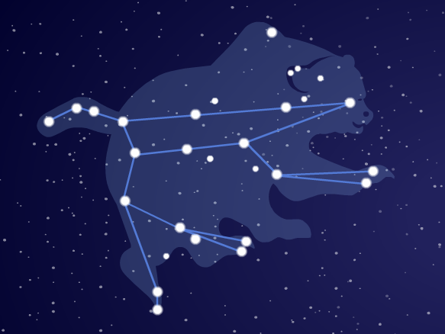
Now that you have learnt about stars and constellations, it’s time to create your own! For this, you will need some paper, something to write with and some small, circular objects (such as lentils, rice or sweets). You will use the random positions of lentils to construct your own constellation by joining the dots. You will need to look for shapes and patterns that you see in the lentils on the paper.
- Look carefully at the picture of the constellation. The dots are the stars. Can you see how the picture is made from the dots?
2. You are going to create your own constellation! Take a small handful of lentils (or another small object), the lentils will be the stars in your constellation.
3. Hold the lentils in your hand over your paper.
4. Open your hand and drop the lentils onto your paper.
5. Look at the lentils on the paper – can you see any shapes in the pattern of your lentils? (If you can’t see a pattern, pick up your lentils and have another go!).
6. Once you can see a pattern in your lentils, take your pen and draw carefully around each lentil.
7. Using the glue, stick your lentils to the paper (optional).
8. Use your pen to connect up the dots so that you have a drawing of your shape.
9. Give your constellation a name and write it on the paper.
10. Decorate your constellation any way you like. Use pens, pencils or crayons to make your constellation look colourful.
11. Use your imagination to come up with a story to explain how your constellation came to be in the sky.

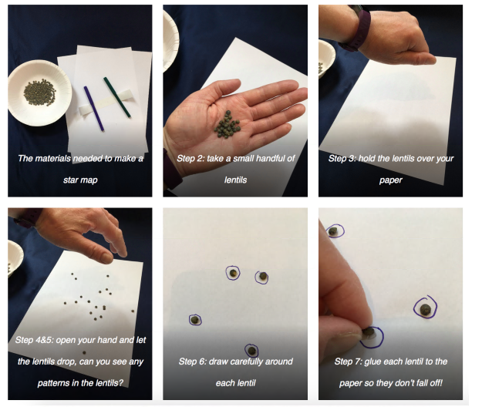

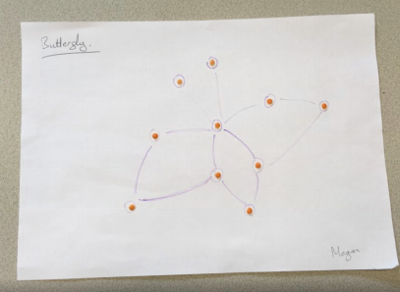

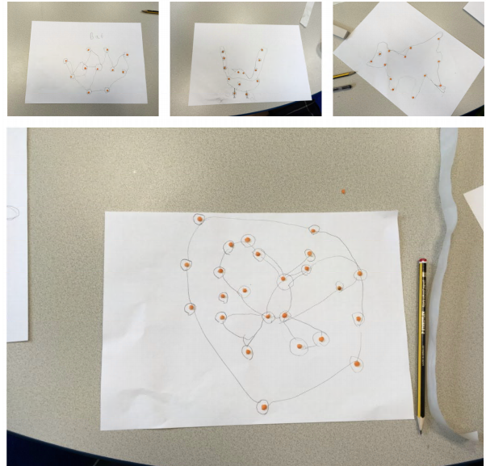

Wednesday – Away From Screen Time – Stargazing
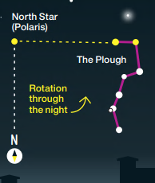
What constellations can you see this time of year?
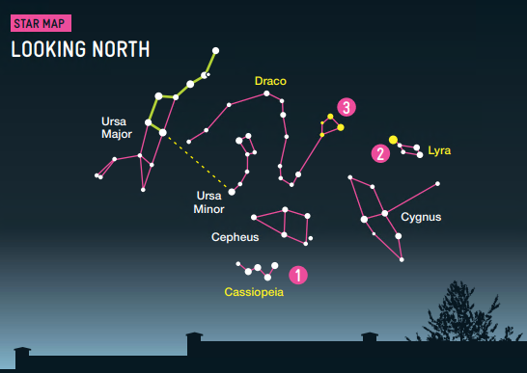
Polaris (the North Star) is positioned above the North Pole, and so it seems to stay still in the night sky as the Earth rotates beneath it and the stars appear to rotate around it. As a result, it has been used for navigation for centuries. It’s easy to spot as two stars in the Plough (part of Ursa Major) point directly towards it, as shown here. If you drop a vertical line from Polaris to the horizon, this is due north. If you are looking north, east is to your right, west is to your left and south is directly behind you.

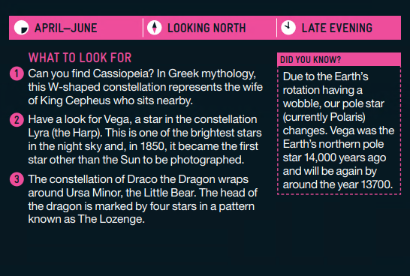
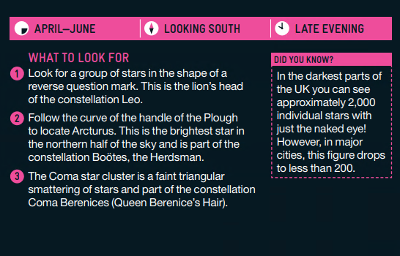
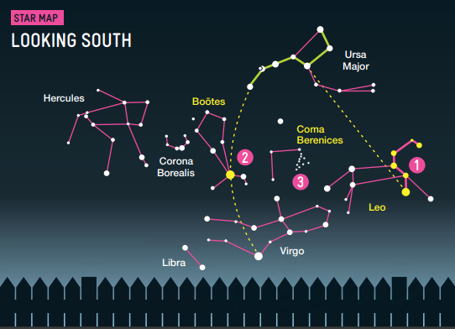

Thursday – Activity 1 – Famous Scientists and How They Changed Our Lives
You now have the opportunity to find out more about famous scientists. You will need to choose a way to display your research. This could be a poster, a slide show, a fact file or any other way you could think of. You can use the website below to watch videos about one of the scientists or use the information below to inspire you.
https://www.bbc.co.uk/teach/class-clips-video/science-ks2-scientists-and-scientific-method/z43mbdm

Sir Issac Newton
https://www.theschoolrun.com/homework-help/sir-isaac-newton#:~:text=Sir%20Isaac%20Newton,(a%20branch%20of%20mathematics).
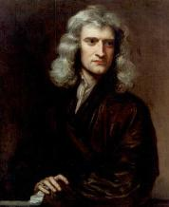
Isaac Newton was born in 1643 and became famous for his work on gravity and his three laws of motion. He was also well known for his work on light and colour, and what is now called calculus (a branch of mathematics).
In 1661, Isaac began to attend college at Cambridge. He would spend much of his life at Cambridge, becoming a professor of mathematics and a fellow of the Royal Society (a group of scientists in England). He eventually was elected to represent Cambridge University as a member of parliament.

Isaac had to leave Cambridge from 1665 to 1667 because of the Great Plague. He spent these two years in study and isolation at his home in Woolsthorpe developing his theories on calculus, gravity, and the laws of motion. He famously discovered gravity while sitting under a tree when an apple fell and hit him on the head.

Hedy Lamarr
https://www.womenshistory.org/education-resources/biographies/hedy-lamarr
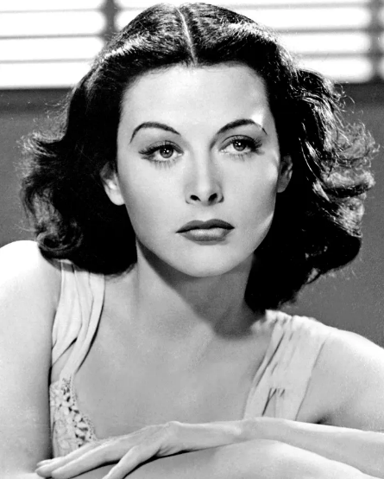
Hedy Lamarr (born 9 November 1914 died 19 January 2000) was an Austrian and American inventor and film actress. She co-invented the technology for frequency hopping which was important for controlling torpedoes. This technology is still used today as part of wifi networks.

Hedy starred in 30 films but her real passion was for inventing. Her first invention was a tablet that when put in liquid, carbonated it making it fizzy. After her emigration to the US, she developed a system which manipulated radio frequencies at irregular intervals to encode classified military messages. This was first used during the Cuban missile crisis. The applications of her invention has made cell phones, fax machines, Bluetooth, and other wireless communications possible.

William and Caroline Herschel
https://kids.kiddle.co/William_Herschel
https://kids.britannica.com/students/article/Caroline-Herschel/326222
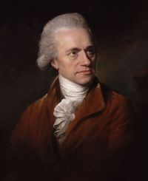
Caroline and William Herschel were brother and sister. They were born in Hanover, Germany during the 1700s. They moved to Britain and made several important discoveries in the field of Astronomy. William is most famous for discovering the planet Uranus in 1781. He also discovered infra-red radiation, catalogued many different stars and nebulae (clouds of dust and gas in space) and also created the world’s largest telescope at the time.
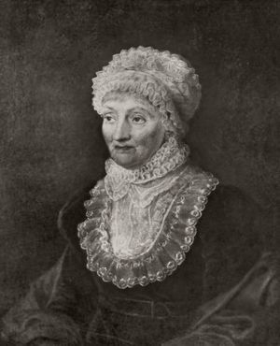
At first, Caroline just helped her brother with his discoveries but soon began making them for herself. She discovered several comets. The comet Herschel-Rigollet is named in her honor. She was the first woman to be officially recognised in a scientific position and was the first woman to join the prestigious Royal Society, an academy dedicated to promoting scientific excellence.

Underneath there is an empty fact file for you to use if you want to.

Thursday – Activity 2 – Reversible and Irriversible Changes
What happens when you heat up an egg?
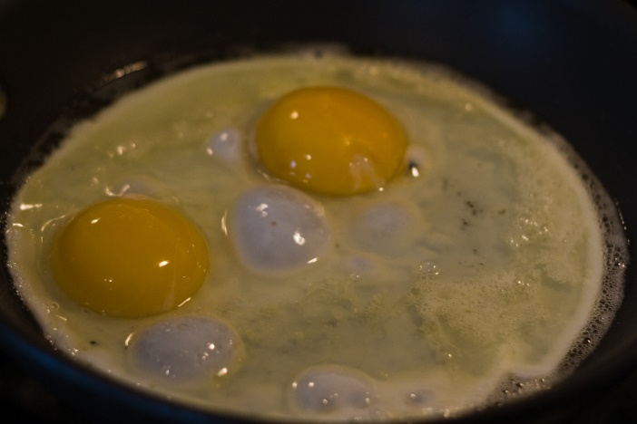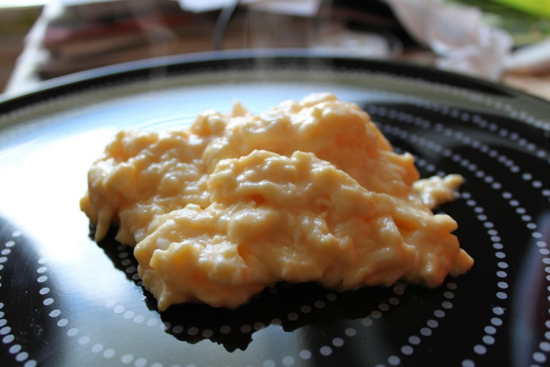
What do you notice changes? Can it be reversed?
Watch this video to discover the difference between the two: https://www.bbc.co.uk/bitesize/topics/zcvv4wx/articles/z9brcwx
Or read the information below:
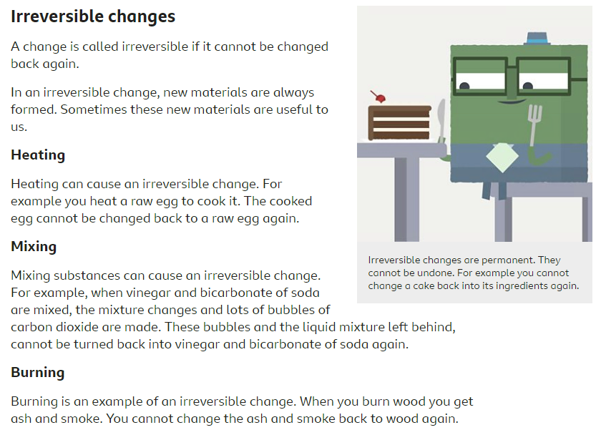
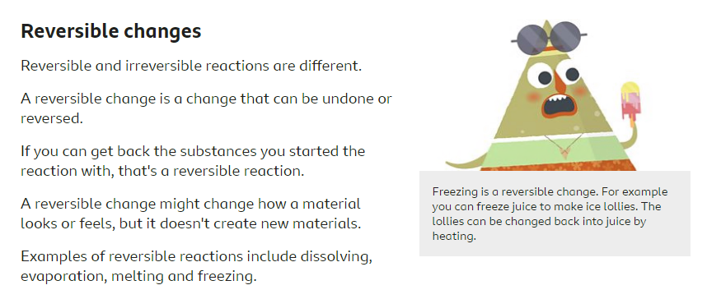
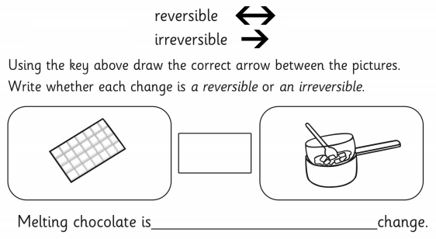
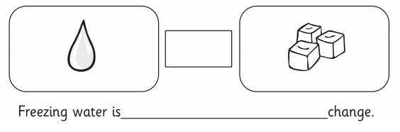
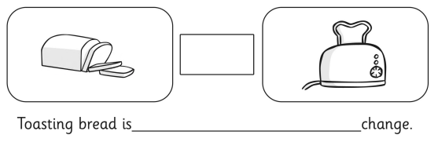
Now explore around your house spotting some changes that can occur. Draw them in the boxes below identifying if they are reversible or irreversible changes.

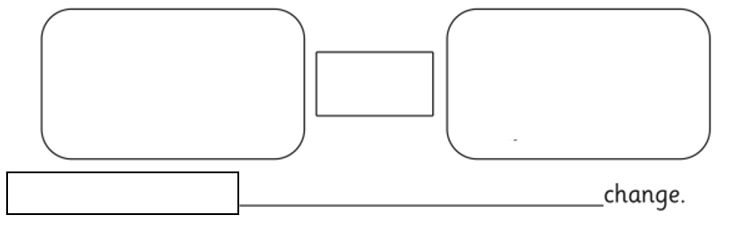

Thursday – Activity 3 – Change Reflection
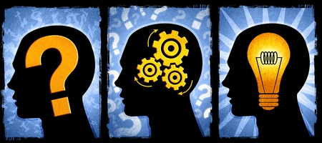
What does this learning tell you about change?
Do you think change is important? How does change affect what goes on in the world around you?
Can you link your new knowledge of changes which occur in Science? How does this build upon change from last week?

………………………………………………………………………………………………………………………………………………………………………………………………………………………………………………………………………………………………………………………………………………………………………………………………………………………………………
…………………………………………………………………………………………………………………………………………………………………………………………………………………………………………………………………………………………………………………………………………………………………………………………………………………………………………
…………………………………………………………………………………………………………………………………………………………………………………………………………………………………………………………………………………………………………………………………………………………………………………………………………………………………………
…………………………………………………………………………………………………………………………………………………………………………………………………………………………………………………………………………………………………………………………………………………………………………………………………………………………………………
…………………………………………………………………………………………………………………………………………………………………………………………………………………………………………………………………………………………………………………………………………………………………………………………………………………………………………
…………………………………………………………………………………………………………………………………………………………………………………………………………………………………………………………………………………………………………………………………………………………………………………………………………………………………………

Thursday – Away from Screen Time
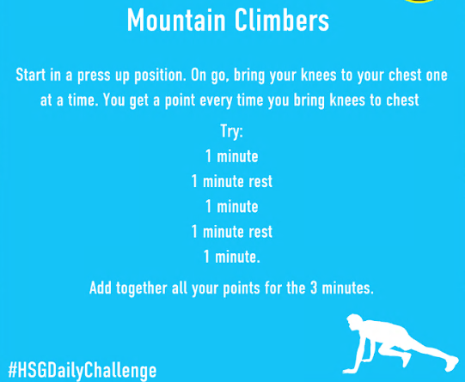

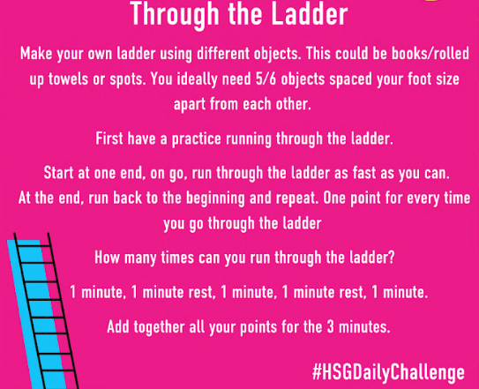
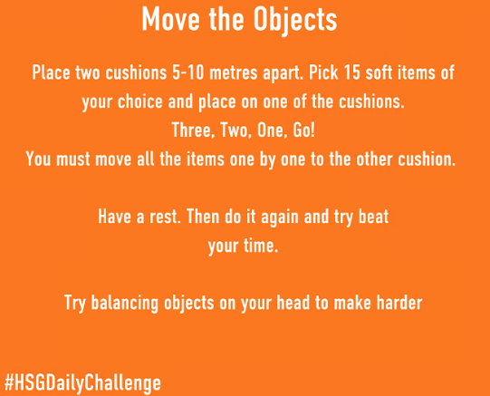
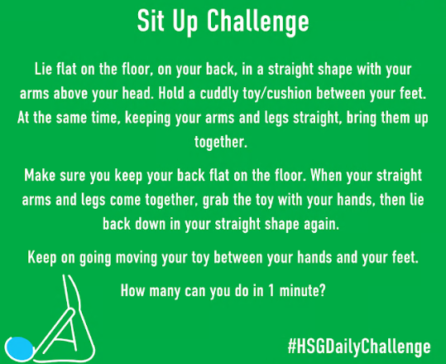

 | Try 1 Points | Try 2 Points | Try 3 Points
Mountain Climbers
Sit Ups
Move the Objects
Through the Ladder

Friday – Catch up and Chill
Today is the day to take part in any of the activities above if you hadn’t had a chance yet. Instead, you may have some ideas of your own! No matter what you choose to do today, make sure you relax and take some time for you!
