Year 4

This is the spelling progression document for year 4. This includes what should be taught, what should be revised while still leaving room for teachers to use assessment for learning to adapt to the needs of the children. Throughout the units children will also be taught a variety of revision strategies and assessed regularly.
Term | Objective | Examples | Taught
Autumn  Revision:  - From Year 2: possessive apostrophe with singular proper nouns | Words ending /ʒə/ | (treasure, measure, pleasure, enclosure, closure)
 | Homophones | (peace/piece, main/mane, fair/fare)
 | Prefixes ‘in-’, ‘il-’, ‘im-’ and ‘ir-’ | All mean “not”  (Independent, illiterate, immature, irresponsible.)
 | Words with the /eɪ/ sound spelt ‘ei’, ‘eigh’ or ‘ey’ | (eight, weigh, grey, sleigh)
 | Words with the /ʃ/ sound spelt ‘ch’ and the /ʌ/ sound spelt ‘ou’ | (chef, brochure, parachute, machine)  (young, touch, trouble, country)
 | Adding suffixes beginning with vowel letters to words of more than one syllable (‘-ing’, ‘-er’, ‘-en’, ‘-ed’) | (cornering, fastening, awakening)  (beginner, gardener, forgetter)  (awaken)  (cornered, fastened, gardened)
Spring | The /g/ sound spelt ‘gu’ | (guide, guitar, guard, guidebook, guest, guardian, guarantee, guess)
 | Words with endings sounding like /tʃə/ spelt ‘-ture’ | (mixture, adventure, capture, feature, moisture, nature, picture, vulture)
 | Possessive apostrophe with plurals | The dogs’ kennel, The cows’ field, the teachers’ book, the boys’ football.
 | Homophones | (scene/seen, mail/male, bawl/ball)
 | Prefixes ‘anti-’ and ‘inter-’ | (antibiotic, antidote, antihistamine, antihero)  (international, intergalactic, intertwine, interrupt)
 | Endings that sound like  /ʃən/ spelt ‘-cian’, ‘-sion’,  ‘-tion’ and ‘-ssion’ | 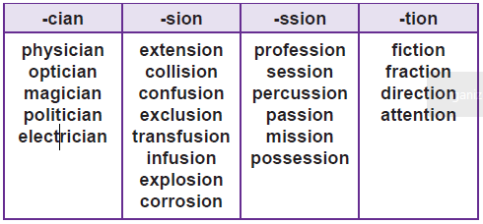
Summer:  Revision:  - Apostrophes for possession, including singular and plural  - Prefixes ‘un-’, ‘dis-’, ‘in-’, ‘re-’, ‘sub-’, ‘inter-’, ‘super-’, ‘anti-’, ‘auto-’ | Words with the /s/ sound  spelt ‘sc’ (Latin in origin) | (science, abscess, ascend, descend, scene, scissors, scented, crescent)
 | Endings that sound like  /ʒən/ spelt ‘sion’ | (division, collision, explosion, corrosion, conclusion, extension, comprehension, evasion, intrusion, conclusion)
 | Homophones | (weather, whether, who’s, whose, medal, meddle, missed, mist, team, teem)
 | Suffix ‘-ous’ | (furious, famous, courageous, mountainous, envious, spacious, poisonous, dangerous, various)
 | Suffix ‘-ly’ added to words ending in ‘y’, ‘le’ and ‘ic’ | (happily, easily, greedily)  (gently, simply, humbly)  (basically, frantically, dramatically)

